**LAPORAN KERJA PRAKTEK**



# PEMBUATAN APLIKASI AKADEMIK BERBASIS JAVA PADA SEKOLAH RAUDHATUL ATHFAL (RA) MARDIYYATUZZIYADAH

Laporan Kerja Praktek

Diajukan untuk melengkapi

Persyaratan mata kuliah

Kerja praktek

Disusun Oleh:

|  |  |
| --- | --- |
| RONALDO PAPUA MANDOSIR | 202043502582 |
| ANWAR HAKIM | 202043501579 |
| RAFI SAIFULLAH | 202043502583 |
| RESA TILAWA | 202043502579 |
| ZIDANE RAMANDA | 202043501564 |
| FADHIL BARA PUTRA | 202043501552 |
| YUDISTIRA ANGGA PRADIPTA | 202043501557 |
| AULIA SUSTRI DEWIYANTI I. | 202043502578 |

**PROGRAM STUDI TEKNIK INFORMATIKA FAKULTAS TEKNIK DAN ILMU KOMPUTER UNIVERSITAS INDRAPRASTA PGRI**

**2024**

# LEMBAR PENGESAHAN PROGRAM STUDI

**LAPORAN KERJA PRAKTEK**

**PEMBUATAN APLIKASI AKADEMIK BERBASIS JAVA PADA SEKOLAH RAUDHATUL ATHFAL (RA) MARDIYYATUZZIYADAH**

**PADA TANGGAL (02 Mei 2024 – 15 Juli 2024)**

Disusun oleh :

|  |  |
| --- | --- |
| RONALDO PAPUA MANDOSIR | 202043502582 |
| ANWAR HAKIM | 202043501579 |
| RAFI SAIFULLAH | 202043502583 |
| RESA TILAWA | 202043502579 |
| ZIDANE RAMANDA | 202043501564 |
| FADHIL BARA PUTRA | 202043501552 |
| YUDISTIRA ANGGA PRADIPTA | 202043501557 |
| AULIA SUSTRI DEWIYANTI I. | 202043502578 |

Mengetahui, Menyetujui,

Ketua Program Studi Dosen Pembimbing

**Mei Lestari, M.Kom Rudi Prasetyo, M.Kom**

# LEMBAR PENGESAHAN PERUSAHAAN / INSTASI

**LAPORAN KERJA PRAKTEK  
PEMBUATAN APLIKASI AKADEMIK BERBASIS JAVA**

**PADA SEKOLAH RAUDHATUL ATHFAL**

**(RA) MARDIYYATUZZIYADAH**

**PADA (02 Mei 2024 – 15 Juli 2024 )**

Disusun oleh :

|  |  |
| --- | --- |
| RONALDO PAPUA MANDOSIR | 202043502582 |
| ANWAR HAKIM | 202043501579 |
| RAFI SAIFULLAH | 202043502583 |
| RESA TILAWA | 202043502579 |
| ZIDANE RAMANDA | 202043501564 |
| FADHIL BARA PUTRA | 202043501552 |
| YUDISTIRA ANGGA PRADIPTA | 202043501557 |
| AULIA SUSTRI DEWIYANTI I. | 202043502578 |

Mengetahui, Menyetujui,

Kepala RA Mardiyyatuzziyadah Dosen Pembimbing



**Reny Rahmawati, SS, S.Pd.I Rudi Prasetya, M.Kom**

# KATA PENGANTAR

Alhamdullilah, puji syukur penulis kami panjatkan kehadirat Tuhan Yang Maha Esa yang telah melimpahkan rahmat dan karunia-Nya, serta kuasa-Nya memberikan pengetahuan, kemampuan, dan kesempatan sehingga penulis dapat menyelesaikan Laporan Kerja Praktek (KKP) dengan judul **“PEMBUATAN APLIKASI AKADEMIK BERBASIS JAVA PADA SEKOLAH RAUDHATUL ATHFAL (RA) MARDIYYATUZZIYADAH”** yang merupakan salah satu syarat kelulusan mata kuliah Kerja Praktek jurusan Teknik Informatika. Oleh karena keterbatasan kemampuan dan pengetahuan, penulis memohon maaf atas segala kesalahan dan kekurangan dalam penulisan pada laporan ini. Oleh karena itu, kritik dan saran yang membangun sangat diharapkan dari semua pihak untuk memperbaiki serta menyempurnakan laporan ini. Pada kesempatan ini, peneliti juga mengucapkan terima kasih kepada pihak-pihak yang telah memberikan bantuan kepada kami sehingga laporan ini dapat tersusun dengan baik.

Maka dari itu, izinkanlah peneliti mengucapkan terima kasih sebesar-besarnya kepada:

1. Bapak Prof. Dr. H. Sumaryoto, selaku Rektor Universitas Indraprasta PGRI.
2. Bapak. Ir. H. Soepardi Haris, M.T., selaku Dekan Fakultas Teknik dan Ilmu Komputer Universitas Indraprasta PGRI.
3. Ibu Mei Lestari, M.Kom., selaku Ketua Program Studi Informatika Fakultas Teknik dan Ilmu Komputer Universitas Indraprasta PGRI.
4. Ibu Reny Rahmawati, SS, S.Pd.**I** selaku Pemimpin RA Mardiyyatuzziyadah
5. Ibu Sri Dewi selaku Pembimbing kami di RA Mardiyyatuzziyadah
6. Bapak Rudi Prasetya, M.Kom Dosen Pembimbing Laporan Kerja Praktek
7. Ibu Lengsi Manurung, M.Pd Dosen Pembimbing Akademik

Kami menyadari bahwa dalam penulisan laporan kerja praktek ini masih jauh dari sempurna. Maka dari itu penulis mengharapkan kritik dan saran yang bersifat membangun guna perbaikan di masa mendatang. Akhir kata, semoga laporan kerja praktek ini dapat bermanfaat bagi penulis, pembaca, serta bagi semua pihak.

Jakarta, 17 Juli 2024

Penulis ,

# DAFTAR ISI

LEMBAR PENGESAHAN PROGRAM STUDI i

LEMBAR PENGESAHAN PERUSAHAAN / ISNTALASI ii

KATA PENGANTAR iii

DAFTAR ISI v

DAFTAR SIMBOL viii

DAFTAR GAMBAR xi

DAFTAR TABLE xiii

DAFTAR LAMPIRAN xiiii

BAB I PENDAHULUAN **Error! Bookmark not defined.**

A. Latar Belakang 1

B. Masalah 3

C. Tujuan Penulisan 3

D. Batasan Permasalahan 2

E. Metodologi 2

F. Sistematika Penulisan 6

BAB I: PENDAHULUAN 6

BAB II: ORGANISASI 6

BAB III: INFRASTUKTUR 6

BAB IV: PEMBAHASAN 6

BAB V: KESIMPULAN DAN SARAN 8

LAMPIRAN 8

BAB II 9

ORGANISASI 9

A. Sejarah Sekolah 9

B. Struktur organisasi 11

C . Penjelasan Unit Kegiatan yang menjadi tempat KP **Error! Bookmark not defined.**

BAB III INFRASTUKTUR 17

A. Spesifikasi Hardware 17

1. Pengertian Perangkat Keras (Hardware) 17

2. Hardware yang digunakan 18

B. Spesifikasi Software 19

1. Pengertian Perangkat Lunak (Software) 19

2. Klasifikasi Perangkat Lunak (Software) 20

3. Software Pendukung 21

BAB IV PEMBAHASAN 25

A. Proses Bisnis 25

B. Proses Sistem yang Berjalan 25

C. Aturan Bisnis Sistem Berjalan 26

D. Kebijakan Sistem 28

E. Dekomposisi Fungsi 30

1. Analisis masukan (input) 32

2. Analisis Proses 35

3. Analisis Keluaran 37

F. Diagram Aliran Data (DAD) Sistem Yang Di Usulkan (Diagram Konteks Nol, Rinci). 39

1. Diagram Konteks 39

2. Diagram Nol 40

3. Diagram Rinci 41

G. Kamus Data 43

H. Spesifikasi Proses 49

I. Bagan Terstruktur 54

J. Spesifikasi Modul 60

K. Analisa Basis Data 64

L. Rancangan Layar, Rancangan Form Masukan, dan Rancangan Form Keluaran 69

BAB V PENUTUP 81

A. Kesimpulan 81

B. Saran 81

DAFTAR PUSTAKA 83

LAMPIRAN 84

# DAFTAR SIMBOL

1. *DFD* *(Data Flow Diagram*)

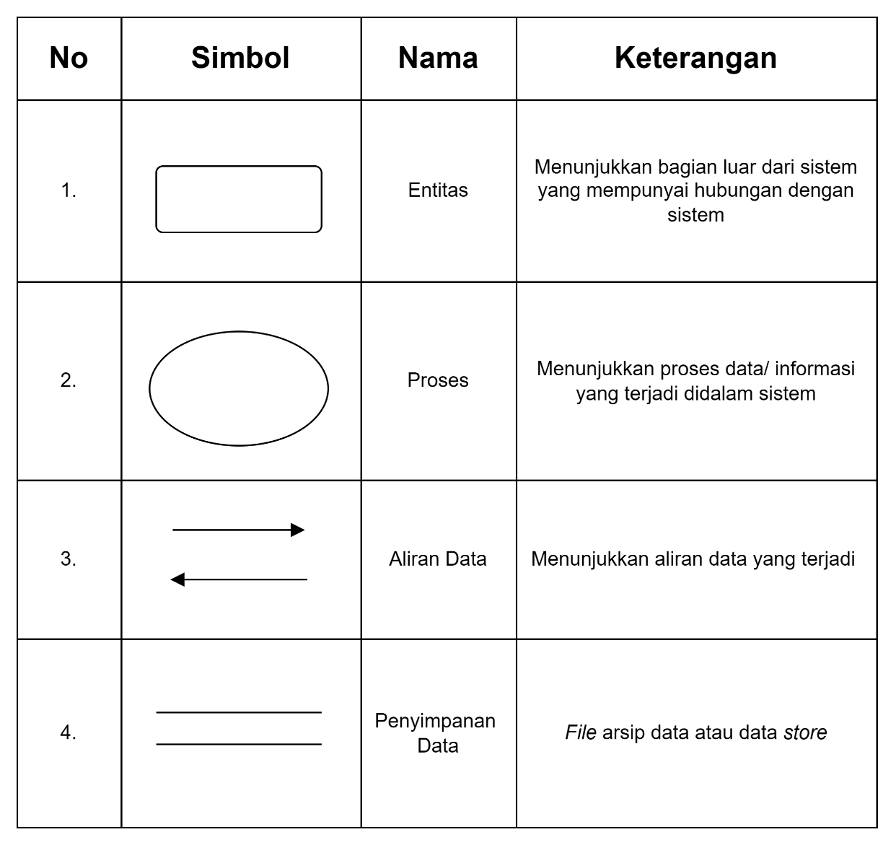

1. *ERD* (*Entity Relationship Diagram*)

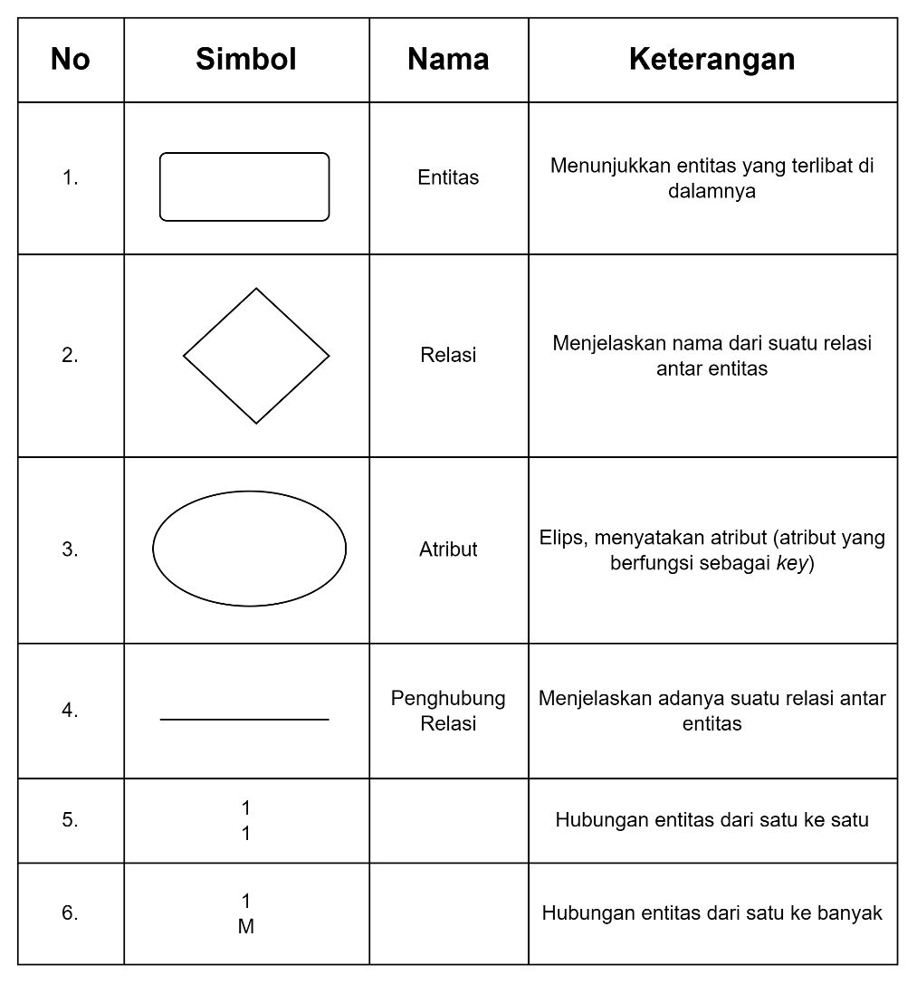

1. Bagan Terstruktur

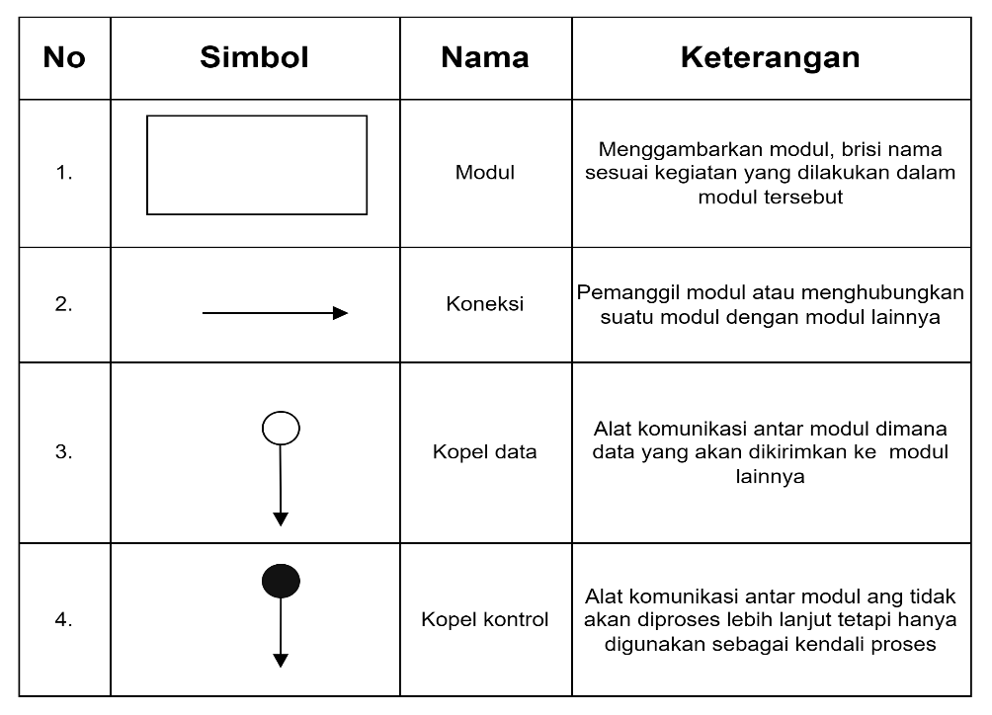

# DAFTAR GAMBAR

Gambar 2 1 Struktur organisasi 11

Gambar 4. 1 Dekomposisi Fungsi 30

Gambar 4. 2 Hirarki Fungsi Sistem Yang Berjalan 31

Gambar 4. 3 Diagram Konteks 39

Gambar 4. 4 Diagram Nol 40

Gambar 4. 5 Diagram Rinci Proses 1 41

Gambar 4. 6 Diagram Rinci Proses 2 42

Gambar 4. 7 Bagan terstruktur data guru 54

Gambar 4. 9Bagan terstruktur data kelas 55

Gambar 4. 10 Matpel 56

Gambar 4. 11 Bagan terstruktur data jadwal 56

Gambar 4. 12 Bagan terstruktur data nilai 57

Gambar 4. 13 Laporan data guru 57

Gambar 4. 14 Laporan data murid 58

Gambar 4. 15 Laporan data kelas 58

Gambar 4. 16 Laporan data matpel 59

Gambar 4. 17 Laporan data jadwal 59

Gambar 4. 18 Laporan data nilai 60

Gambar 4. 19 ERD (Entity Relashionship Diagram) 64

Gambar 4. 20 Rancangan Layar Login 69

Gambar 4. 21 Rayangan layar menu utama 69

Gambar 4. 22 Rancangan layar data guru 70

Gambar 4. 23 Rancangan Layar Data Murid 70

Gambar 4. 24 Rancangan Layar Data Matpel 71

Gambar 4. 25 Rancangan Layar Data Jadwal 72

Gambar 4. 26 Rancangan Layar Data Nilai 72

Gambar 4. 27 Rancangan Keluaran laporan data guru **Error! Bookmark not defined.**

Gambar 4. 28 Rancangan keluaran laporan data murid **Error! Bookmark not defined.**

Gambar 4. 29 Rancangan keluaran laporan data kelas **Error! Bookmark not defined.**

Gambar 4. 30 Rancangan keluaran laporan data Matpel **Error! Bookmark not defined.**

Gambar 4. 31 Rancangan keluaran laporan data jadwal **Error! Bookmark not defined.**

Gambar 4. 32 Rancangan keluaran laporan data nilai **Error! Bookmark not defined.**

# DAFTAR TABEL

TABLE 4. 1 Sistem Berjalan 28

TABLE 4. 2 tb_guru 65

TABLE 4. 3 tb_ murid 66

TABLE 4. 4 tb_kelas 66

TABLE 4. 5 tb_Matpel 67

TABLE 4. 6 tb_jadwal 68

TABLE 4. 7 tb_nilai 68

# DAFTAR LAMPIRAN

Lampiran 1 : Formulir masukan dan keluaran KKP

Lampiran 2 : Listing program

Lampiran 3 : Lembar berita acara konsultasi dengan dosen pembimbing KKP

Lampiran 4 : Lembar berita acraa kunjungan ke instansi

Lampiran 5 : Lembar penilaian KKP

Lampiran 5 : Lembar penilaian INSTANSI

# BAB I

# PENDAHULUAN

## Latar Belakang

Saat ini, teknologi sangat berkembang dengan pesat, dan teknologi ini mampu menciptakan kemajuan dan kemudahan pada setiap bidang kehidupan. Baik bidang pendidikan, ekonomi, sosial budaya, kesehatan dan lain sebagainya. Suatu organisasi maupun instansi perusahaan juga membutuhkan perkembangan teknologi baik untuk mendapatkan informasi yang cepat, tepat dan akurat. Karena itu, keberadaan sistem informasi yang sudah menjadi kebutuhan yang mutlak bagi organisasi, instansi, maupun perusahaan dalam menjalankan proses bisnisnya. Sistem akademik akan menjadikan seseorang mampu untuk menjalani kehidupan ini dengan baik. Dengan pendidikan akademik akan menjadikan seseorang mampu untuk mengatasi segala masalah dengan kehidupan. Sebuah pendidikan akademik dapat diperoleh di sekolah, di mana terdapat perpustakaan sebagai tempat meminjam buku sebagai sumber ilmu. Namun sebuah pendidikan akademik dapat diperoleh tanpa materi dari sebuah sumber tertulis. Ilmu kehidupan bukanlah pendidikan akademik, tetapi pendidikan akademik berkaitan dengan pembelajaran di kelas yang besifat ilmiah. Sedangkan pendidikan non akademik di luar kelas secara umum tidak bersifat ilmiah.

Seiring dengan perkembangan teknologi dan informasi yang begitu cepat, sistem informasi memiliki peranan yang sangat penting bagi suatu organisasi atau perusahaan. Komputer sebagai media pengolah data, apabila dikelola dengan benar, akan menjadi sebuah media informasi yang sangat cepat, tepat dan akurat yang tentunya sangat membantu dalam proses kemajuan suatu organisasi. Komputer juga memiliki kaitan erat dalam memajukan dunia pendidikan karena dapat dijadikan sebagai alat bantu untuk melakukan aktivitas misalnya dalam pengolahan data, pembuatan laporan dan penyimpanan data dimana menghasilkan suatu informasi yang cepat, tepat dan akurat. Raudhatul Athfal (RA) Mardiyyatuzziyadah merupakan instansi pendidikan yang sangat membutuhkan aplikasi.

Salah satu aplikasi yang sangat dibutuhkan oleh Raudhatul Athfal (RA) Mardiyyatuzziyadah adalah Aplikasi Akademik. Aplikasi akademik yang berjalan di Raudhatul Athfal (RA) Mardiyyatuzziyadah dalam pengolahan data akademiknya masih menggunakan sistem komputerisasi sederhana. Walaupun sudah didukung dengan komputer tetapi hanya memanfaatkan program aplikasi sederhana seperti Microsoft Office Excel dan Word sehingga memungkinkan banyak sekali kesalahan dalam pengolahan data akademik. Hal ini dapat menghambat pelayanan akademik terhadap murid dan guru serta mengakibatkan kesulitan dalam pencarian data dan menyita waktu dalam pembuatan laporan. Untuk membantu pengolahan data akademik di Raudhatul Athfal (RA) Mardiyyatuzziyadah perlu adanya suatu aplikasi agar setiap pekerjaan yang menyangkut pengolahan data akademik di Raudhatul Athfal (RA) Mardiyyatuzziyadah tersebut dapat dikurangi tingkat kesalahannya serta dapat memberikan pelayanan yang memuaskan terhadap murid. Berdasarkan latar belakang di atas maka peneliti mengambil judul: **“PEMBUATAN APLIKASI AKADEMIK BERBASIS JAVA PADA SEKOLAH RAUDHATUL ATHFAL (RA) MARDIYYATUZZIYADAH”**. Identifikasi masalah yang terdapat di Raudhatul Athfal (RA) Mardiyyatuzziyadah yaitu tidak adanya suatu aplikasi yang bertujuan untuk melakukan Input maupun Output data.

## Masalah

Dari latar belakang masalah yang telah diuraikan sebelumnya, identifikasi masalah pada penelitian ini adalah:

* 1. Sistem keamanannya yang belum terjamin aman
  2. Masih menggunakan berbasis web yang masih bisa dikategorikan kurang dalam keamanan menjaga data data nya
  3. Pendataannya belum efektif, masih sering terjadi error.

Data yang masih bisa dihack/ dibobol karena masih menggunakan jaringan web.

## Tujuan Penulisan

Tujuan pembuatan penelitian ini adalah :

* 1. Untuk merancang dan membangun sistem akademik di Raudhatul Athfal (RA)Mardiyyatuzziyadah
  2. Untuk memperlancar pendataan akademik dan mengurangi tingkat kesalahan dengan menggunakan Java Netbeans pada Raudhatul Athfal (RA)Mardiyyatuzziyadah
  3. Untuk meningkatkan keamanan data-data dan lebih terintegrasi menggunakan java Netbeans
  4. Untuk membangun sistem akademik menggunakan aplikasi Java Netbeans

## Batasan Permasalahan

Dalam penelitian ini, terdapat beberapa batasan masalah dari masalah yang diteliti yaitu sebagai berikut:

* 1. Membahas tentang sistem akademik pada Raudhatul Athfal (RA) Mardiyyatuzziyadah
  2. Aplikasi berbasis Java, sehingga tidak dapat diakses melalui jaringan
  3. Aplikasi ini menghasilkan laporan akademik di Raudhatul Athfal (RA) Mardiyyatuzziyadah seperti adanya absensi guru dan murid, jadwal matpel, dan lain-lain
  4. Aplikasi ini menggunakan Java Netbeans IDE 8.2 sehingga system ini hanya bisa dijalankan disistem operasi *windows* saja
  5. Pengguna aplikasi Java ini diperuntukan untuk melakukan pendataan atau menginput data pada Raudhatul Athfal (RA)Mardiyyatuzziyadah.

## Metodologi

Dalam upaya melengkapi data-data atau informasi dalam pengerjaan tugas perancangan sistem ini, maka penulis memperoleh data-data atau informasi yang dibutuhkan tersebut dengan beberapa metode. Metode penelitian data tersebut adalah sebagai berikut:

* 1. **Perencanaan**

Perancanaan ialah sejumlah kegiatan yang ditentukan sebelumnya untuk dilaksanakan pada suatu periode tertentu dalam rangka mencapai tujuan yang ditetapkan.

* + 1. Teknik pengumpulan data

Proses pengumpulan data dalam menyusun penelitian ini diperoleh penulis dengan cara sebagai berikut:

1. Observasi (Pengamatan Langsung)

Yaitu metode untuk mendapatkan data dengan melakukan pengamatan langsung, pencatatan dan pengumpulan data-data yang dilakukan pada Raudhatul Athfal (RA) Mardiyyatuzziyadah.

1. Interview (Wawancara)

Penulis juga melakukan metode wawancara dalam pengumpulan data. Metode wawancara ini penulis tunjukan kepada orang-orang yang berkecimpung langsung maupun tidak langsung dalam proses pengelolaan pada Raudhatul Athfal (RA) Mardiyyatuzziyadah, guna mencari penjelasan pada saat observasi.

1. Metode Perpustakaan (Studi Literatur)

Terkait pengumpulan data yang bersumber dari buku-buku serta catatan selama perkuliahan, atau buku penunjang lainnya sehingga data tersebut dapat diambil berdasarkan kaitan topik yang tersusun sebagai penunjang

* + 1. Studi kelayakan

Studi kelayakan yaitu studi yang mempertimbangkan kebutuhan-kebutuhan dalam pembangunan sebuah sistem sehingga dapat ditentukan layak atau tidaknya sistem tersebut. Dan penelitian yang dibuat oleh penulis sangat layak untuk dilakukan dalam hal ini untuk meningkatkan dunia pendidikan.

* 1. **Analisa**

Merangkum sejumlah data besar data yang masih mentah menjadi informasi yang dapat diinterpretasikan. Kategorisasi atau pemisahan dari komponen-komponen atau bagian-bagian yang relevan dari seperangkat data juga merupakan bentuk analisis untuk membuat data-data tersebut mudah diatur. Penulis memaparkan beberapa tahapan yang diperlukan dalam pembuatan aplikasi ini :

Mengidentifikasi penyebab masalah, Permasalahan yang akan dipecahkan dalam mengidentifikasi penyebab masalah ini dapat dirangkum sebagai berikut :

1. Informasi tentang data nilai, Absen dan jadwal matpel yang diterapkan di Raudhatul Athfal (RA) Mardiyyatuzziyadah belum tersedia melalui aplikasi.
2. Informasi tentang nilai dan jadwal matpel serta yang lainnya masih bersifat manual, dimana murid masih datang kesekolah untuk melihat nilai mereka.
3. Merancang dan membangun aplikasi yang bisa mempermudah murid dalam pengaksesan informasi akademik di Raudhatul Athfal (RA) Mardiyyatuzziyadah menggunakan aplikasi.
   1. **Perancangan**

Penggambaran, perencanaan dan pembuatan sketsa atau pengaturan dari beberapa elemen yang terpisah ke dalam satu kesatuan yang utuh dan berfungsi Perancangan sistem dapat dirancang dalam bentuk bagan alir sistem (system flowchart), yang merupakan alat bentuk grafik yang dapat digunakan

* 1. **Implementasi**

Proses untuk memastikan terlaksananya suatu kegiatan dan tercapainya tujuan kegiatan tersebut. Keberhasilan implementasi dapat dilihat dari program tersebut dirancang dengan landasan yang jelas, dengan kelompok sasaran, dan tujuan yang jelas. untuk menunjukan urutan-urutan proses dari sistem.

1. **Sistematika Penulisan**

Penulis serta pembahasan kuliah kerja praktik (KKP) ini dibagi beberapa bab dengan sistematika penulisan sebagai berikut :

**BAB I PENDAHULUAN**

Pada bab ini membahas pendahuluan yang membahas tentang latar belakang, identifikasi masalah, tujuan penelitian, batasan permasalahan, metodologi, dan sistematika penulisan.Pada bab ini membahas pendahuluan yang membahas tentang latar belakang, identifikasi masalah, tujuan penulisan, batasan permasalahan, metodologi, dan sistematika penulisan.

**BAB II ORGANISASI**

Pada bab ini membahas tentang organsisasi yang berisi Sejarah Sekolah dan Struktur Organisasi berserta tugas dan tanggung jawabnya.

**BAB III INFRASTUKTUR**

Pada bab ini menjelaskan mengenai Spesifikasi Hardware, Berisi tentang teori dan Hardware yang dipakai. Spesifikasi Software berisi tentang teori dan Software yang dipakai

**BAB IV PEMBAHASAN**

1. Proses Bisnis berisi penjelasan tentang definisi proses bisnis,
2. Aturan Bisnis berisi penjelasan tentang proses kerja sistem,
3. Dekomposisi Fungsi Berisi diagram untuk menguraikan sistem kedalam sub sistem, proses dan sub proses komponennya
4. Menggambarkan hirarki fungsi yang ada di suatu sistem yang dibahas Berisi laporan yang akan ditampilkan pada sistem
5. Analisa masukan (input), (proses), dan keluaran (output) Berisi analisa masukan dari input, proses, dan analisis keluaran.
6. Output Diagram Alir Data (DAD) Berisi diagram konteks, diagram nol, dan diagram rinci
7. Kamus Data Berisi katalog fakta tentang data dan kebutuhan informasi dari suatu sistem informasi yang sistemnya dapat mendefiniskan data yang mengalir dari sistem secara lengkap.
8. Spesifikasi Proses Menguraikan proses yang ada dalam sistem melalui aturan transformasi aliran data yang masuk menjadi aliran data yang keluar
9. Bagan Terstruktur Untuk mendefinisakn dan mengilustrasikan organisasi dari sistem informasi secara berjenjang dalam bentuk sub modul
10. Spesifikasi Modul Berisi proses dalam menjalankan aplikasi
11. Analisa Basis Data Berisi ERD (Entity Relatinonship Diagram) dan spesifikasi file basis data
12. Rancangan Layar, Rancangan Form Masukan, dan Rancangan Form Keluaran Berisi rancang layar yang ada di aplikasi.

**BAB V KESIMPULAN DAN SARAN**

Pada bab ini berisi kesimpulan yang didapat dari hasil penelitian pada bab sebelumnya dan saran yang merupakan hal yang penting untuk menyempurnakan hasil program.

### LAMPIRAN

Listing Program Berisi Source Code pada bagian-bagian dalam aplikasi.

# BAB II

# ORGANISASI

## Sejarah Sekolah

Pada tahun 1999 daerah Pejaten dan sekitarnya belum ada Taman Kanak-kanak. Banyak anak- anak yang memerlukan layanan pendidikan. Dengan kondisi seperti inilah yang menjadi keprihatinan para tokoh agama di wilayah sekitarnya. Guna menyelamatkan generasi yang akan datang, mengingat anak-anak adalah generasi bangsa yang sangat potensial untuk kemajuan suatu bangsa, terlebih lagi bagi kemajuan dunia Islam maka munculah pemikiran untuk merintis usaha mendidik anak-anak dengan pendidikan Taman Kanak-kanak. Berdirinya Raudhatul Athfal (RA) Mardiyyatuzziyadah tak lepas dari peran tokoh masyarakat saat itu. Melihat banyaknya anak-anak yang memerlukan layanan pendidikan, maka Bapak joko dan Bapak Buchori tergerak hatinya untuk merintis taman kanak-kanak. Pada tahun 1999 didirikanlah Raudhatul Athfal (RA) Mardiyyatuzziyadah.

Sejak berdirinya kegiatan taman kanak-kanak ini dikelola oleh Ibu Djaer, Ibu raisa. Pada tahun 2002 pengelolaan TK diserahkan kepada Ibu Ismiyatun dan dibantu oleh Bapak Drs. Djumhari Idris. Dalam perjalanannya Raudhatul Athfal (RA) Mardiyyatuzziyadah berkembang sangat pesat. Banyak warga yang ingin menyekolahkan anak-anaknya di Raudhatul Athfal (RA) Mardiyyatuzziyadah ini. Untuk itu TK membutuhkan sarana prasarana yang lebih banyak lagi. Untuk memenuhi kebutuhan sarana prasarana tersebut, salah satunya pengurus TK mengajukan bantuan ke PKAK. Dari hasil pengajuan bantuan tersebut TK mendapatkan meja dan kursi untuk belajar serta menambah seorang guru baru bernama Ibu Djujuk. Besarnya minat dari masyarakat untuk menyekolahkan putra-putrinya di Raudhatul Athfal (RA) Mardiyyatuzziyadah membuat pengurus mengajukan lagi bantuan ke PKAK .

## B. Struktur organisasi

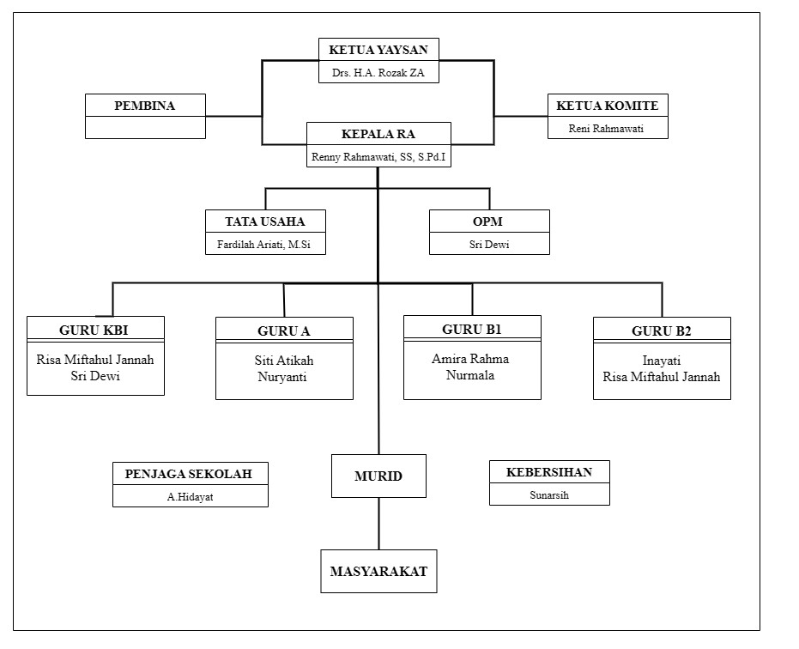

Gambar 2 1 Struktur organisasi

* + 1. Kepala Sekolah

Kepala sekolah memiliki banyak sekali tugas dan kewenangan. Berikut ini tugas dan wewenangnya:

1. Menyusun rencana strategis dan rencana program sekolah Raudhatul Athfal (RA) Mardiyyatuzziyadah.
2. Memberikan pengarahan tentang tumbuh kembang anak usia dini.
3. Melaksanakan pembinaan kurikulum TK yang berlaku.
4. Melakukan pembinaan diktatik, metodik, secara umum maupun khusus.
5. Mengarahkan guru membuat perencanaan pembelajaran.
6. Memberikan contoh pengelolaan proses belajar mengajar.
7. Membina penggunaan standar operasional prosedur (SOP) dan pelaporan perkembangan anak.
8. Memberikan pemahaman kepada guru dalam mengatasi berbagai persoalan anak usia dini (bimbingan konseling TK).
9. Membina kegiatan administrasi kelembagaan sekolah Raudhatul Athfal (RA) Mardiyyatuzziyadah.
10. Membuat perencanaan anggaran sekolah.
11. Melakukan kegiatan supervisi internal.
12. Menjalin kerjasama dengan orang tua dan lembaga-lembaga lain yang terkait.
13. Memberikan berbagai alternatif inovasi dan pengembangan pembelajaran TK.
14. Membuat kegiatan promosi lembaga TK yang dipimpinnya.
    * 1. Bendahara
15. Pembukukan, mengkoordinir & melaksanakan pengumpulan sumbangan dari orangtua/wali murid.
16. Mempersiapkan rapat dengan orangtua/wali murid dalam upaya dukungan pengumpulan dana pendidikan.
17. Bertugas menyerahkan gaji bulanan untuk pegawai dengan cara berkala setiap tanggal 21 setiap bulan.
18. Mendayagunakan uang dengan cara rutin sesuai dgn budget yg sudah ditetapkan peruntukannya.
19. Membuat dan menyampaikan laporan pertanggung jawaban penggunaan dana lembaga TK dengan cara berkala ke Dinas Pendidikan tingkat kabupaten / kota.
20. Membuat pertanggung jawaban laporan keuangan sekolah dengan sebaik mungkin.
    * 1. Tata Usaha
21. Membantu fungsi bendahara, maupun kepala sekolah.
22. Menyusun dan menyajikan data statistik dan grafik keadaan murid dan profil guru dengan rapi.
23. Membuat dan menyiapkan segala hal yang berkaitan dengan surat menyurat dan dokumen lain yang diperlukan.
24. Menyiapkan berbagai sarana prasarana, khususnya yang dibutuhkan untuk menunjang proses pembelajaran.
    * 1. Guru

Seorang guru TK maupun guru pendamping (asisten) wajib memiliki empat kompetensi dasar yaitu kompetensi pedagogis, kepribadian, profesional, dan sosial (sesuai lampiran 2 kemendikbud 137 tahun 2014). Apa saja uraian tugas guru TK kelompok bermain dapat dicontohkan berikut ini:

1. Mengidentifikasi kepribadian anak secara mendalam untuk dapat melihat karakternya;
2. Menguasai profil perkembangan anak yang terdiri dari enam aspek sesuai dengan kurikulum paud yang berlaku Membimbing kreativitas yang menumbuhkan potensi secara sabar, bijak, menyenangkan, ceria, santai dan penuh kasih sayang.
3. Kreatif dalam merancang dan menciptakan berbagai permainan untuk anak, dalam konteks pendekatan belajar yang lebih memotivasi anak.
4. Mampu menjalin komunikasi dengan orangtua anak secara bijaksana
5. Mengidentifikasi tiap-tiap anak sebagai individu yang memiliki kebutuhan unik dalam pengalaman hidup, kepribadian anak, minat anak, dan gaya belajar anak.
6. Menyelenggarakan kegiatan bermain yang memicu tumbuh kembang anak dengan cara bernyanyi, bercerita, dan bereksplorasi

## C. Penjelasan Unit Kegiatan yang menjadi tempat KKP

Raudhatul Athfal (RA) Mardiyyatuzziyadah adalah sebuah lembaga pendidikan dasar berbasis Islam yang menyediakan pendidikan tingkat pra-sekolah RA Mardiyyatuzziyadah menerapkan pendekatan pendidikan berbasis Islam dalam semua aspek kurikulum dan kegiatan sekolah. Hal ini mencakup pembelajaran agama Islam, nilai-nilai moral, serta kegiatan keagamaan yang memperkuat identitas keislaman siswa. Sekolah ini melayani anak usia pra-sekolah. Ini mencakup pengembangan berbagai keterampilan akademis, sosial, dan kepribadian pada anak-anak di berbagai tahap perkembangan mereka.

Sejauh ini sistem informasi pada Raudhatul Athfal (RA) Mardiyyatuzziyadah untuk mendata masih menggunakan metode manual yaitu menggunakan tulis tangan dan menggunakan *microsoft office excel,* yang tentunya membuat hal tersebut tidak efisien untuk sekolah karena terlalu memakan waktu dan memakan banyak tenaga dalam proses pendataannya.

Supaya pada proses pendataan tidak terjadi banyaknya kesalahan yang dilakukan secara manual. Maka dibuat sebuat aplikasi yang bisa memudahkan dan meringankan dalam proses pendataan pada sekolah. Pada proses riset untuk membuat sistem aplikasi akademik adapun data yang diperlukan seperti data guru, data murid, data kelas, data matpel, data jadwal, data nilai.

Berdasarkan penjelasan unit kegiatan diatas dan setelah data-data terkumpul, kemudian memasukkan semua data yang sudah terkumpul, maka dibuatlah sebuah sistem aplikasi akademik berbasis java yang berjalan di dekstop sesuai dengan kebutuhan Raudhatul Athfal (RA) Mardiyyatuzziyadah.

# BAB III

# INFRASTUKTUR

## Spesifikasi Hardware

### Pengertian Perangkat Keras (Hardware)

Menurut (Rifauddin, 2016) Hardware merupakan peralatan fisik dari komputer yang dapat kita lihat dan rasakan.

Menurut (Herdianto Situmorang et al., 2018) Hardware merupakan peralatan fisik dari komputer yang dapat kita lihat dan rasakan.

Menurut (Dame Hutauruk et al., 2017)Hardware merupakan komponen yang terlihat secara fisik yang saling bekerja sama dalam pengolahan data.

Menurut (Dalimunthe & Simanjuntak, 2023) Hardware merupakan semua piranti atau komponen dari sebuah komputer yang sifatnya dapat dilihat secara kasat mata dan bisa diraba secara langsung atau dalam bentuk nyata.

Menurut (Jurnal Publikasi et al., 2022)Hardware adalah sebuah komponen pada sebuah komputer yang dapat dilihat atau berbentuk fisik.

Dari kutipan diatas dapat disimpulkan bahwa, Hardware adalah komponen fisik dari sebuah komputer yang dapat dilihat dan diraba secara langsung. Komponen-komponen ini bekerja sama dalam pengolahan data dan menjalankan fungsi-fungsi komputer.

### Hardware yang digunakan

Penelitian ini dilakukan dengan menggunakan komputer sebagai alat bantu dalam pengolahan data, dimana segala data tentang anggota guru dan murid Raudhatul Athfal (RA) Mardiyyatuzziyadah ini dikumpulkan dan diolah sehingga dapat menghasilkan suatu sistem informasi yang diharapkan dapat berguna bagi siapa saja. Adapun spesifikasi perangkat keras dan perangkat lunak yang akan digunakan adalah :

* + 1. Spesifikasi Hardware

*Hard disk* : 500 GB

*Processor* : Intel® Core™ i7-7500U CPU @ 2.70GHz 2.90 GHz

*Memory* : RAM 8,00 GB

*Mouse* : Mouse wired ROBOT M130 Colorful LED 3

*Keyboard* : SteelSeries APES 300

*Modem* : TP-LINK-WA854RE Wifi Range Extender Repeater Penguat sinyal TpLink

*Printer* : -

* + 1. Software

Sistem Operasi Microsoft Windows 10 Home Single Language Software Java Netbeans 17.0. Serta software pendukung lainnya. Spesifikasi diatas sudah sangat mendukung untuk melakukan pekerjaan dalam penyimpanan data. Untuk kecepatan akses tergolong cepat, dengan RAM (Random Acces Memory) 8 GB dan Software Microsoft Windows 10 Home Single Language tidak terlalu berat untuk menjalankan serta mengakses sebuah program database. Begitu juga untuk penyimpanan data, dengan Hard disk 500 GB data besar akan bisa di tampung sebanyak-banyaknya dengan asumsi harus melakukan kegiatan maintenaince pada database.

## Spesifikasi Software

### Pengertian Perangkat Lunak (Software)

Menurut Mustaqim dkk. (2017), Perangkat lunak (Software) merupakan program dasar pada komputer yang menghubungkan pengguna dengan perangkat keras (Hardware) komputer.

Menurut Frisdayanti (2019), perangkat lunak adalah program yang berisi perintah-perintah untuk melakukan proses tertentu.

Menurut Harahap dkk. (2022), Perangkat lunak atau software merupakan bagian dari komputer yang mengacu pada bentuk digital. Komponen ini tidak terlihat secara fisiknya, namun dapat dioperasikan oleh penggunanya dengan menjalankan perintah apapun dari pengguna.

Menurut Gede dkk. (2022), software, yaitu suatu program berbasis komputer yang mampu menerima instruksi atau perintah yang diberikan oleh seorang programmer dalam melaksanakan pekerjaan tertentu.

Menurut Jamaludin dkk. (2019), Perangkat lunak merupakan salah satu perangkat yang dibutuhkan dalam menjalankan komputer.

Perangkat lunak adalah perangkat yang tidak dapat dilihat dan disentuh secara langsung, namun dapat dioperasikan oleh user atau penggunanya.

### Klasifikasi Perangkat Lunak (Software)

#### Perangkat Lunak Sistem Operasi

Sistem operasi *software* merupakan perangkat lunak yang berfungsi untuk mengkonfigurasikan *komputer* agar dapat menerima berbagai perintah dasar yang diberikan sebagai masukan. Perangkat lunak *system* juga merupakan sekumpulan program yang ditulis untuk melayani program-program yang lain. Contoh : *MS-DOS, LINUX, UNIX, OS/2, FREE BSD, WINDOWS, MACINTOSH, SUN OS (JAVA), NOVELL, Dan lain-lain.*

#### Pengertian Sistem Informasi

Menurut Bonnie Suheman dan Marion Pinontoan (2008:5) dalam buku yang berjudul *Designing Information System,* Sistem Informasi merupakan serangkaian komponen berupa manusia, prosedur, data, dan teknologi (seperti komputer) yang digunakan untuk melakukan sebuah proses untuk menghasilkan informasi yang bernilai untuk pengambilan keputusan.

### Software Pendukung

* + 1. Pengertian Java

Menurut Jubilee Enterprise (2015:1), dalam buku yang berjudul Mengenal Java dan Database dengan NetBeans, Java merupakan bahas pemograman yang mampu bekerja dengan sebuah database. Java bersifat Write once, Run Anywhere (program yang ditulis satu kali dan dapat berjalan pada banyak platform). Dengan demikian tidak mengherankan apabila aplikasi yang dibuat

menggunakan Java bisa ditemukan dilingkungan komputer dan smartphone tanpa perbedaan yang berarti.

Untuk mengembangkan aplikasi berbasis java, kita memerlukan Java Development Kit (JDK). Saat ini JDK telah berkembang dan mempunyai banyak versi antara lain Java 2 platform, Java 2 platform dibagi menjadi 3 kategori, yaitu :

* + - 1. Java 2 Standard Edition (J2SE)

Kategori ini digunakan untuk mengembangkan dan menjalankan aplikasi Java berbasis PC.

* + - 1. Java 2 Enterprise Edition (J2EE)

Kategori ini Digunakan untuk mengembangkan dan menjalankan aplikasi java pada lingkungan enterprise, dengan fungsi-fungsi seperti Enterprise Java Bean (EJB), COBRA, Servlet, dan Java Server Page (JSP).

* + - 1. Java 2 Micro Edition (J2ME)

Kategori ini digunakan untuk mengembangkan dan menjalankan aplikasi Java berbasis handheld devices, seperti Personal Data Assistant (PDA), handphone, dan pocket PC.

#### b. Pengertian Java

Netbeans merupakan salah satu aplikasi Inegrated Development Environment (IDE) yang berbasiskan Java dan Sun Microsystems yang berjalan di atas swing. Swing merupakan sebuah teknologi Java untuk pengembangan aplikasi desktop yang dapat berjalan pada berbagai macam platform seperti windows, linux, Mac OS X dan Solaris. Sebuah IE merupakan lingkup pemrograman yang di integrasikan ke dalam suatu aplikasi perangkat lunak

yang menyediakan Graphic User Interface (GUI), suatu kode editor atau text, suatu compiler, dan suatu debugger.

Netbeans juga digunakan oleh sang programmer untuk menulis, mengompile, mencari kesalahan dan menyebarkan program netbeans yang ditulis dalam bahasa pemograman lainnya dan program ini pun bebas untuk digunakan dan untuk membuat professional desktop, enterprise, web and mobile applications dengan Java Language, CC++, dan bahkan dynamic language seperti PHP, JavaScript, Groovy, dan Ruby.

Netbeans merupakan sebuah proyek kode terbuka yang sukses dengan pengguna yang sangat luas, komunitas yang terus tumbuh, dan memiliki hampir 100 mitra (dan terus bertambah). Sun Microsystems mendirikan proyek kode terbuka Netbeans pada bulan Juni 2000 dan terus menjadi sponsor utama. Dan saat ini pun netbeans memiliki 2 produk yaitu Platform Netbeans dan Netbeans IDE. Platform Netbeans merupakan framework yang dapat digunakan kembali (reusable) untuk menyederhanakan pegembangan aplikasi desktop dan platform Netbeans juga menawarkan layanan- layanan yang umum bagi aplikasi desktop, mengijinkan pengembang untuk *focus* ke logika yang spesifik terhadap aplikasi. *Netbeans* IDE merupakan sebuah IDE *open source* yang ditulis sepenuhnya dengan bahasa *pemrograman java* menggunakan *platform netbeans*. *Netbeans* IDE mendukung pengembangan semua tipe aplikasi *Java* (J2SE, *web*, EJB, dan aplikasi *mobile*). Fitur lainnya adalah *system* proyek berbasis *Ant, control* versi dan *refactoring.*

#### c. Pengenalan MySQL

Menurut Abdul Kadir (2013:413) dalam buku yang berjudul *Buku Pintar Programmer Pemula PHP,* MySQL (Structured Query Language) adalah suatu bahasa yang digunakan untuk mengakses database relasional. Bahasa ini mendukung perintah untuk membuat database, menciptakan tabel, menambahkan data, mengubah data, menghapus data, dan mengambil data. SQL juga menyediakan perintah untuk mengatur akses database sehingga keamanan data bisa terjamin. Artinya, bisa diatur agar pemakai tertentu hanya bisa mengakses data tertentu.

#### d. Pengenalan XAMPP

Menurut Rohi Abdulloh (2015:5) dalam buku yang berjudul *Web Programming Is Easy*, XAMPP adalah salah satu paket installer yang berisi apache yang merupakan web server tempat menyimpan file-file yang diperlukan website, dan phpmyadmin merupakan aplikasi berbasis web yang digunakan untuk perancangan database MySQL sebagai tempat untuk menyimpan data-data website. Keduanya sudah disediakan dalam satu paket aplikasi seperti Appserv dan XAMPP*.*

# BAB IV

# PEMBAHASAN

## Proses Bisnis

Penulis melakukan peninjauan langsung, diketahui bahwa sistem yang sedang berjalan di RA Mardiyyatuzziyadah masih menggunakan cara manual yang artinya tidak menggunakan aplikasi sebagai media pengenalan, khususnya pada bagian pendataan Murid dan sistem yang harus dibuat harus dapat meningkatkan pelayanan serta meningkatkan kinerja sistem sekolah berikut

## Proses Sistem yang Berjalan

Analisis sistem yang sedang berjalan yaitu menganalisis sistem yang saat ini digunakan pada RA Mardiyyatuzziyadah. Sistem lama yang sedang berjalan yaituPada prosedur pencatatan data murid, Wali Murid mengisi formulir pada kertas untuk mengisi data lengkap murid dan diberikan kepada bagian administrasi atau Tata Usaha (TU).Prosedur pencatatan data guru, guru mengisi formulir pada kertas untuk mengisi data lengkap guru dan diberikan kepada bagian administrasi atau bagian Tata Usaha (TU).Prosedur pembagian kelas, Kepala Sekolah melakukan rapat dengan guru-guru dan jajaran lain untuk pembagian kelas murid. Setla rapat selesai bidang Tata Usaha (Tu) membagi kelas murid dan melaporkan pada kepala sekolah.Prosesn pembuatan matpel, guru memberikan nilai pada murid berdasarkan absesnsi, tugas, dan keaktifan murid. Nilai tersebut diserahkan pada guru dan di teruskan ke bidang Tata Usaha (TU) untuk dicatat pada buku induk dan dilaporkan pada kepala sekolah.Berdasarkan analisis di atas, sistem yang sedang berjalan sering timbul permasalahan yang menjadi kelemahan pada sistem itu sendiri seperti tidak lengkapnya data, kehilangan data saat data tersebut diperlukan sehingga harus menulisulang data itu kembali ang membuat proses pendataan menjadi sangat lambat. Dari permasalahan ini diambil sebuah keputusan untuk membuat aplikasi akademik berbasis java yang diharapkan dapat mempermudah proses pendataan Murid dan guru di RA Mardiyyatuzziyadah.

## C. Aturan Bisnis Sistem Berjalan

Kebutuhan Fungsional Berdasarkan Pengguna dalam Aplikasi Akademik Berbasis Java untuk RA Mardiyyatuyyizadah. Berdasarkan judul "Pembuatan Aplikasi Akademik Berbasis Java pada Sekolah Dasar" dan aturan bisnis yang ditentukan sekolah, kebutuhan fungsional untuk sistem (perangkat lunak) dapat diidentifikasi dan dibagi berdasarkan penggunanya, yaitu tata usaha, guru, dan kepala sekolah.

|  |  |
| --- | --- |
| Pengguna | Kebutuhan Fungsional |
| Guru | Melihat data murid di kelas yang diajar.  Mengelola hasil belajar murid.  Mencatat kehadiran murid di kelas.  Melihat jadwal mengajar sendiri.  Melihat jadwal pelajaran kelas lain. |
| Kepala sekolah | Melihat data murid, guru, dan tata usaha.  Menghasilkan laporan statistik yang lebih lengkap tentang data murid, guru, akademik, dan keuangan sekolah.  Mengatur parameter sistem seperti tahun ajaran dan periode penilaian.  Mengelola akun pengguna.  Penting untuk dicatat bahwa daftar ini tidak lengkap dan dapat bervariasi tergantung pada kebutuhan spesifik sekolah dasar.  Selain kebutuhan fungsional, penting juga untuk mempertimbangkan aspek non-fungsional seperti performa, skalabilitas, dan keandalan saat mengembangkan aplikasi akademik berbasis Java. |
| Admin  (Tata usaha) | Menambahkan, mengedit, dan menghapus data murid.  Mengimpor data murid dari sistem lain.  Mencetak rapor dan kartu murid.  Menambahkan, mengedit, dan menghapus data guru.  Mengelola jadwal mengajar guru.  Membuat dan mengedit jadwal pelajaran.  Menugaskan guru untuk mengajar di kelas tertentu.  Mengatur ruangan kelas untuk setiap matpel. |

Tabel 4. 1 Sistem Berjalan

## D. Kebijakan Sistem

Pembuatan aplikasi akademik berbasis Java untuk RA Mardiyyatuzziyadah memerlukan beberapa kebijakan sistem yang penting untuk memastikan keberhasilan dan keamanan sistem tersebut. Berikut adalah beberapa kebijakan yang perlu dipertimbangkan:

1. Kebijakan Privasi dan Keamanan Data: Pastikan bahwa data pribadi murid, guru, dan staf sekolah disimpan dengan aman dan hanya diakses oleh pihak yang berwenang. Terapkan enkripsi data untuk melindungi informasi sensitif.
2. Kebijakan Akses Pengguna: Tetapkan tingkat akses yang sesuai untuk setiap jenis pengguna, seperti administrator, guru, dan kepala sekolah. Batasi akses ke fitur dan informasi tertentu berdasarkan peran pengguna.
3. Kebijakan Backup Data: Tetapkan kebijakan backup data secara berkala untuk menghindari kehilangan data yang tidak diinginkan. Pastikan backup dilakukan secara teratur dan data dapat dipulihkan dengan cepat jika diperlukan.
4. Kebijakan Penyimpanan File: Atur kebijakan untuk penyimpanan file yang diunggah oleh pengguna, seperti tugas murid atau dokumen guru. Pastikan file disimpan dengan aman dan dapat diakses hanya oleh pihak yang berwenang.

Menetapkan kebijakan sistem yang baik adalah langkah penting untuk memastikan bahwa aplikasi akademik berbasis Java untuk sekolah dasar dapat berjalan dengan lancar, aman, dan efektif.

Top of Form

## E. Dekomposisi Fungsi

Bottom of Form

Dekomposisi fungsional merupakan gambaran fungsi-fungsi yang akan dicapai oleh suatu sistem. Dekomposisi fungsional disusun secara hierarkis

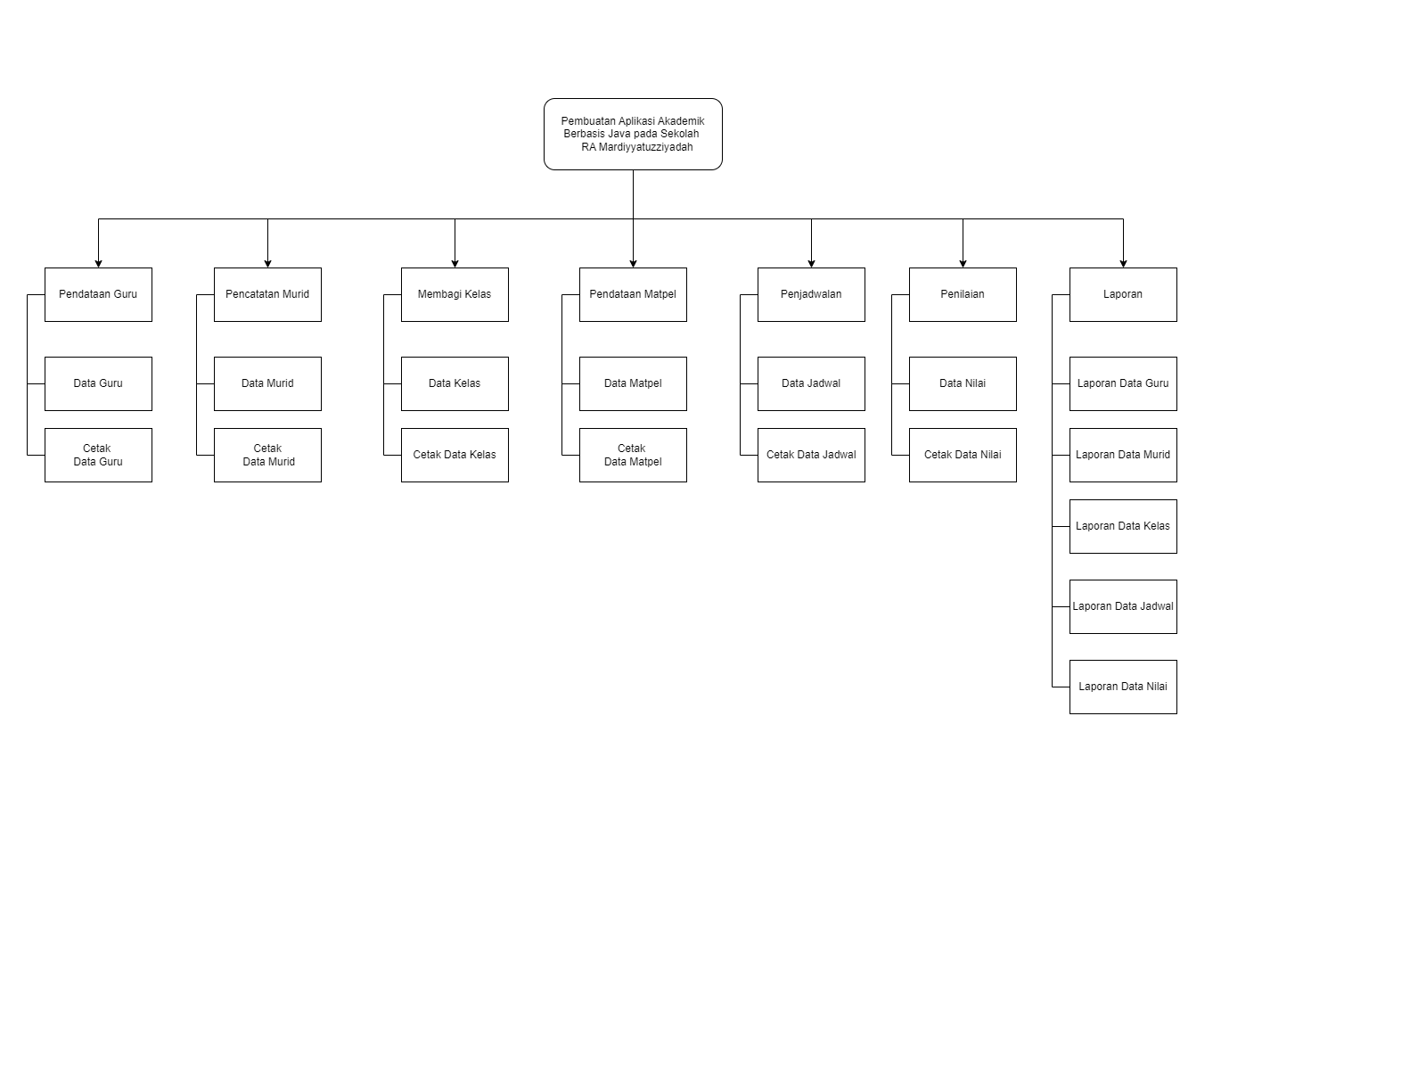

Gambar 4. 1 Dekomposisi Fungsi

**F. Hirarki Fungsi Sistem Yang Berjalan**

Hierarki adalah urutan tingkatan atau jenjang jabatan (pangkat kedudukan). Arti lainnya dari hierarki adalah organisasi dengan tingkat wewenang dari yang paling bawah sampai yang paling atas. Hirarki fungsi dari proses berjalan dari sistem adalah sebagai berikut:

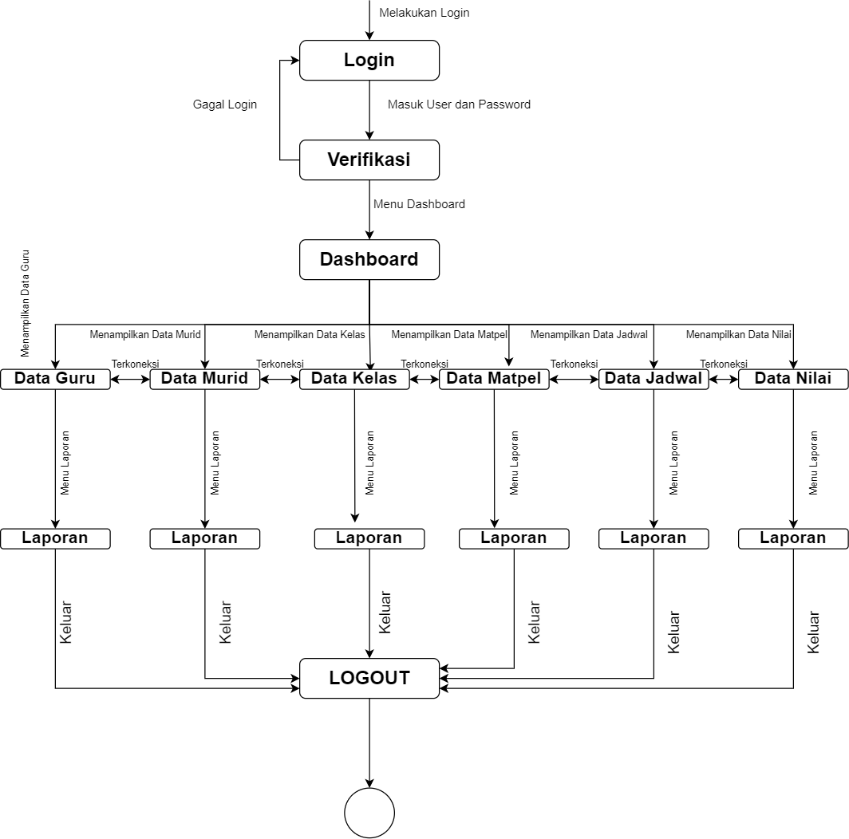

Gambar 4. 2 Hirarki Fungsi Sistem Yang Berjalan

**G. Analisa Masukan (*Input)*, Proses dan Keluaran *(Output)***

Analisis masukan, proses dan keluaran pada Raudhatul Athfal (RA) Mardiyyatuzziyadah sebagai berikut:

### Analisis masukan (input)

* + 1. Nama Masukan : Input Data Guru

Fungsi : Memasukkan data guru

Sumber : Administrasi

Media : Keyboard

Keterangan : Berisikan data guru

* + 1. Nama Masukan : Input Data Murid

Fungsi : Memasukkan data murid

Sumber : Administrasi

Media : Keyboard

Keterangan : Berisikan data murid

* + 1. Nama Masukan : Input Data Kelas

Fungsi : Memasukkan data kelas

Sumber : Administrasi

Media : Keyboard

Keterangan : Berisikan data kelas

* + 1. Nama Masukan : Input Data matpel

Fungsi : Memasukkan data matpel

Sumber : Administrasi

Media : Keyboard

Keterangan : Berisikan data matpel

* + 1. Nama Masukan :Input Data Jadwal

Fungsi : Memasukkan data jadwal

Sumber : Administrasi

Media : Keyboard

Keterangan : Berisikan data jadwal

* + 1. Nama Masukan : Input Data Nilai

Fungsi : Memasukkan data nilai

Sumber : Administrasi

Media : Keyboard

Keterangan : Memasukkan data nilai

* + 1. Nama Masukan : Data Guru

Fungsi : Mengetahui Data Guru

Sumber : Administrasi

Media : Keyboard

Keterangan : Berisikan Data Guru

* + 1. Nama Masukan : Data Murid

Fungsi : Mengetahui Data Murid

Sumber : Administrasi

Media : Keyboard

Keterangan : Berisikan Data Murid

* + 1. Nama Masukan : Data Kelas

Fungsi : Mengetahui Data Kelas

Sumber : Administrasi

Media : Keyboard

Keterangan : Berisikan Data Kelas

* + 1. Nama Masukan : Data Matpel

Fungsi : Mengetahui Data Matpel

Sumber : Administrasi

Media : Keyboard

Keterangan : Berisikan Data Matpel

* + 1. Nama Masukan : Data Jadwal

Fungsi : Mengetahui Data Jadwal

Sumber : Administrasi

Media : Keyboard

Keterangan : Berisikan Data Jadwal

l. Nama Masukan : Data Nilai

Fungsi : Mengetahui Data Nilai

Sumber : Administrasi

Media : Keyboard

Keterangan : Berisikan Data Nilai

### Analisis Proses

1. Nama Proses : Data Guru

Fungsi : Mencatat data guru yang masuk

Sumber : Administrasi

Media : File

Keterangan : Berisi tentang data guru

1. Nama Proses : Data Murid

Fungsi : Mencatat data murid yang masuk

Sumber : Administrasi

Media : File

Keterangan : Berisi tentang data murid

1. Nama Proses : Data Kelas

Fungsi : Mencatat data kelas yang masuk

Sumber : Administrasi

Media : File

Keterangan : Berisi tentang data kelas

1. Nama Proses : Data Matpel

Fungsi : Mencatat data matpel yang masuk

Sumber : Administrasi

Media : File

Keterangan : Berisi tentang data matpel

1. Nama Proses : Data Jadwal

Fungsi : Mencatat data jadwal yang masuk

Sumber : Administrasi

Media : File

Keterangan : Berisi tentang data jadwal

1. Nama Proses : Data Nilai

Fungsi : Mencatat data nilai yang masuk

Sumber : Administrasi

Media : File

Keterangan : Berisi tentang data nilai

### Analisis Keluaran

* + 1. Nama Keluaran : Rekap data guru perbulan

Fungsi : Membuat data guru

Sumber : Administrasi

Media : Kertas & File

Keterangan : Berisikan Data guru

* + 1. Nama Keluaran : Rekap data murid perbulan

Fungsi : Membuat data murid

Sumber : Administrasi

Media : Kertas & File

Keterangan : Berisikan Data murid

* + 1. Nama Keluaran : Rekap data kelas perbulan

Fungsi : Membuat data kelas

Sumber : Administrasi

Media : Kertas & File

Keterangan : Berisikan Data kelas

* + 1. Nama Keluaran : Rekap data matpel perbulan

Fungsi : Membuat data matpel

Sumber : Administrasi

Media : Kertas & File

Keterangan : Berisikan Data matpel

* + 1. Nama Keluaran : Rekap data jadwal perbulan

Fungsi : Membuat data jadwal

Sumber : Administrasi

Media : Kertas & File

Keterangan : Berisikan Data jadwal

* + 1. Nama Keluaran : Rekap data nilai perbulan

Fungsi : Membuat data nilai

Sumber : Administrasi

Media : Kertas & File

Keterangan : Berisikan Data nilai

## F. Diagram Aliran Data (DAD) Sistem Yang Di Usulkan (Diagram Konteks Nol, Rinci).

### Diagram Konteks

Diagram konteks adalah diagram yang terdiri dari suatu proses dan menggambarkan ruang lingkup suatu sistem. Diagram konteks merupakan diagram level tertinggi dari DFD yang menggambarkan seluruh input ke sistem output dari sistem. Ia akan memberi gambaran tentang keseluruhan sistem.

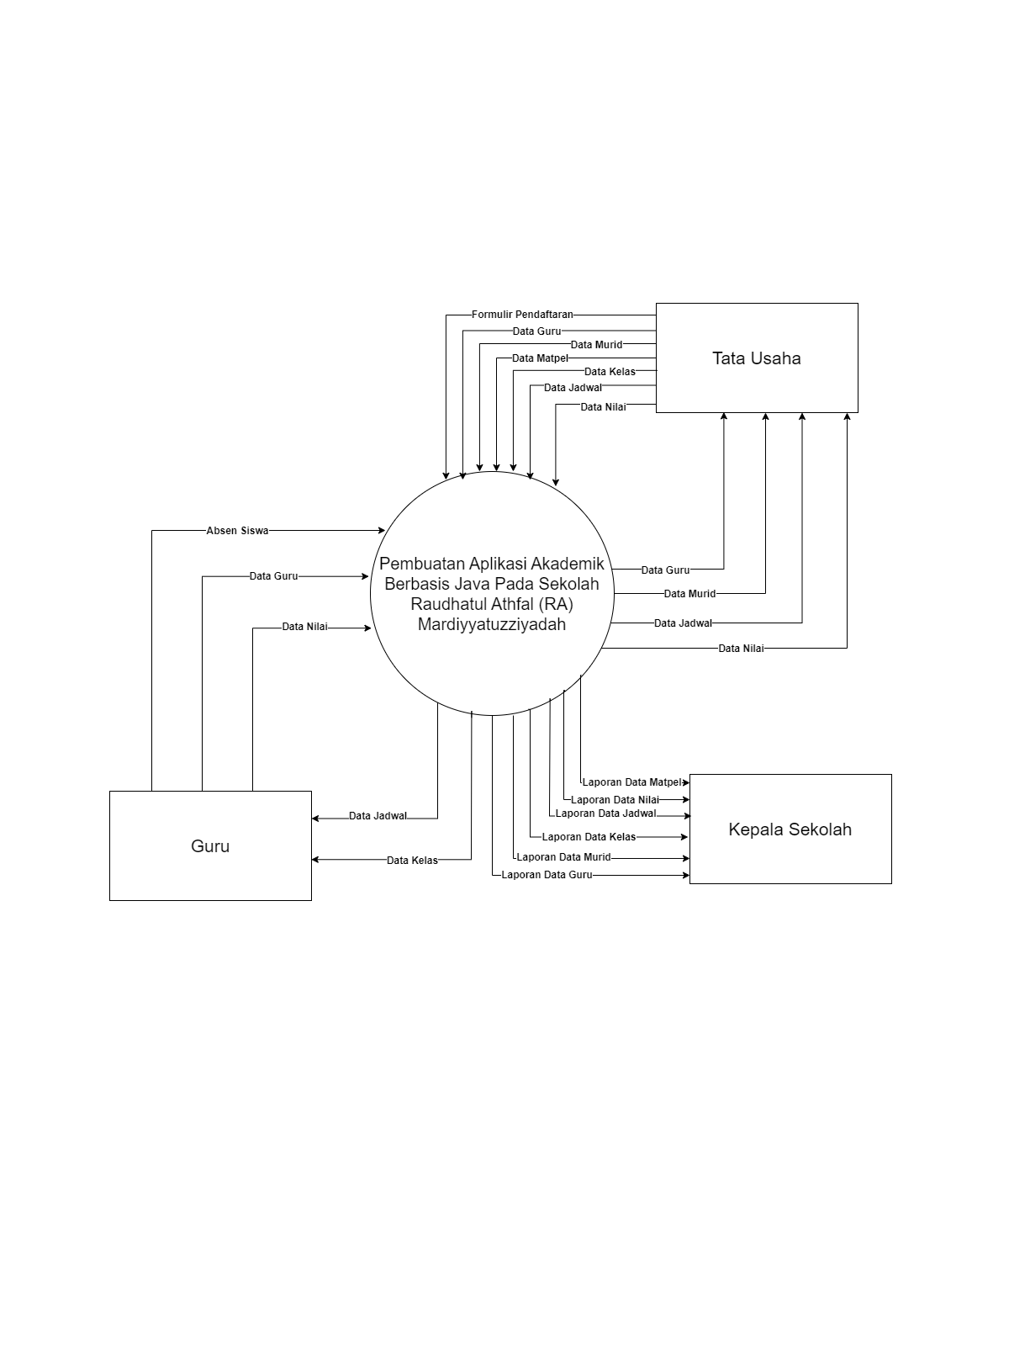

Gambar 4. 3 Diagram Konteks

### Diagram Nol

Diagram nol adalah diagram yang menggambarkan proses dari dataflow diagram. Diagram nol memberikan pandangan secara menyeluruh mengenai sistem yang ditangani, menunjukan tentang fungsi-fungsi utama atau proses yang ada, aliran data, dan eksternal entity.

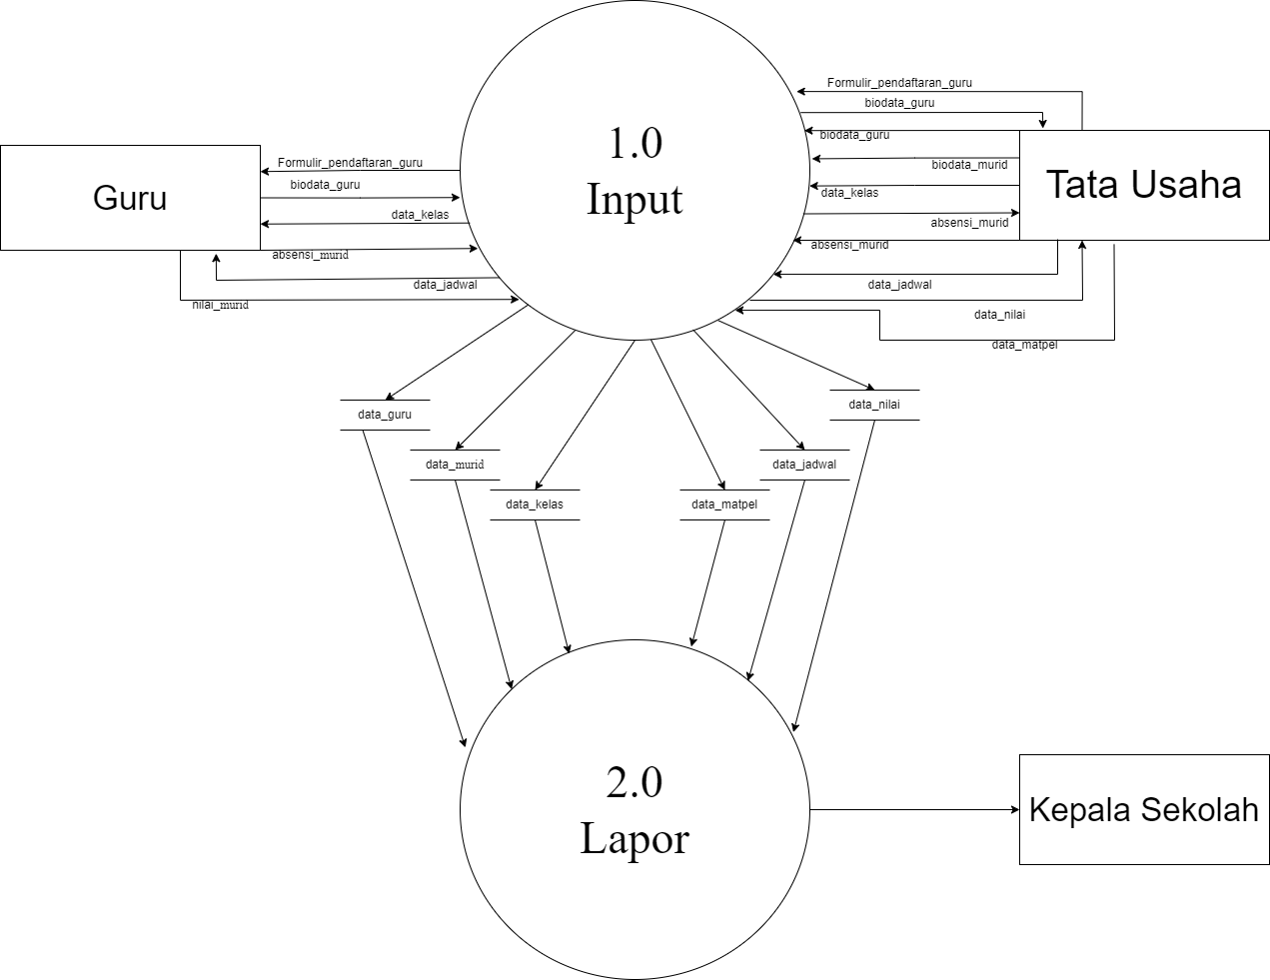

Gambar 4. 4 Diagram Nol

### Diagram Rinci

Diagram rinci adalah diagram yang menguraikan proses apa yang ada dalam diagram zero atau diagram level di atasnya.

#### Diagram Rinci Proses 1

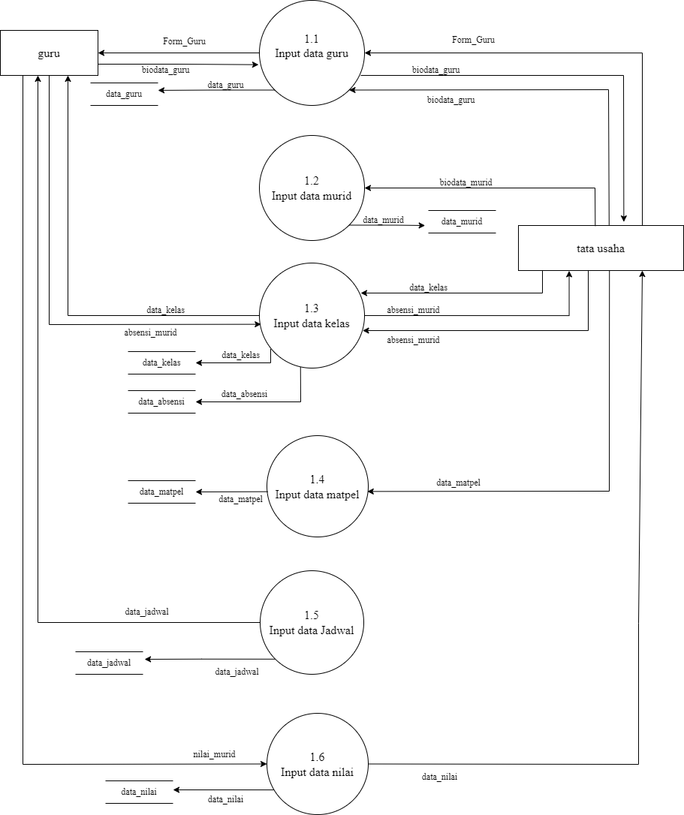

Gambar 4.5 Diagram Rinci Proses 1

#### Diagram Rinci Proses 2

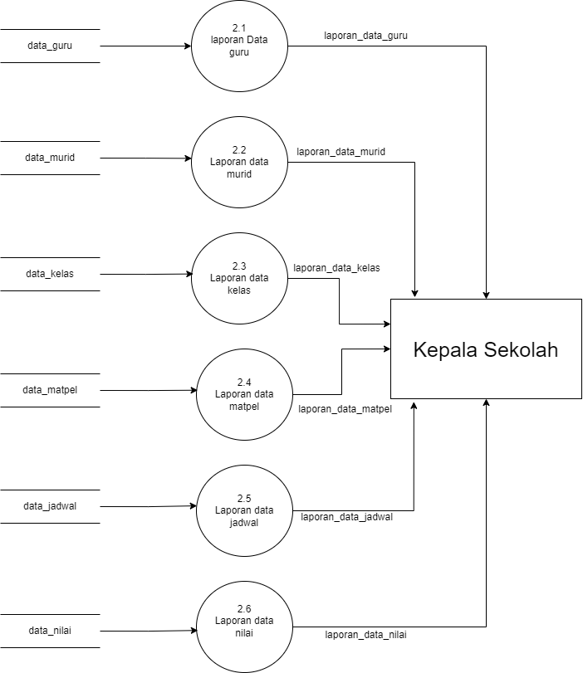

Gambar 4. 6 Diagram Rinci Proses 2

## G. Kamus Data

Kamus Data Sistem Yang Diusulkan

* + - 1. Kamus data guru

Nama arus data : Data guru

Bentuk dokumen : Kertas & File

Arus data : Guru - proses 1.1 (Input Data Guru) proses 1.1(Input Data Guru) - tata usaha

Penjelasan data : Bidang administrasi menginput data guru kedalam sistem informasi akademik.

Periode : Setiap masuk guru baru

Struktur data : NIP* +Nama+ Tanggal_Lahir + Agama + Hp+ Alamat + Jenis_Kelamin

* + - 1. Kamus data murid

Nama arus data : Data Murid

Bentuk dokumen : Kertas & File

Arus data : Murid - proses 1.2 (Input data murid) proses 1.2 (Input data murid)- tata usaha

Penjelasan data : Bidang administrasi menginput data murid kedalam sistem ınformasi akademik

Periode : Setiap tahun ajaran baru

Strukturdata : NIS* +Nama_Murid + Tanggal_Lahir +Agama +Alamat + Jenis_Kelamin

* + - 1. Kamus data kelas

Nama arus data : Data kelas

Bentuk dokumen : Kertas & File

Arus data : Tata Usaha- proses 1.3(Input data kelas) Proses 1.3 (Input data kelas) - guru

Penjelasan data : Bidang administrasi meng-input data kelas kedalam sistem informasi akademik

Periode : Setiap tahun ajaran baru

Struktur data : NIS*+Nama+Kelas

* + - 1. Kamus data matpel

Nama arus data : Data matpel

Bentuk dokumen : Kertas & File

Arus data : Tata Usaha - proses 1.4 (Input data matpel)- Matpel

Penjelasan data : Bidang administrasi meng-input data matpel kedalam sistem informasi akademik

Periode : Setiap tahun ajaran baru

Struktur data :Kode_Matpel* + Nama_Matpel + NIP + Nama_Guru

* + - 1. Kamus data jadwal

Nama arus data : Data jadwal

Bentuk dokumen : Kertas & File

Arus data : Bid. Kurikulum - proses 1.4

proses 1.4 (input data jadwal) - Tatausaha tatausaha - Proses 1.4 (input data jadwal) Proses 1.4 (input data jadwal) - guru Proses 1.4 (input data jadwal) - murid

Penjelasan data : Bidang administrasi meng-input data jadwal kedalam sistem informasi akademik

Periode : Setiap tahun ajaran baru

Struktur data :NIP* + Kode_Matpel+ Nama_Matpel + Nama_Guru + Kode_Kelas + Hari + Jam

* + - 1. Kamus data nilai

Nama arus data : Data nilai

Bentuk dokumen : Kertas & File

Arus data : guru – proses 1.5 (input data nilai) proses 1.5 (input data nilai) - wali kelas Wali kelas - proses 1.5 (input data nilai) Proses 1.5 (input data nilai) - tata usaha

Penjelasan data : Administrasi/Tata Usaha meng-input data nilai kedalam sistem informasi akademik

Periode : 1 semester

Struktur data : Nomor* + Nama_Murid + Kode_Matpel + Nama_Matpel + Absen + Grade

* + - 1. Kamus data laporan data guru

Nama keluaran : Laporan data guru

Bentuk dokumen : Kertas & File

Arus data : tata usaha – proses 2.1 (lapor) – kepala sekolah

Penjelasan data : Mencetak data guru dan laporan ke kepala sekolah Periode : Setiap guru baru masuk

Struktur data : NIP*+Nama+Tanggal_Lahir+Agama+Hp+Alamat+Jenis_Kelamin

* + - 1. Kamus data laporan data murid

Nama keluaran : Laporan data Murid

Bentuk dokumen : Kertas & File

Arus data : tatausaha – proses 2.2 (lapor) – kepala sekolah Penjelasan data : Mencetak data Murid dan laporan ke kepala sekolah Periode : Setiap tahun ajaran baru

Struktur data : NIS* +Nama_Murid +Tanggal_Lahir +Agama +Alamat +Jenis_Kelamin

* + - 1. Kamus data laporan data kelas

Nama keluaran : Laporan data kelas

Bentuk dokumen : Kertas & File

Arus data : tata usaha – proses 2.3 (lapor) – kepala sekolah Penjelasan data : Mencetak data kelas dan laporan ke kepala sekolah Periode : Setiap tahun ajaran

Struktur data : NIS*+Nama+Kelas

* + - 1. Kamus data laporan data matpel

Nama keluaran : Laporan data kelas

Bentuk dokumen : Kertas & File

Arus data : tata usaha – proses 2.4 (lapor) – kepala sekolah Penjelasan data : Mencetak data matpel dan laporan ke kepala sekolah Periode : Setiap tahun ajaran

Struktur data : Kode_Matpel +Nama_Matpel +NIP* Nama_Guru

* + - 1. Kamus data laporan data jadwal

Nama keluaran : Laporan data jadwal

Bentuk dokumen : Kertas & File

Arus data : tata usaha – proses 2.5 (lapor) – kepala sekolah Penjelasan data : Mencetak data jadwal dan laporan ke kepala sekolah Periode : Setiap tahun ajaran baru

Struktur data : id_jadwal* + kd_matpel + nama_matpel + nip_guru + nama_guru + kd_kelas + hari + jam

* + - 1. kamus data laporan data nilai

Nama keluaran : Laporan data nilai

Bentuk dokumen : Kertas & File

Arus data : tata usaha – proses 2.6 (lapor) – kepala sekolah Penjelasan data : Mencetak data nilai dan laporan ke kepala sekolah Periode : Setiap semester

Struktur data : Nomor* + Nama_Murid + Kode_Matpel + Nama_Matpel + Absen + Grade

## H. Spesifikasi Proses

Spesifikasi proses menjelaskan spesifikasi dari setiap proses dalam diagram rinci.

Spesifikasi Proses Sistem Yang diusulkan

1. No Proses : 1.1

Nama Proses : Input data guru

Jenis Proses : Kertas & File

Masukan : Inputan data uru

Keluaran : File laporan data guru

Keterangan : Guru memberikan data lengkap pada bidang administrasi/Tata usaha untuk di input kedalam sistem.

1. No Proses : 2.1

Nama Proses : Input data murid

Jenis Proses : Kertas & File

Masukan : Inputan data murid

Keluaran : File laporan data murid

Keterangan : Murid memberikan data lengkap pada bidang administrasi/tata usaha untuk di input kedalam sistem.

1. No Proses : 1.3

Nama Proses : Input data kelas

Jenis Proses : File

Masukan : Inputan data kelas

Keluaran : File laporan data kelas

Keterangan : Administrasi/Tata Usaha menginput data kelas

1. No Proses : 1.4

Nama Proses : Input data matpel

Jenis Proses : Kertas & File

Masukan : Inputan data mata pelajaran

Keluaran : File laporan data mata pelajaran

Keterangan : Adminitrasi/Tata Usaha menginput data mata pelajaran

1. No Proses : 1.5

Nama Proses : Input data jadwal

Jenis Proses : Kertas & File

Masukan :Inputan data jadwal

Keluaran : File laporan data jadwal

Keterangan : Bidang kurikulum mengatur penjadwalan dan di input kedalam sistem oleh bidang adminitrasi

|  |  |  |
| --- | --- | --- |
| 6. | No Proses  Nama Proses  Jenis Proses  Masukan  Keluaran  Keterangan | : 1.6  : *Input* data nilai  : Kertas & File  : Inputan Data nilai  : File laporan Data nilai  : Guru memberikan nilai pada walikelas kemudian direkap dan di *input* kedalam sistem oleh administrasi/Tata Usaha |
| 7. | No Proses Nama Proses Jenis Proses Masukan Keluaran Keterangan | : 2.1  : Cetak laporan data guru  : Kertas & File  : Inputan *Database* tabel guru  : File laporan Laporan data guru  : Laporan data guru yang ada didalam *Database* dicetak dan dilaporkan ke kepala sekolah. |
| 8. | No Proses Nama Proses Jenis Proses Masukan Keluaran Keterangan | : 2.2  : Cetak laporan data murid  : Kertas & File  : Inputan *Database* tabel guru  : File laporan Data murid  : Data murid yang ada didalam *Database* dicetak dan dilaporkan ke kepala sekolah. |
| 9. | No Proses Nama Proses Jenis Proses Masukan Keluaran Keterangan | : 2.3  : Cetak laporan data kelas  : Kertas & File  : Inputan *Database* table kelas  : File laporan Data Kelas  : Data kelas yang ada didalam *Database* dicetak dan dilaporkan ke kepala sekolah. |
| 10 | No Proses  Nama Proses  Jenis Proses  Masukan  Keluaran  Keterangan | : 2.4  : Cetak laporan data matpel  : Kertas & File  : Inputan *Database* table matpel  : File laporan Data Matpel  : Data matpel yang ada didalam *Database* dicetak dan dilaporkan ke kepala sekolah. |
| 11. | No Proses Nama Proses Jenis Proses Masukan Keluaran Keterangan | : 2.5  : Cetak laporan data jadwal  : Kertas & File  : Inputan *Database* table jadwal  : File laporan Data jadwal  : Data jadwal yang ada didalam *Database* dicetak dan dilaporkan ke kepala sekolah. |
| 12. | No Proses Nama Proses Jenis Proses Masukan Keluaran Keterangan | : 2.6  : Cetak laporan data nilai  : Kertas & File  : Inputan *Database* table nilai  : File laporan data nilai  : Data nilai yang ada didalam *Database* dicetak dan dilaporkan ke kepala sekolah. |

## Bagan Terstruktur

Bagan terstuktur berfungsi mengidentifikasi dan mengilustrasikan organisasi dari sistem informasi secara berjenjang dalam bentuk modul dan sub modul. Bagan terstuktur juga menunjukan hubungan antar elemen data dan elemen control antara hubungan modulnya serta dapat memberikan penjelasan lengkap dari sistem, dipandang dari elemen data kontrol modul dan hubungan antara modul.

* + 1. Bagan terstruktur data guru

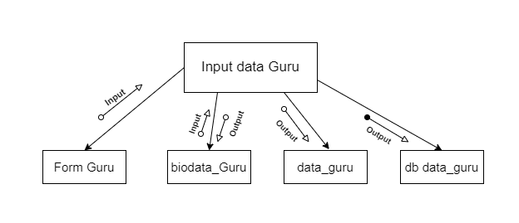

Gambar 4. 7 Bagan terstruktur data guru

* + 1. Bagan terstruktur data murid

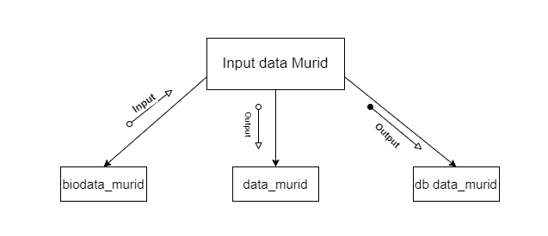

Gambar 4. 8 Bagan terstruktur data murid

* + 1. Bagan terstruktur data kelas

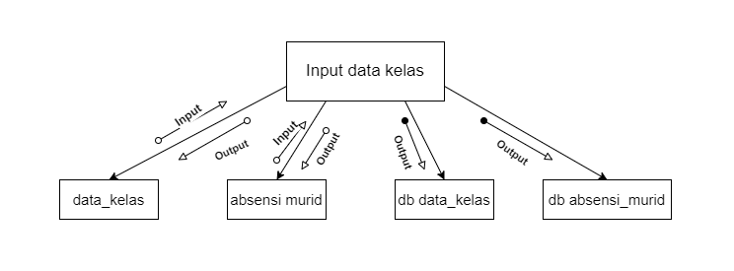

Gambar 4. 9 Bagan terstruktur data kelas

* + 1. Bagan terstruktur data Matpel

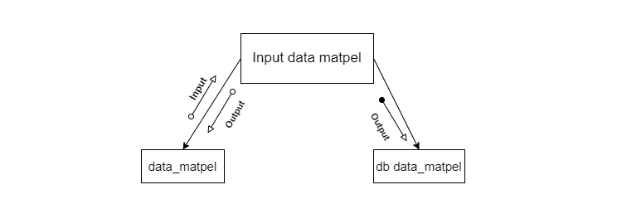

Gambar 4. 10 terstruktur data Matpel

* + 1. Bagan terstruktur data jadwal

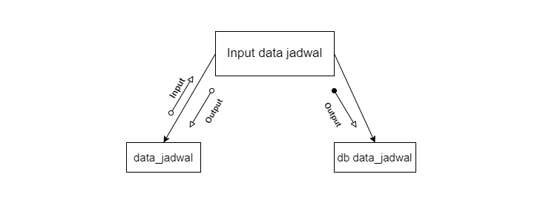

Gambar 4. 11 Bagan terstruktur data jadwal

* + 1. Bagan terstruktur data nilai

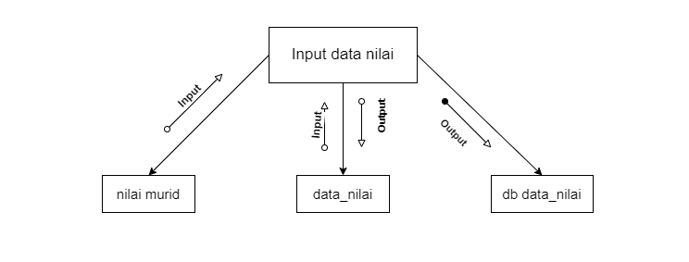

Gambar 4. 12 Bagan terstruktur data nilai

* + 1. Laporan data guru

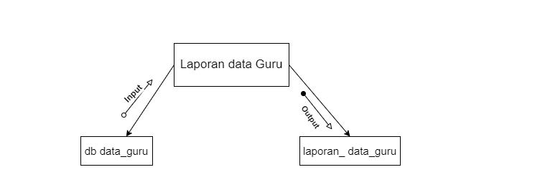

Gambar 4. 13 Laporan data guru

* + 1. Laporan data murid

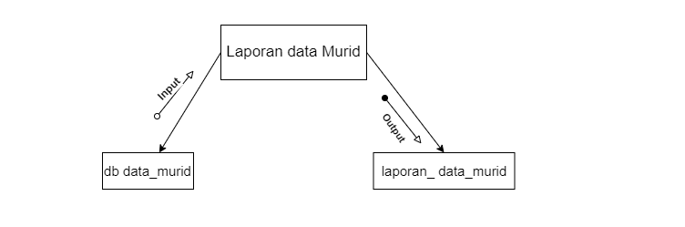

Gambar 4. 14 Laporan data murid

* + 1. Laporan data kelas

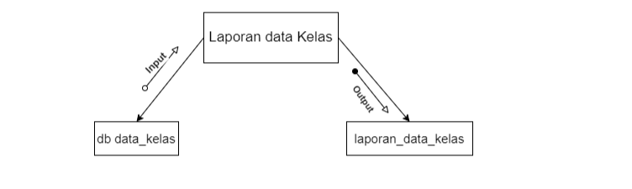

Gambar 4. 15 Laporan data kelas

* + 1. Laporan data matpel

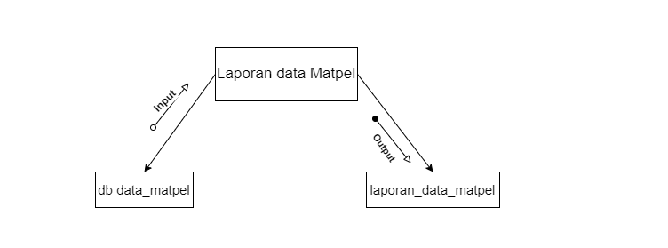

Gambar 4. 16 Laporan data matpel

* + 1. Laporan data jadwal

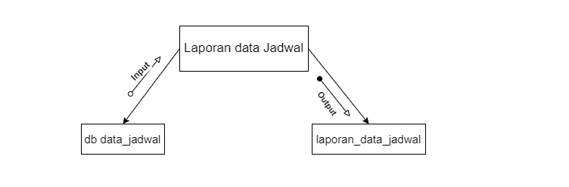

Gambar 4. 17 Laporan data jadwal

* + 1. Laporan data nilai

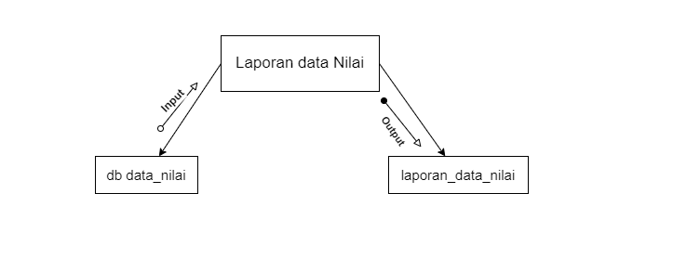

Gambar 4. 18 Laporan data nilai

## J. Spesifikasi Modul

Spesifikasi yang diusulkan

1. Modul data guru

Mulai

Input data guru

Simpan data guru

Selesai

1. Modul data murid

Mulai

Input data murid

Simpan data murid

Selesai

1. Modul data kelas

Mulai

Input data kelas

Simpan data kelas

Selesai

1. Modul data matpel

Mulai

Input data matpel

Simpan data matpel

Selesai

1. Modul data jadwal

Mulai

Input data jadwal

Simpan data jadwal

Selesai

1. Modul data nilai

Mulai

Input data nilai

Simpan data nilai

Selesai

1. Modul data guru

Mulai

Input data guru

Simpan data guru

Selesai

1. Model laporan data murid

Mulai

Baca database data murid

Cetak data murid

Selesai

1. Modul laporan data kelas

Mulai

Baca database data kelas

Cetak data kelas

Selesai

1. Modul laporan data Matpel

Mulai

Baca database data Matpel

Cetak data kelas

Selesai

11.Modul laporan data jadwal

Mulai

Baca database data jadwal

Cetak data jadwal

Selesai

12.Modul laporan data nilai

Baca database data nilai

Cetak data nilai

Mulai

## K. Analisa Basis Data

1. ERD (Entity Relashionship Diagram)

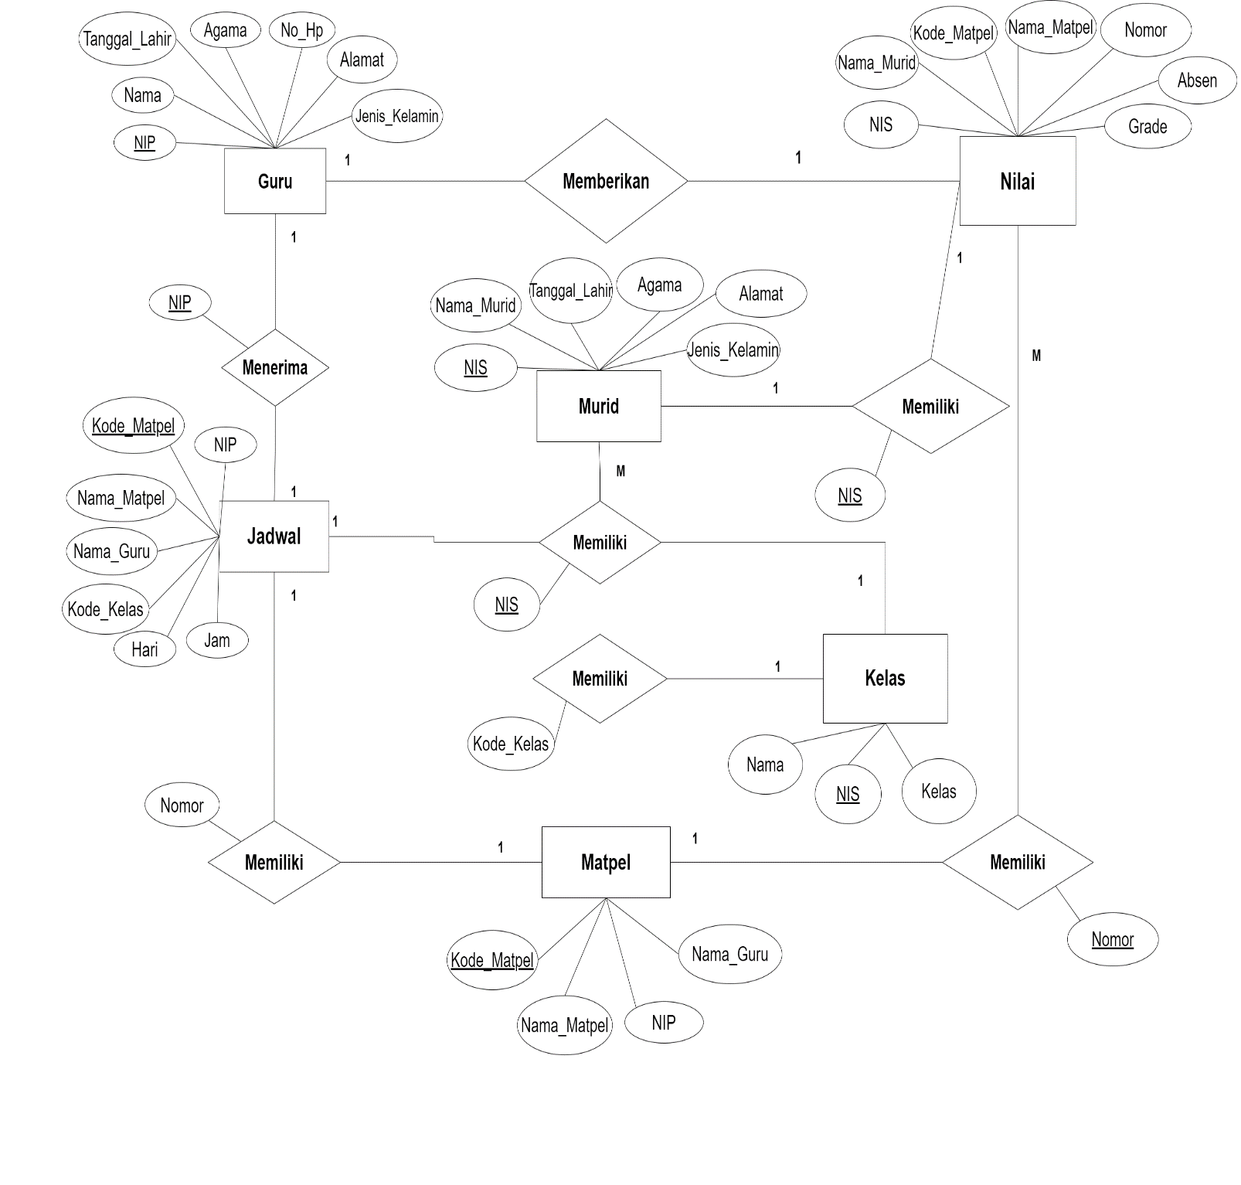

Gambar 4. 19 ERD (Entity Relashionship Diagram)

1. Spesifikasi File Basis Data
   1. Nama tabel : tb_guru

Media : *Hardisk*

Keterangan : Data guru

*Primary Key* : NIP*

|  |  |  |  |  |
| --- | --- | --- | --- | --- |
| No | Nama *Field* | *Type* Data | Value | Keterangan |
| 1 | NIP* | varchar | 15 | *Primary key* |
| 2 | Nama | varchar | 100 |  |
| 3 | Tanggal_Lahir | varchar | 30 |  |
| 4 | Agama | varchar | 20 |  |
| 5 | Hp | varchar | 20 |  |
| 6 | Alamat | varchar | 30 |  |
| 7 | Jenis_Kelamin | varchar | 30 |  |

Panjang Record : 15 + 100 + 30 + 20 + 20 + 30 + 30

Jumlah Record : 245

TABLE 4. 2 tb_guru

* 1. Nama tabel : tb_murid

Media : *Hardisk*

Keterangan : Data murid

*Primary Key* : NIS*

Panjang Record : 20 + 100 + 30 + 30 + 30 + 20

Jumlah Record : 240

|  |  |  |  |  |
| --- | --- | --- | --- | --- |
| No | Nama *Field* | *Type* Data | Value | Keterangan |
| 1 | NIS* | varchar | 20 | *Primary key* |
| 2 | Nama_ murid | varchar | 100 |  |
| 3 | Tanggal_Lahir | varchar | 30 |  |
| 4 | Agama | varchar | 30 |  |
| 5 | Alamat | varchar | 30 |  |
| 6 | Jenis_Kelamin | varchar | 20 |  |

TABLE 4. 3 tb_ murid

* 1. Nama tabel : tb_kelas Media : *Hardisk*

Keterangan : Data kelas

*Primary Key* : NIS*

Panjang Record : 30 + 100 + 30

Jumlah Record :160

|  |  |  |  |  |
| --- | --- | --- | --- | --- |
| No | Nama *Field* | *Type* Data | Value | Keterangan |
| 1 | NIS* | varchar | 30 | *Primary key* |
| 2 | Nama | varchar | 100 |  |
| 3 | Kelas | varchar | 30 |  |

TABLE 4. 4 tb_kelas

* 1. Nama tabel : tb_matpel

Media : *Hardisk*

Keterangan : Data matpel

*Primary Key* : Kode_Matpel*

Panjang Record : 30 + 30 + 30 + 100

Jumlah Record : 190

|  |  |  |  |  |
| --- | --- | --- | --- | --- |
| NO | Nama *Field* | *Type* Data | Value | Keterangan |
| 1 | Kode_Matpel* | varchar | 30 | *Primary key* |
| 2 | Nama_Matpel | varchar | 30 |  |
| 3 | NIP | varchar | 30 |  |
| 4 | Nama_Guru | varchar | 100 |  |

TABLE 4. 5 tb_Matpel

* 1. Nama tabel : tb_jadwal

Media : *Hardisk*

Keterangan : Data Jadwal

*Primary Key* : Kode_Matpel*

Panjang Record : 30 + 30 + 30 + 100 + 30 + 30 + 30

Jumlah Record : 280

|  |  |  |  |  |
| --- | --- | --- | --- | --- |
| No | Nama *Field* | *Type* Data | Value | Keterangan |
| 1 | NIP | varchar | 30 | *Primary Key* |
| 2 | Kode_Matpel* | varchar | 30 |  |
| 3 | Nama_Matpel | varchar | 30 |  |
| 4 | Nama_Guru | varchar | 100 |  |
| 5 | Kode_Kelas | varchar | 30 |  |
| 6 | Hari | varchar | 30 |  |

TABLE 4. 6 tb_jadwal

* 1. Nama tabel : tb_nilai Media : *Hardisk*

Keterangan : Data Nilai

*Primary Key* : Nomor*

Panjang Record : 30 + 100 + 30 + 30 + 30 + 30 + 30

Jumlah Record :280

|  |  |  |  |  |
| --- | --- | --- | --- | --- |
| No | Nama *Field* | *Type* Data | Value | Keterangan |
| 1 | Nomor* | integer | 11 | *Primary Key* |
| 2 | NIS | varchar | 30 |  |
| 3 | Nama_ murid | varchar | 100 |  |
| 4 | Kode_Matpel | varchar | 30 |  |
| 5 | Nama_Matpel | varchar | 30 |  |
| 6 | Absen | varchar | 30 |  |
| 7 | Grade | varchar | 30 |  |

TABLE 4. 7 tb_nilai

## L. Rancangan Layar, Rancangan Form Masukan, dan Rancangan Form Keluaran

1. Rancangan Layar Login

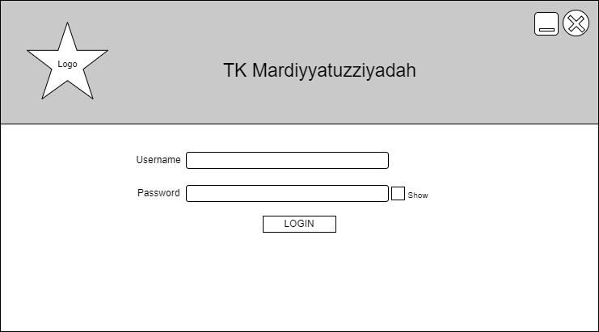Gambar 4. 20 Rancangan Layar Login

1. Rayangan Layar Beranda



Gambar 4. 21 Rayangan layar Beranda

3. Rancangan layar data guru

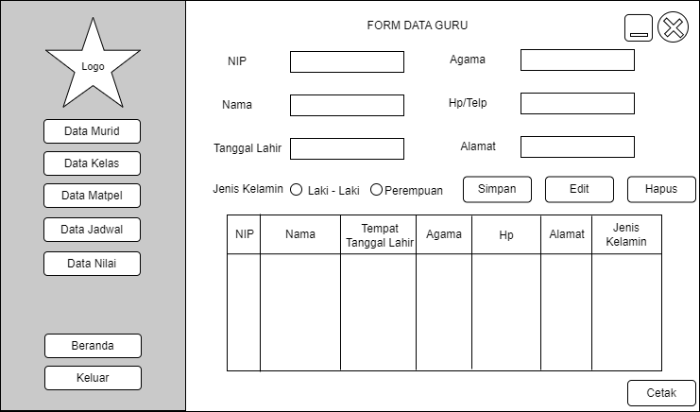

Gambar 4. 22 Rancangan layar data guru

4. Rancangan Layar Data Murid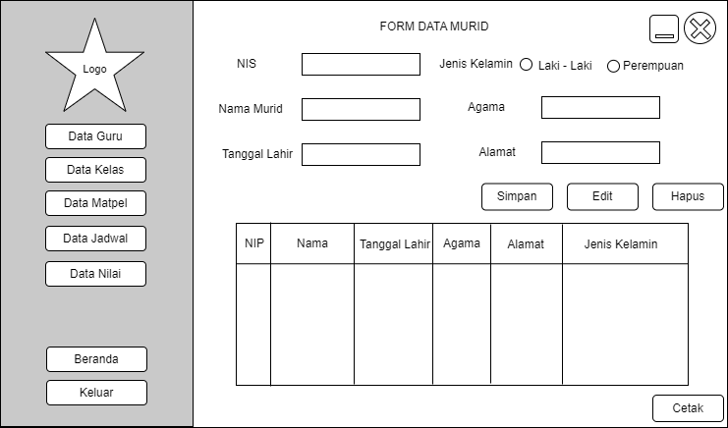

Gambar 4. 23 Rancangan Layar Data Murid

5. Rancangan Layar Data Kelas

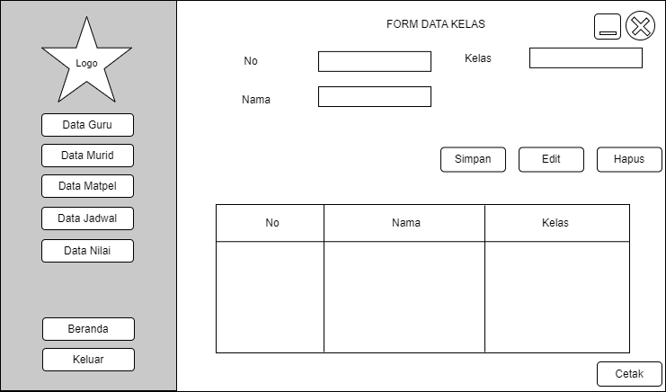

**G**ambar 4. 24 Rancangan Layar Data Kelas

6. Rancangan Layar Data Matpel

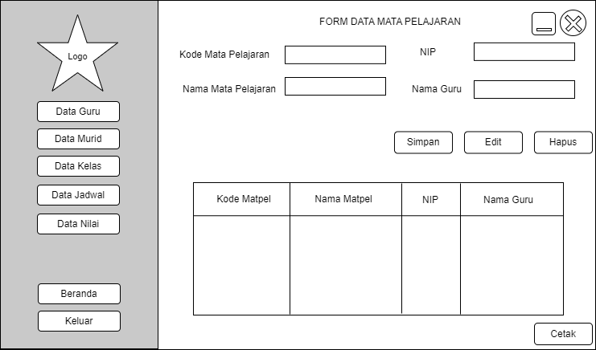

Gambar 4. 25 Rancangan Layar Data Matpel

7. Rancangan Layar Data Jadwal

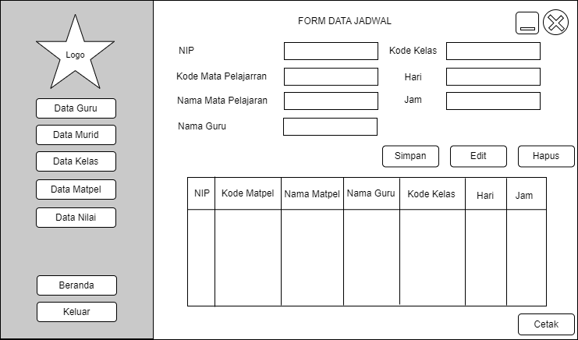

Gambar 4. 26 Rancangan Layar Data Jadwal

8. Rancangan Layar Data Nilai

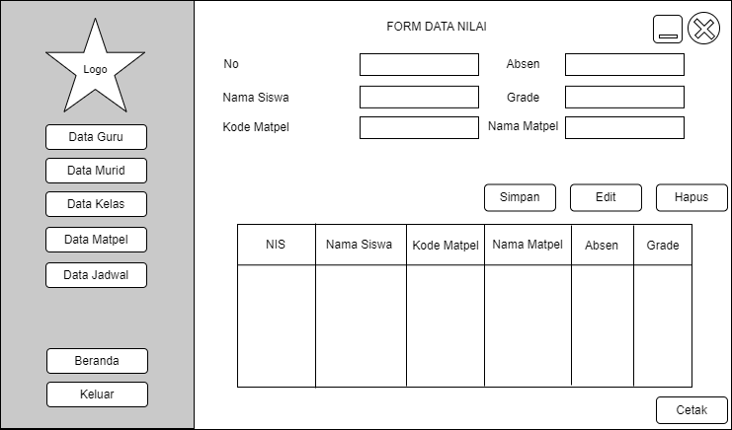

Gambar 4. 27 Rancangan Layar Data Nilai

## M. Tampilan Layar, Tampilan Form Masukan, dan Tampilan Form Keluaran

1. Tampilan Layar Login

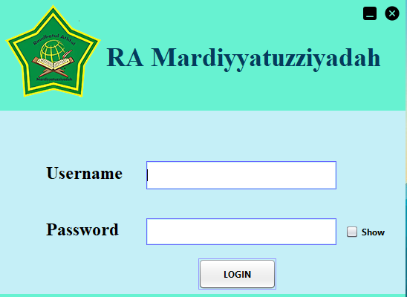

Gambar 4. 28 **Tampilan** Layar Login

2. Rayangan layar Beranda

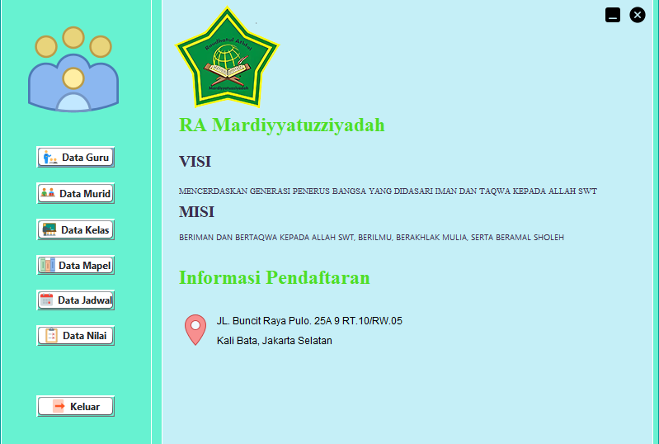

Gambar 4. 29 Tampilan Layar Beranda

3. Tampilan layar Data Guru

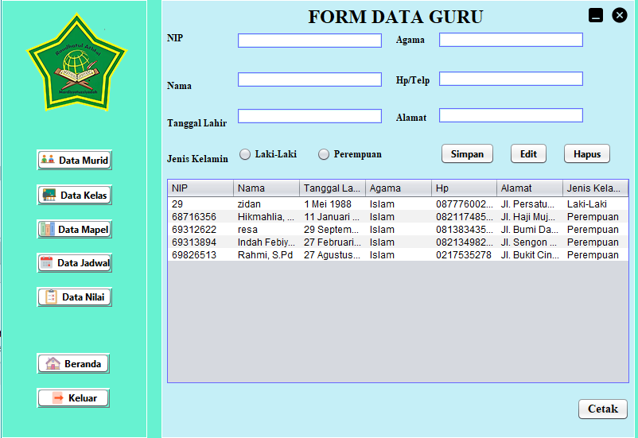

Gambar 4. 30 Tampilan Layar Data Guru

4. Tampilan Layar Data Murid

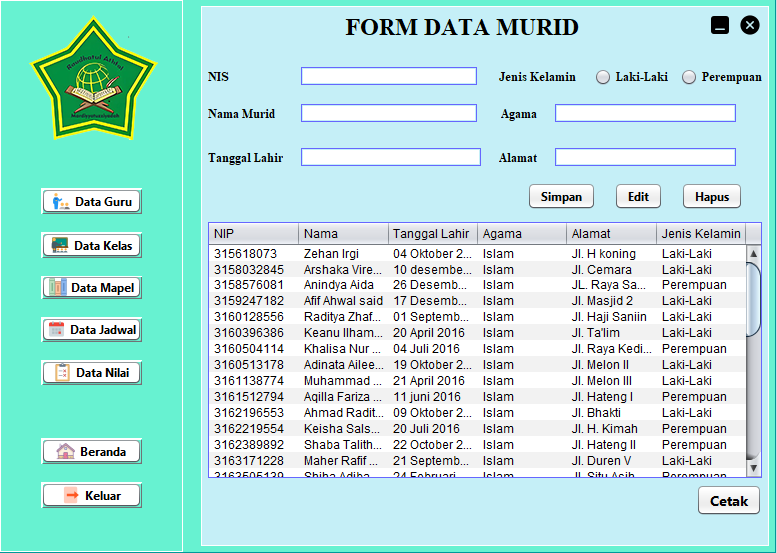

Gambar 4. 31 Tampilan Layar Data Murid

5. Tampilan Layar Data Kelas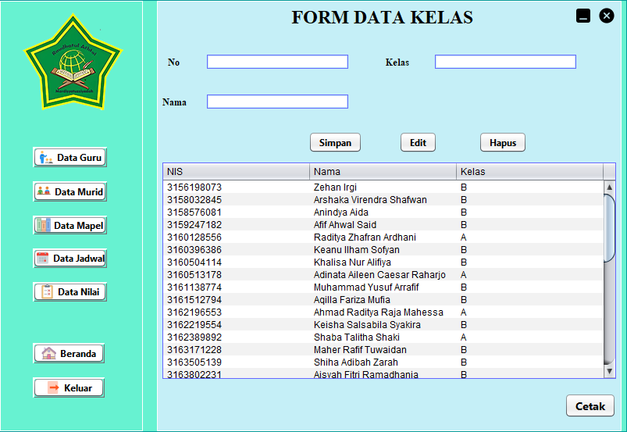

Gambar 4. 32 Tampilan Layar Data Kelas

6. Tampilan Layar Data Mapel

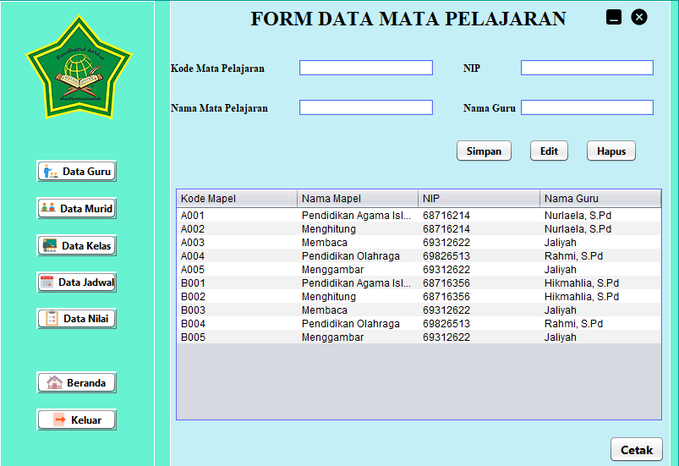

Gambar 4. 33 Tampilan Layar Data Mapel

7. Tampilan Layar Data Jadwal

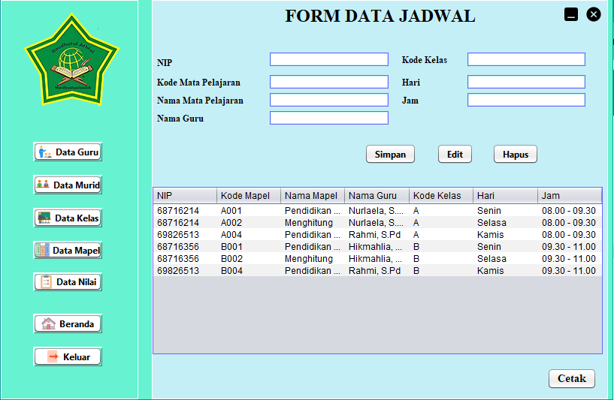

Gambar 4. 34 Tampilan Layar Data Jadwal

8. Tampilan Layar Data Nilai

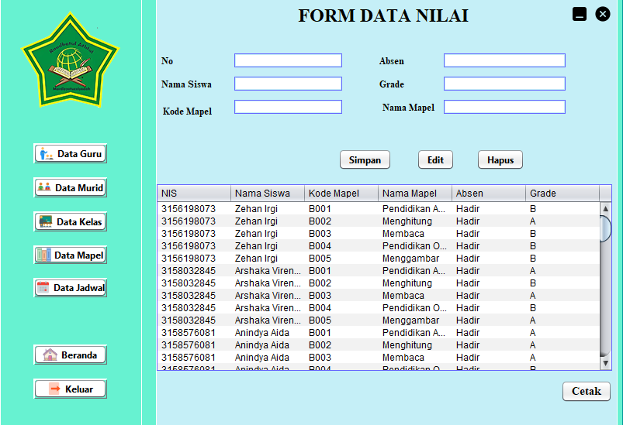

Gambar 4. 35 Tampilan Layar Data Nilai

9. Tampilan Keluaran Laporan Data Guru

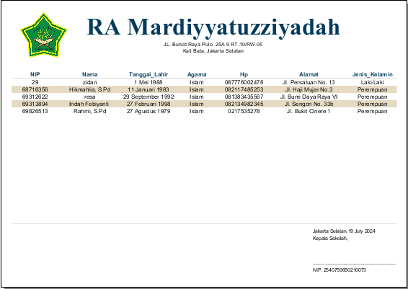

Gambar 4. 36 Tampilan Keluaran Laporan Data Guru

10. Tampilan Keluaran Data Murid

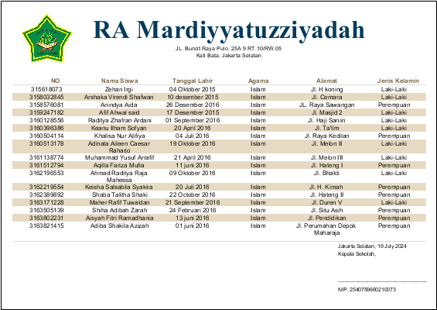

Gambar 4. 37 Tampilan Keluaran Data Murid

11. Tampilan keluaran Laporan Data Kelas 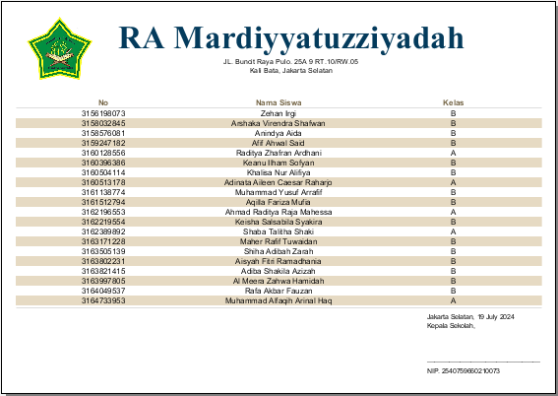

Gambar 4. 38 Tampilan Keluaran Laporan Data Kelas

12. Tampilan keluaran laporan Data Mapel

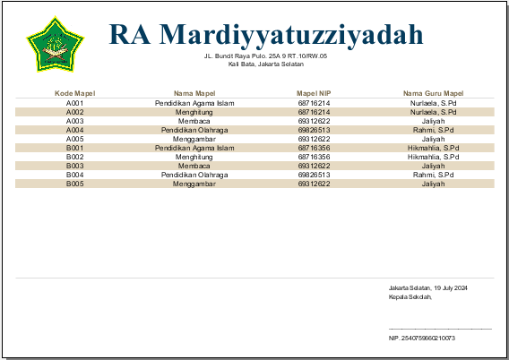

Gambar 4. 39 Tampilan keluaran laporan data Mapel

13. Tampilan Keluaran Laporan Data Jadwal

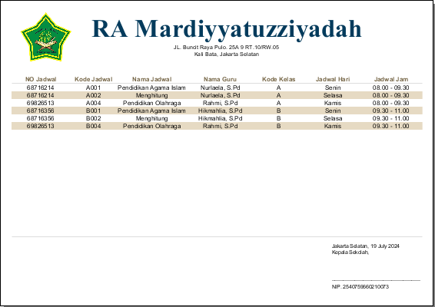

Gambar 4. 40 Tampilan keluaran laporan data jadwal

14. Tampilan Keluaran Laporan Data Nilai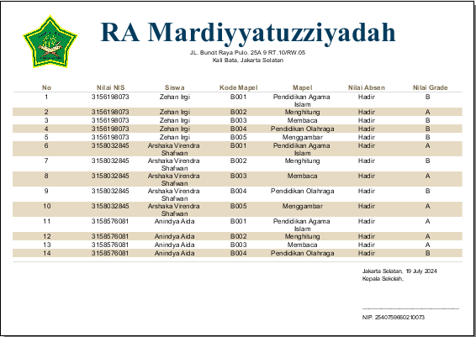

Gambar 4. 41 Tampilan Keluaran Laporan Data Nilai

# BAB V

# PENUTUP

## Kesimpulan

Sistem informasi akademik pada Raudhatul Athfal (RA) Mardiyyatuzziyadah masih tergolong manual, sehingga sering terjadi kesalahan dalam memberikan pelayanan informasi. Dari permasalahan tersebut dapat ditarik kesimpulan sebagai berikut:

* + 1. Dengan adanya sistem informasi akademik ini maka dapat mempermudah pengolahan data guru, data murid, data kelas, data matpel dan data nilai.
    2. Menghasilkan informasi akademik yang akurat dan tepat waktu.
    3. Dapat mempermudah pekerjaan dalam mengontrol data dan mengakses informasi, sehingga dapat mengoptimalkan waktu dalam melakukan pencarian data.

## Saran

Berikut beberapa saran untuk memaksimalkan kinerja dari sistem informasi akademik pengolahan data murid pada Raudhatul Athfal (RA) Mardiyyatuzziyadah:

* + 1. Dengan adanya sistem informasi akademik ini diharapkan dapat dikembangkan menjadi sistem informasi akademik lebih baik lagi untuk menunjang kegiatan akademik pada Raudhatul Athfal (RA) Mardiyyatuzziyadah.
    2. Meningkatkan dalam segi spesifikasi computer, supaya kinerja sistem informasi lebih baik.
    3. Keamanan sistem perlu dijaga dengan baik dengan cara melakukan maintenance secara berkala

# DAFTAR PUSTAKA

Lutfi, A. (2020). School Using Php and Mysql. *Jurnal AiTech*, 3(2), 104-112. <https://www.ejournal.amiki.ac.id/index.php/Aitech/article/view/51>

Rifai, A. (2017). Perancangan Sistem Presensi Mahasiswa Berbasis Online. *Prosiding Annual Research Seminar*, 3(1), 191-193.

Immayani, D., & Munandar, M. H. (2020). Sistem Informasi Pengelolaan Data Siswa Pada SMA Negeri 02 Bilah Hulu Berbasis Web*. Jurnal Informatika*, 8(2), 65–71. <https://doi.org/10.36987/informatika.v8i2.1427>

Sarinta, & Oki sakina. (2016). Perancangan Sistem Informasi Pengolahan Data Akademik*.*

*Perancangan Sistem Informasi Pengolahan Data Akademik Pada TK Al-Hidayah Lolu*, 2(1).

Vincensius, D., & Wasito, B. (2017). Analisis Dan Perancangan Sistem Informasi Point of Sales Pada Cv. Sanjaya Abadi. *Journal of Chemical Information and Modeling*, 53(9), 1689-1699.

Siagian, S. H. T., & Effiyaldi. (2018). Analisis Dan Perancangan Sistem Informasi Akademik Pada Stikes Prima Jambi. *Jurnal Manajemen Sistem Informasi*, 3(4), 1282-1291.

Arthalita, I., & Hidayat, A. (2021). Pengolahan Data Siswa Pada Sekolah Menengah Kejuruan 1 Kartikatama Kota Metro. *JIKI (Jurnal Llmu Komputer & Informatika)*, 2(1), 118-128. <https://doi.org/10.24127/jiki.v2i1.1113>

Susanti, M. (2016). Perancangan Sistem Informasi Akademik Berbasis Web Pada Smk Pasar Minggu Jakarta. *Informatika*, 3(1), 91-99.

Saraswati, E. “Sistem informasi akademik berbasis web pada sekolah menengah pertama negeri 3 pringkuku,” *IJNS - Indones. J. Netw. Secur.,* vol. 2, no. 4, pp. 34–39, 2013.

Dengen, N. “Sistem Informasi Akademik Berbasis Web SMP Negeri 4 Samarinda,” *Inform.*

*Mulawarman J. Ilm. Ilmu Komput.*, vol. 4, no. 2, pp. 18–29, 2016.

# LAMPIRAN

1. **Program Login**

/*

Click nbfs://nbhost/SystemFileSystem/Templates/Licenses/license-default.txt to change this license

Click nbfs://nbhost/SystemFileSystem/Templates/GUIForms/JFrame.java to edit this template

*/

package tkalfajr;

import Connect.Koneksi;

import javax.swing.JFrame;

import java.sql.*;

import java.util.logging.Level;

import java.util.logging.Logger;

import javax.swing.JOptionPane;

/**

*

@author ASUS

*/

public class A_LoginForm extends javax.swing.JFrame {

Connection conn = new Koneksi().connect();

int xx, xy;

void login() throws SQLException{

try {

B_Beranda menuUtama = new B_Beranda();

String query = "SELECT * FROM login where Username=? AND Password=?";

PreparedStatement pst = conn.prepareStatement(query);

pst.setString(1, juser.getText());

pst.setString(2, jpass.getText());

ResultSet rs = pst.executeQuery();

int count = 0;

while (rs.next()) {

count++;

if (count == 1) {

menuUtama.setVisible(true);

dispose();

} else if (count > 1) {

JOptionPane.showMessageDialog(null, "Selamat Datang di TK Alfajr");

}

}

if (count == 0) {

JOptionPane.showMessageDialog(null, "Username or Password is wrong");

}

rs.close();

pst.close();

} catch (Exception e) {

JOptionPane.showMessageDialog(null, e);

}

}

/**

Creates new form LoginForm

*/

public A_LoginForm() {

initComponents();

}

/**

This method is called from within the constructor to initialize the form.

WARNING: Do NOT modify this code. The content of this method is always

regenerated by the Form Editor.

*/

@SuppressWarnings("unchecked")

// <editor-fold defaultstate="collapsed" desc="Generated Code">

private void initComponents() {

jPasswordField1 = new javax.swing.JPasswordField();

jPanel1 = new javax.swing.JPanel();

jLabel4 = new javax.swing.JLabel();

jLabel5 = new javax.swing.JLabel();

jLabel6 = new javax.swing.JLabel();

jLabel7 = new javax.swing.JLabel();

jPanel2 = new javax.swing.JPanel();

jLabel2 = new javax.swing.JLabel();

jLabel3 = new javax.swing.JLabel();

juser = new javax.swing.JTextField();

btlogin = new javax.swing.JButton();

show = new javax.swing.JCheckBox();

jpass = new javax.swing.JPasswordField();

jPasswordField1.setText("jPasswordField1");

setDefaultCloseOperation(javax.swing.WindowConstants.EXIT_ON_CLOSE);

setUndecorated(true);

addMouseMotionListener(new java.awt.event.MouseMotionAdapter() {

public void mouseDragged(java.awt.event.MouseEvent evt) {

formMouseDragged(evt);

}

});

addMouseListener(new java.awt.event.MouseAdapter() {

public void mousePressed(java.awt.event.MouseEvent evt) {

formMousePressed(evt);

}

});

jPanel1.setBackground(new java.awt.Color(103, 242, 209));

jLabel4.setIcon(new javax.swing.ImageIcon(getClass().getResource("/img/icons8_cancel_24px.png"))); // NOI18N

jLabel4.setCursor(new java.awt.Cursor(java.awt.Cursor.HAND_CURSOR));

jLabel4.addMouseListener(new java.awt.event.MouseAdapter() {

public void mouseClicked(java.awt.event.MouseEvent evt) {

jLabel4MouseClicked(evt);

}

});

jLabel5.setIcon(new javax.swing.ImageIcon(getClass().getResource("/img/icons8_minimize_window_24px.png"))); // NOI18N

jLabel5.setCursor(new java.awt.Cursor(java.awt.Cursor.HAND_CURSOR));

jLabel5.addMouseListener(new java.awt.event.MouseAdapter() {

public void mouseClicked(java.awt.event.MouseEvent evt) {

jLabel5MouseClicked(evt)

}

});

jLabel6.setFont(new java.awt.Font("Times New Roman", 1, 36)); // NOI18N

jLabel6.setForeground(new java.awt.Color(4, 59, 92));

jLabel6.setText("TK Mardiyyatuzziyadah");

jLabel7.setIcon(new javax.swing.ImageIcon(getClass().getResource("/img/logo atk.png"))); // NOI18N

javax.swing.GroupLayout jPanel1Layout = new javax.swing.GroupLayout(jPanel1);

jPanel1.setLayout(jPanel1Layout);

jPanel1Layout.setHorizontalGroup(

jPanel1Layout.createParallelGroup(javax.swing.GroupLayout.Alignment.LEADING)

addGroup(jPanel1Layout.createSequentialGroup()

.addContainerGap(javax.swing.GroupLayout.DEFAULT_SIZE, Short.MAX_VALUE)

.addComponent(jLabel7)

.addPreferredGap(javax.swing.LayoutStyle.ComponentPlacement.RELATED)

.addGroup(jPanel1Layout.createParallelGroup(javax.swing.GroupLayout.Alignment.LEADING)

.addGroup(javax.swing.GroupLayout.Alignment.TRAILING, jPanel1Layout.createSequentialGroup()

.addComponent(jLabel5)

.addPreferredGap(javax.swing.LayoutStyle.ComponentPlacement.RELATED)

.addComponent(jLabel4))

.addComponent(jLabel6, javax.swing.GroupLayout.Alignment.TRAILING, javax.swing.GroupLayout.PREFERRED_SIZE, 397, javax.swing.GroupLayout.PREFERRED_SIZE))

.addContainerGap())

);

jPanel1Layout.setVerticalGroup(jPanel1Layout.createParallelGroup(javax.swing.GroupLayout.Alignment.LEADING)

.addGroup(javax.swing.GroupLayout.Alignment.TRAILING, jPanel1Layout.createSequentialGroup()

addContainerGap()

.addGroup(jPanel1Layout.createParallelGroup(javax.swing.GroupLayout.Alignment.TRAILING)

addGroup(jPanel1Layout.createSequentialGroup(

.addGap(0, 0, Short.MAX_VALUE)

.addComponent(jLabel7))

addGroup(jPanel1Layout.createSequentialGroup()

.addGroup(jPanel1Layout.createParallelGroup(javax.swing.GroupLayout.Alignment.TRAILING)

.addComponent(jLabel5)

.addComponent(jLabel4))

.addPreferredGap(javax.swing.LayoutStyle.ComponentPlacement.RELATED, javax.swing.GroupLayout.DEFAULT_SIZE, Short.MAX_VALUE)

.addComponent(jLabel6)))

.addGap(19, 19, 19))

);

jPanel2.setBackground(new java.awt.Color(197, 239, 247));

jLabel2.setFont(new java.awt.Font("Times New Roman", 1, 24)); // NOI18N

jLabel2.setText("Username");

jLabel3.setFont(new java.awt.Font("Times New Roman", 1, 24)); // NOI18N

jLabel3.setText("Password");

juser.setBorder(javax.swing.BorderFactory.createLineBorder(new java.awt.Color(102, 102, 255)));

juser.addActionListener(new java.awt.event.ActionListener() {

public void actionPerformed(java.awt.event.ActionEvent evt) {

juserActionPerformed(evt);

}

});

btlogin.setBackground(new java.awt.Color(204, 204, 204));

btlogin.setFont(new java.awt.Font("Segoe UI", 1, 12)); // NOI18N

btlogin.setText("LOGIN");

btlogin.setBorder(javax.swing.BorderFactory.createLineBorder(new java.awt.Color(153, 153, 255)));

btlogin.setCursor(new java.awt.Cursor(java.awt.Cursor.HAND_CURSOR));

btlogin.addActionListener(new java.awt.event.ActionListener() {

public void actionPerformed(java.awt.event.ActionEvent evt) {

btloginActionPerformed(evt);

}

});

show.setFont(new java.awt.Font("Segoe UI", 1, 12)); // NOI18N

show.setText("Show");

show.addActionListener(new java.awt.event.ActionListener() {

public void actionPerformed(java.awt.event.ActionEvent evt) {

showActionPerformed(evt);

}

});

jpass.setBorder(javax.swing.BorderFactory.createLineBorder(new java.awt.Color(102, 102, 255)));

javax.swing.GroupLayout jPanel2Layout = new javax.swing.GroupLayout(jPanel2);

jPanel2.setLayout(jPanel2Layout);

jPanel2Layout.setHorizontalGroup(

jPanel2Layout.createParallelGroup(javax.swing.GroupLayout.Alignment.LEADING)

.addGroup(jPanel2Layout.createSequentialGroup()

.addGap(62, 62, 62)

.addGroup(jPanel2Layout.createParallelGroup(javax.swing.GroupLayout.Alignment.TRAILING)

.addComponent(jLabel3, javax.swing.GroupLayout.PREFERRED_SIZE, 129, javax.swing.GroupLayout.PREFERRED_SIZE)

.addComponent(jLabel2, javax.swing.GroupLayout.PREFERRED_SIZE, 129, javax.swing.GroupLayout.PREFERRED_SIZE))

addPreferredGap(javax.swing.LayoutStyle.ComponentPlacement.RELATED)

.addGroup(jPanel2Layout.createParallelGroup(javax.swing.GroupLayout.Alignment.LEADING)

.addComponent(juser, javax.swing.GroupLayout.PREFERRED_SIZE, 256, javax.swing.GroupLayout.PREFERRED_SIZE)

.addGroup(jPanel2Layout.createSequentialGroup()

.addComponent(jpass, javax.swing.GroupLayout.PREFERRED_SIZE, 256, javax.swing.GroupLayout.PREFERRED_SIZE)

.addPreferredGap(javax.swing.LayoutStyle.ComponentPlacement.UNRELATED)

.addComponent(show)))

.addContainerGap(27, Short.MAX_VALUE))

.addGroup(javax.swing.GroupLayout.Alignment.TRAILING, jPanel2Layout.createSequentialGroup()

.addContainerGap(javax.swing.GroupLayout.DEFAULT_SIZE, Short.MAX_VALUE)

.addComponent(btlogin, javax.swing.GroupLayout.PREFERRED_SIZE, 105, javax.swing.GroupLayout.PREFERRED_SIZE)

.addGap(174, 174, 174))

);

jPanel2Layout.linkSize(javax.swing.SwingConstants.HORIZONTAL, new java.awt.Component[] {jpass, juser});

jPanel2Layout.setVerticalGroup(

jPanel2Layout.createParallelGroup(javax.swing.GroupLayout.Alignment.LEADING)

.addGroup(jPanel2Layout.createSequentialGroup()

.addGap(68, 68, 68)

.addGroup(jPanel2Layout.createParallelGroup(javax.swing.GroupLayout.Alignment.BASELINE)

.addComponent(jLabel2, javax.swing.GroupLayout.PREFERRED_SIZE, 31, javax.swing.GroupLayout.PREFERRED_SIZE)

.addComponent(juser, javax.swing.GroupLayout.PREFERRED_SIZE, 38, javax.swing.GroupLayout.PREFERRED_SIZE))

.addGap(39, 39, 39)

.addGroup(jPanel2Layout.createParallelGroup(javax.swing.GroupLayout.Alignment.LEADING)

.addGroup(jPanel2Layout.createParallelGroup(javax.swing.GroupLayout.Alignment.BASELINE)

.addComponent(jLabel3, javax.swing.GroupLayout.PREFERRED_SIZE, 31, javax.swing.GroupLayout.PREFERRED_SIZE)

.addComponent(show))

.addGroup(jPanel2Layout.createSequentialGroup()

.addComponent(jpass, javax.swing.GroupLayout.PREFERRED_SIZE, 36, javax.swing.GroupLayout.PREFERRED_SIZE)

.addGap(18, 18, 18)

.addComponent(btlogin, javax.swing.GroupLayout.PREFERRED_SIZE, 42, javax.swing.GroupLayout.PREFERRED_SIZE)))

.addContainerGap(javax.swing.GroupLayout.DEFAULT_SIZE, Short.MAX_VALUE))

);

javax.swing.GroupLayout layout = new javax.swing.GroupLayout(getContentPane());

getContentPane().setLayout(layout);

layout.setHorizontalGroup(

layout.createParallelGroup(javax.swing.GroupLayout.Alignment.LEADING)

.addComponent(jPanel1, javax.swing.GroupLayout.DEFAULT_SIZE, javax.swing.GroupLayout.DEFAULT_SIZE, Short.MAX_VALUE)

.addComponent(jPanel2, javax.swing.GroupLayout.DEFAULT_SIZE, javax.swing.GroupLayout.DEFAULT_SIZE, Short.MAX_VALUE)

);

layout.setVerticalGroup(

layout.createParallelGroup(javax.swing.GroupLayout.Alignment.LEADING)

.addGroup(layout.createSequentialGroup()

.addComponent(jPanel1, javax.swing.GroupLayout.PREFERRED_SIZE, javax.swing.GroupLayout.DEFAULT_SIZE, javax.swing.GroupLayout.PREFERRED_SIZE)

.addContainerGap(javax.swing.GroupLayout.DEFAULT_SIZE, Short.MAX_VALUE))

.addGroup(layout.createSequentialGroup()

.addGap(100, 100, 100)

.addComponent(jPanel2, javax.swing.GroupLayout.DEFAULT_SIZE, javax.swing.GroupLayout.DEFAULT_SIZE, Short.MAX_VALUE))

);

setSize(new java.awt.Dimension(546, 400));

setLocationRelativeTo(null);

}// </editor-fold>

private void juserActionPerformed(java.awt.event.ActionEvent evt) {

// TODO add your handling code here:

}

private void jLabel4MouseClicked(java.awt.event.MouseEvent evt) {

dispose();

}

private void jLabel5MouseClicked(java.awt.event.MouseEvent evt) {

this.setState(JFrame.ICONIFIED);

}

private void formMousePressed(java.awt.event.MouseEvent evt) {

xx= evt.getX();

xy = evt.getY();

}

private void formMouseDragged(java.awt.event.MouseEvent evt) {

int x = evt.getXOnScreen();

int y = evt.getYOnScreen();

this.setLocation(x - xx, y - xy);

}

private void showActionPerformed(java.awt.event.ActionEvent evt) {

if (show.isSelected()){

jpass.setEchoChar((char)0);

}else {

jpass.setEchoChar('*');

}

}

private void btloginActionPerformed(java.awt.event.ActionEvent evt) {

try {

login();

} catch (SQLException ex) {

Logger.getLogger(A_LoginForm.class.getName()).log(Level.SEVERE, null, ex);

}

}

/**

@param args the command line arguments

*/

public static void main(String args[]) {

/* Set the Nimbus look and feel */

//<editor-fold defaultstate="collapsed" desc=" Look and feel setting code (optional) ">

/* If Nimbus (introduced in Java SE 6) is not available, stay with the default look and feel.

For details see http://download.oracle.com/javase/tutorial/uiswing/lookandfeel/plaf.html

*/

try {

for (javax.swing.UIManager.LookAndFeelInfo info : javax.swing.UIManager.getInstalledLookAndFeels()) {

if ("Nimbus".equals(info.getName())) {

javax.swing.UIManager.setLookAndFeel(info.getClassName());

break;

}

}

} catch (ClassNotFoundException ex) {

java.util.logging.Logger.getLogger(A_LoginForm.class.getName()).log(java.util.logging.Level.SEVERE, null, ex);

} catch (InstantiationException ex) {

java.util.logging.Logger.getLogger(A_LoginForm.class.getName()).log(java.util.logging.Level.SEVERE, null, ex);

} catch (IllegalAccessException ex) {

java.util.logging.Logger.getLogger(A_LoginForm.class.getName()).log(java.util.logging.Level.SEVERE, null, ex);

} catch (javax.swing.UnsupportedLookAndFeelException ex) {

java.util.logging.Logger.getLogger(A_LoginForm.class.getName()).log(java.util.logging.Level.SEVERE, null, ex);

}

//</editor-fold>

//</editor-fold>

/* Create and display the form */

java.awt.EventQueue.invokeLater(new Runnable() {

public void run() {

new A_LoginForm().setVisible(true);

}

});

}

// Variables declaration - do not modify

private javax.swing.JButton btlogin;

private javax.swing.JLabel jLabel2;

private javax.swing.JLabel jLabel3;

private javax.swing.JLabel jLabel4;

private javax.swing.JLabel jLabel5;

private javax.swing.JLabel jLabel6;

private javax.swing.JLabel jLabel7;

private javax.swing.JPanel jPanel1;

private javax.swing.JPanel jPanel2;

private javax.swing.JPasswordField jPasswordField1;

private javax.swing.JPasswordField jpass;

private javax.swing.JTextField juser;

private javax.swing.JCheckBox show;

// End of variables declaration

}

1. **Program Beranda**

/*

* Click nbfs://nbhost/SystemFileSystem/Templates/Licenses/license-default.txt to change this license

* Click nbfs://nbhost/SystemFileSystem/Templates/GUIForms/JFrame.java to edit this template

*/

package tkalfajr;

import javax.swing.JFrame;

/**

*

* @author ASUS

*/

public class B_Beranda extends javax.swing.JFrame {

int xx, xy ;

void dataguru(){

C_DataGuru A=new C_DataGuru();

A.setVisible(true);

dispose();

}

public B_Beranda() {

initComponents();

}

/**

* This method is called from within the constructor to initialize the form.

* WARNING: Do NOT modify this code. The content of this method is always

* regenerated by the Form Editor.

*/

@SuppressWarnings("unchecked")

// <editor-fold defaultstate="collapsed" desc="Generated Code">

private void initComponents() {

jPanel3 = new javax.swing.JPanel();

jPanel4 = new javax.swing.JPanel();

bdatasiswa = new javax.swing.JButton();

bdatakelas = new javax.swing.JButton();

bdatamapel = new javax.swing.JButton();

bdatajadwal = new javax.swing.JButton();

bdatanilai = new javax.swing.JButton();

btkeluar = new javax.swing.JButton();

jLabel13 = new javax.swing.JLabel();

bdataguru = new javax.swing.JButton();

jPanel1 = new javax.swing.JPanel();

jLabel1 = new javax.swing.JLabel();

jLabel2 = new javax.swing.JLabel();

jLabel4 = new javax.swing.JLabel();

jLabel5 = new javax.swing.JLabel();

jLabel6 = new javax.swing.JLabel();

jLabel7 = new javax.swing.JLabel();

jLabel8 = new javax.swing.JLabel();

jLabel9 = new javax.swing.JLabel();

jLabel10 = new javax.swing.JLabel();

jLabel11 = new javax.swing.JLabel();

jLabel12 = new javax.swing.JLabel();

jLabel3 = new javax.swing.JLabel();

setDefaultCloseOperation(javax.swing.WindowConstants.EXIT_ON_CLOSE);

setBackground(new java.awt.Color(103, 242, 209));

setUndecorated(true);

addMouseMotionListener(new java.awt.event.MouseMotionAdapter() {

public void mouseDragged(java.awt.event.MouseEvent evt) {

formMouseDragged(evt);

}

});

addMouseListener(new java.awt.event.MouseAdapter() {

public void mousePressed(java.awt.event.MouseEvent evt) {

formMousePressed(evt);

}

});

jPanel3.setBackground(new java.awt.Color(103, 242, 209));

jPanel3.setBorder(javax.swing.BorderFactory.createMatteBorder(1, 1, 1, 1, new java.awt.Color(0, 153, 153)));

jPanel4.setBackground(new java.awt.Color(103, 242, 209));

jPanel4.setBorder(javax.swing.BorderFactory.createMatteBorder(1, 1, 1, 1, new java.awt.Color(255, 255, 255)));

bdatasiswa.setBackground(new java.awt.Color(232, 236, 241));

bdatasiswa.setFont(new java.awt.Font("Segoe UI", 1, 12)); // NOI18N

bdatasiswa.setForeground(new java.awt.Color(36, 37, 42));

bdatasiswa.setIcon(new javax.swing.ImageIcon(getClass().getResource("/img/icons8_classmates_sittings_skin_type_4_20px.png"))); // NOI18N

bdatasiswa.setText("Data Murid");

bdatasiswa.setBorder(new javax.swing.border.SoftBevelBorder(javax.swing.border.BevelBorder.RAISED));

bdatasiswa.setCursor(new java.awt.Cursor(java.awt.Cursor.HAND_CURSOR));

bdatasiswa.addActionListener(new java.awt.event.ActionListener() {

public void actionPerformed(java.awt.event.ActionEvent evt) {

bdatasiswaActionPerformed(evt);

}

});

bdatakelas.setBackground(new java.awt.Color(232, 236, 241));

bdatakelas.setFont(new java.awt.Font("Segoe UI", 1, 12)); // NOI18N

bdatakelas.setForeground(new java.awt.Color(36, 37, 42));

bdatakelas.setIcon(new javax.swing.ImageIcon(getClass().getResource("/img/icons8_classroom_20px.png"))); // NOI18N

bdatakelas.setText("Data Kelas");

bdatakelas.setBorder(new javax.swing.border.SoftBevelBorder(javax.swing.border.BevelBorder.RAISED));

bdatakelas.setCursor(new java.awt.Cursor(java.awt.Cursor.HAND_CURSOR));

bdatakelas.addActionListener(new java.awt.event.ActionListener() {

public void actionPerformed(java.awt.event.ActionEvent evt) {

bdatakelasActionPerformed(evt);

}

});

bdatamapel.setBackground(new java.awt.Color(232, 236, 241));

bdatamapel.setFont(new java.awt.Font("Segoe UI", 1, 12)); // NOI18N

bdatamapel.setForeground(new java.awt.Color(36, 37, 42));

bdatamapel.setIcon(new javax.swing.ImageIcon(getClass().getResource("/img/icons8_Books_18px.png"))); // NOI18N

bdatamapel.setText("Data Mapel");

bdatamapel.setBorder(new javax.swing.border.SoftBevelBorder(javax.swing.border.BevelBorder.RAISED));

bdatamapel.setCursor(new java.awt.Cursor(java.awt.Cursor.HAND_CURSOR));

bdatamapel.addActionListener(new java.awt.event.ActionListener() {

public void actionPerformed(java.awt.event.ActionEvent evt) {

bdatamapelActionPerformed(evt);

}

});

bdatajadwal.setBackground(new java.awt.Color(232, 236, 241));

bdatajadwal.setFont(new java.awt.Font("Segoe UI", 1, 12)); // NOI18N

bdatajadwal.setForeground(new java.awt.Color(36, 37, 42));

bdatajadwal.setIcon(new javax.swing.ImageIcon(getClass().getResource("/img/icons8_planner_19px.png"))); // NOI18N

bdatajadwal.setText("Data Jadwal");

bdatajadwal.setBorder(new javax.swing.border.SoftBevelBorder(javax.swing.border.BevelBorder.RAISED));

bdatajadwal.setCursor(new java.awt.Cursor(java.awt.Cursor.HAND_CURSOR));

bdatajadwal.addActionListener(new java.awt.event.ActionListener() {

public void actionPerformed(java.awt.event.ActionEvent evt) {

bdatajadwalActionPerformed(evt);

}

});

bdatanilai.setBackground(new java.awt.Color(232, 236, 241));

bdatanilai.setFont(new java.awt.Font("Segoe UI", 1, 12)); // NOI18N

bdatanilai.setForeground(new java.awt.Color(36, 37, 42));

bdatanilai.setIcon(new javax.swing.ImageIcon(getClass().getResource("/img/icons8_scorecard_19px.png"))); // NOI18N

bdatanilai.setText("Data Nilai");

bdatanilai.setBorder(new javax.swing.border.SoftBevelBorder(javax.swing.border.BevelBorder.RAISED));

bdatanilai.setCursor(new java.awt.Cursor(java.awt.Cursor.HAND_CURSOR));

bdatanilai.addActionListener(new java.awt.event.ActionListener() {

public void actionPerformed(java.awt.event.ActionEvent evt) {

bdatanilaiActionPerformed(evt);

}

});

btkeluar.setBackground(new java.awt.Color(232, 236, 241));

btkeluar.setFont(new java.awt.Font("Segoe UI", 1, 12)); // NOI18N

btkeluar.setForeground(new java.awt.Color(36, 37, 42));

btkeluar.setIcon(new javax.swing.ImageIcon(getClass().getResource("/img/icons8_export_20px.png"))); // NOI18N

btkeluar.setText("Keluar");

btkeluar.setBorder(new javax.swing.border.SoftBevelBorder(javax.swing.border.BevelBorder.RAISED));

btkeluar.setCursor(new java.awt.Cursor(java.awt.Cursor.HAND_CURSOR));

btkeluar.addActionListener(new java.awt.event.ActionListener() {

public void actionPerformed(java.awt.event.ActionEvent evt) {

btkeluarActionPerformed(evt);

}

});

jLabel13.setIcon(new javax.swing.ImageIcon(getClass().getResource("/img/icons8_conference_110px.png"))); // NOI18N

bdataguru.setBackground(new java.awt.Color(232, 236, 241));

bdataguru.setFont(new java.awt.Font("Segoe UI", 1, 12)); // NOI18N

bdataguru.setForeground(new java.awt.Color(36, 37, 42));

bdataguru.setIcon(new javax.swing.ImageIcon(getClass().getResource("/img/icons8_coach_20px.png"))); // NOI18N

bdataguru.setText("Data Guru");

bdataguru.setBorder(new javax.swing.border.SoftBevelBorder(javax.swing.border.BevelBorder.RAISED));

bdataguru.setCursor(new java.awt.Cursor(java.awt.Cursor.HAND_CURSOR));

bdataguru.addActionListener(new java.awt.event.ActionListener() {

public void actionPerformed(java.awt.event.ActionEvent evt) {

bdataguruActionPerformed(evt);

}

});

javax.swing.GroupLayout jPanel4Layout = new javax.swing.GroupLayout(jPanel4);

jPanel4.setLayout(jPanel4Layout);

jPanel4Layout.setHorizontalGroup(

jPanel4Layout.createParallelGroup(javax.swing.GroupLayout.Alignment.LEADING)

.addGroup(jPanel4Layout.createSequentialGroup()

.addGroup(jPanel4Layout.createParallelGroup(javax.swing.GroupLayout.Alignment.LEADING)

.addGroup(jPanel4Layout.createSequentialGroup()

.addGap(32, 32, 32)

.addComponent(jLabel13))

.addGroup(jPanel4Layout.createSequentialGroup()

.addGap(42, 42, 42)

.addGroup(jPanel4Layout.createParallelGroup(javax.swing.GroupLayout.Alignment.LEADING, false)

.addComponent(bdatasiswa, javax.swing.GroupLayout.DEFAULT_SIZE, javax.swing.GroupLayout.DEFAULT_SIZE, Short.MAX_VALUE)

.addComponent(bdatakelas, javax.swing.GroupLayout.DEFAULT_SIZE, javax.swing.GroupLayout.DEFAULT_SIZE, Short.MAX_VALUE)

.addComponent(bdatamapel, javax.swing.GroupLayout.DEFAULT_SIZE, javax.swing.GroupLayout.DEFAULT_SIZE, Short.MAX_VALUE)

.addComponent(bdatanilai, javax.swing.GroupLayout.DEFAULT_SIZE, javax.swing.GroupLayout.DEFAULT_SIZE, Short.MAX_VALUE)

.addComponent(btkeluar, javax.swing.GroupLayout.DEFAULT_SIZE, javax.swing.GroupLayout.DEFAULT_SIZE, Short.MAX_VALUE)

.addComponent(bdatajadwal, javax.swing.GroupLayout.DEFAULT_SIZE, javax.swing.GroupLayout.DEFAULT_SIZE, Short.MAX_VALUE)

.addComponent(bdataguru, javax.swing.GroupLayout.DEFAULT_SIZE, javax.swing.GroupLayout.DEFAULT_SIZE, Short.MAX_VALUE))))

.addContainerGap(39, Short.MAX_VALUE))

);

jPanel4Layout.setVerticalGroup(

jPanel4Layout.createParallelGroup(javax.swing.GroupLayout.Alignment.LEADING)

.addGroup(jPanel4Layout.createSequentialGroup()

.addGap(29, 29, 29)

.addComponent(jLabel13)

.addGap(38, 38, 38)

.addComponent(bdataguru)

.addGap(18, 18, 18)

.addComponent(bdatasiswa)

.addGap(18, 18, 18)

.addComponent(bdatakelas)

.addGap(18, 18, 18)

.addComponent(bdatamapel)

.addGap(18, 18, 18)

.addComponent(bdatajadwal)

.addGap(18, 18, 18)

.addComponent(bdatanilai)

.addPreferredGap(javax.swing.LayoutStyle.ComponentPlacement.RELATED, 60, Short.MAX_VALUE)

.addComponent(btkeluar)

.addGap(33, 33, 33))

);

jPanel1.setBackground(new java.awt.Color(197, 239, 247));

jPanel1.setBorder(javax.swing.BorderFactory.createMatteBorder(1, 1, 1, 1, new java.awt.Color(255, 255, 255)));

jLabel1.setIcon(new javax.swing.ImageIcon(getClass().getResource("/img/icons8_cancel_24px.png"))); // NOI18N

jLabel1.setCursor(new java.awt.Cursor(java.awt.Cursor.HAND_CURSOR));

jLabel1.addMouseListener(new java.awt.event.MouseAdapter() {

public void mouseClicked(java.awt.event.MouseEvent evt) {

jLabel1MouseClicked(evt);

}

});

jLabel2.setIcon(new javax.swing.ImageIcon(getClass().getResource("/img/icons8_minimize_window_24px.png"))); // NOI18N

jLabel2.setCursor(new java.awt.Cursor(java.awt.Cursor.HAND_CURSOR));

jLabel2.addMouseListener(new java.awt.event.MouseAdapter() {

public void mouseClicked(java.awt.event.MouseEvent evt) {

jLabel2MouseClicked(evt);

}

});

jLabel4.setFont(new java.awt.Font("Times New Roman", 1, 24)); // NOI18N

jLabel4.setForeground(new java.awt.Color(78, 222, 39));

jLabel4.setText("TK Mardiyyatuzziyadah");

jLabel5.setFont(new java.awt.Font("Times New Roman", 1, 20)); // NOI18N

jLabel5.setForeground(new java.awt.Color(57, 46, 74));

jLabel5.setText("VISI");

jLabel6.setFont(new java.awt.Font("Times New Roman", 0, 10)); // NOI18N

jLabel6.setForeground(new java.awt.Color(57, 46, 74));

jLabel6.setText("MENCERDASKAN GENERASI PENERUS BANGSA YANG DIDASARI IMAN DAN TAQWA KEPADA ALLAH SWT");

jLabel7.setFont(new java.awt.Font("Times New Roman", 1, 20)); // NOI18N

jLabel7.setForeground(new java.awt.Color(57, 46, 74));

jLabel7.setText("MISI");

jLabel8.setFont(new java.awt.Font("Segoe UI", 0, 10)); // NOI18N

jLabel8.setForeground(new java.awt.Color(57, 46, 74));

jLabel8.setText("BERIMAN DAN BERTAQWA KEPADA ALLAH SWT, BERILMU, BERAKHLAK MULIA, SERTA BERAMAL SHOLEH");

jLabel9.setFont(new java.awt.Font("Times New Roman", 1, 24)); // NOI18N

jLabel9.setForeground(new java.awt.Color(78, 222, 39));

jLabel9.setText("Informasi Pendaftaran");

jLabel10.setIcon(new javax.swing.ImageIcon(getClass().getResource("/img/icons8_Location_40px_1.png"))); // NOI18N

jLabel11.setText("JL. Buncit Raya Pulo. 25A 9 RT.10/RW.05");

jLabel12.setText("Kali Bata, Jakarta Selatan");

jLabel3.setIcon(new javax.swing.ImageIcon(getClass().getResource("/img/logo atk.png"))); // NOI18N

javax.swing.GroupLayout jPanel1Layout = new javax.swing.GroupLayout(jPanel1);

jPanel1.setLayout(jPanel1Layout);

jPanel1Layout.setHorizontalGroup(

jPanel1Layout.createParallelGroup(javax.swing.GroupLayout.Alignment.LEADING)

.addGroup(jPanel1Layout.createSequentialGroup()

.addGroup(jPanel1Layout.createParallelGroup(javax.swing.GroupLayout.Alignment.LEADING)

.addGroup(jPanel1Layout.createSequentialGroup()

.addGap(14, 14, 14)

.addGroup(jPanel1Layout.createParallelGroup(javax.swing.GroupLayout.Alignment.LEADING)

.addComponent(jLabel3)

.addGroup(jPanel1Layout.createSequentialGroup()

.addGap(6, 6, 6)

.addGroup(jPanel1Layout.createParallelGroup(javax.swing.GroupLayout.Alignment.LEADING)

.addComponent(jLabel4)

.addComponent(jLabel6)

.addComponent(jLabel8)

.addComponent(jLabel7)

.addComponent(jLabel5)

.addComponent(jLabel9)

.addGroup(jPanel1Layout.createSequentialGroup()

.addComponent(jLabel10)

.addPreferredGap(javax.swing.LayoutStyle.ComponentPlacement.RELATED)

.addGroup(jPanel1Layout.createParallelGroup(javax.swing.GroupLayout.Alignment.LEADING)

.addComponent(jLabel11)

.addComponent(jLabel12))))))

.addGap(0, 61, Short.MAX_VALUE))

.addGroup(jPanel1Layout.createSequentialGroup()

.addContainerGap(javax.swing.GroupLayout.DEFAULT_SIZE, Short.MAX_VALUE)

.addComponent(jLabel2)

.addPreferredGap(javax.swing.LayoutStyle.ComponentPlacement.RELATED)

.addComponent(jLabel1)))

.addContainerGap())

);

jPanel1Layout.setVerticalGroup(

jPanel1Layout.createParallelGroup(javax.swing.GroupLayout.Alignment.LEADING)

.addGroup(jPanel1Layout.createSequentialGroup()

.addContainerGap()

.addGroup(jPanel1Layout.createParallelGroup(javax.swing.GroupLayout.Alignment.LEADING)

.addGroup(jPanel1Layout.createSequentialGroup()

.addComponent(jLabel3)

.addPreferredGap(javax.swing.LayoutStyle.ComponentPlacement.RELATED)

.addComponent(jLabel4))

.addGroup(jPanel1Layout.createParallelGroup(javax.swing.GroupLayout.Alignment.TRAILING)

.addComponent(jLabel2)

.addComponent(jLabel1)))

.addGap(18, 18, 18)

.addComponent(jLabel5)

.addGap(18, 18, 18)

.addComponent(jLabel6)

.addPreferredGap(javax.swing.LayoutStyle.ComponentPlacement.RELATED)

.addComponent(jLabel7)

.addPreferredGap(javax.swing.LayoutStyle.ComponentPlacement.UNRELATED)

.addComponent(jLabel8)

.addGap(28, 28, 28)

.addComponent(jLabel9)

.addGap(30, 30, 30)

.addGroup(jPanel1Layout.createParallelGroup(javax.swing.GroupLayout.Alignment.LEADING, false)

.addComponent(jLabel10)

.addGroup(jPanel1Layout.createSequentialGroup()

.addComponent(jLabel11)

.addPreferredGap(javax.swing.LayoutStyle.ComponentPlacement.RELATED, javax.swing.GroupLayout.DEFAULT_SIZE, Short.MAX_VALUE)

.addComponent(jLabel12)))

.addContainerGap(javax.swing.GroupLayout.DEFAULT_SIZE, Short.MAX_VALUE))

);

javax.swing.GroupLayout jPanel3Layout = new javax.swing.GroupLayout(jPanel3);

jPanel3.setLayout(jPanel3Layout);

jPanel3Layout.setHorizontalGroup(

jPanel3Layout.createParallelGroup(javax.swing.GroupLayout.Alignment.LEADING)

.addGroup(jPanel3Layout.createSequentialGroup()

.addComponent(jPanel4, javax.swing.GroupLayout.PREFERRED_SIZE, javax.swing.GroupLayout.DEFAULT_SIZE, javax.swing.GroupLayout.PREFERRED_SIZE)

.addPreferredGap(javax.swing.LayoutStyle.ComponentPlacement.UNRELATED)

.addComponent(jPanel1, javax.swing.GroupLayout.DEFAULT_SIZE, javax.swing.GroupLayout.DEFAULT_SIZE, Short.MAX_VALUE)

.addContainerGap())

);

jPanel3Layout.setVerticalGroup(

jPanel3Layout.createParallelGroup(javax.swing.GroupLayout.Alignment.LEADING)

.addComponent(jPanel4, javax.swing.GroupLayout.DEFAULT_SIZE, javax.swing.GroupLayout.DEFAULT_SIZE, Short.MAX_VALUE)

.addComponent(jPanel1, javax.swing.GroupLayout.DEFAULT_SIZE, javax.swing.GroupLayout.DEFAULT_SIZE, Short.MAX_VALUE)

);

javax.swing.GroupLayout layout = new javax.swing.GroupLayout(getContentPane());

getContentPane().setLayout(layout);

layout.setHorizontalGroup(

layout.createParallelGroup(javax.swing.GroupLayout.Alignment.LEADING)

.addComponent(jPanel3, javax.swing.GroupLayout.DEFAULT_SIZE, javax.swing.GroupLayout.DEFAULT_SIZE, Short.MAX_VALUE)

);

layout.setVerticalGroup(

layout.createParallelGroup(javax.swing.GroupLayout.Alignment.LEADING)

.addComponent(jPanel3, javax.swing.GroupLayout.DEFAULT_SIZE, javax.swing.GroupLayout.DEFAULT_SIZE, Short.MAX_VALUE)

);

setSize(new java.awt.Dimension(799, 542));

setLocationRelativeTo(null);

}// </editor-fold>

private void formMousePressed(java.awt.event.MouseEvent evt) {

xx= evt.getX();

xy = evt.getY();

}

private void formMouseDragged(java.awt.event.MouseEvent evt) {

int x = evt.getXOnScreen();

int y = evt.getYOnScreen();

this.setLocation(x - xx, y - xy);

}

private void bdataguruActionPerformed(java.awt.event.ActionEvent evt) {

new C_DataGuru().setVisible(true);

dispose();

}

private void bdatasiswaActionPerformed(java.awt.event.ActionEvent evt) {

new D_DataSiswa().setVisible(true);

dispose();

}

private void bdatakelasActionPerformed(java.awt.event.ActionEvent evt) {

new E_DataKelas().setVisible(true);

dispose();

}

private void btkeluarActionPerformed(java.awt.event.ActionEvent evt) {

new A_LoginForm().setVisible(true);

dispose();

}

private void bdatamapelActionPerformed(java.awt.event.ActionEvent evt) {

new F_DataMapel().setVisible(true);

dispose();

}

private void bdatajadwalActionPerformed(java.awt.event.ActionEvent evt) {

new G_DataJadwal().setVisible(true);

dispose();

}

private void bdatanilaiActionPerformed(java.awt.event.ActionEvent evt) {

new H_DataNilai().setVisible(true);

dispose();

}

private void jLabel2MouseClicked(java.awt.event.MouseEvent evt) {

this.setState(JFrame.ICONIFIED);

}

private void jLabel1MouseClicked(java.awt.event.MouseEvent evt) {

dispose();

}

/**

* @param args the command line arguments

*/

public static void main(String args[]) {

/* Set the Nimbus look and feel */

//<editor-fold defaultstate="collapsed" desc=" Look and feel setting code (optional) ">

/* If Nimbus (introduced in Java SE 6) is not available, stay with the default look and feel.

* For details see http://download.oracle.com/javase/tutorial/uiswing/lookandfeel/plaf.html

*/

try {

for (javax.swing.UIManager.LookAndFeelInfo info : javax.swing.UIManager.getInstalledLookAndFeels()) {

if ("Nimbus".equals(info.getName())) {

javax.swing.UIManager.setLookAndFeel(info.getClassName());

break;

}

}

} catch (ClassNotFoundException ex) {

java.util.logging.Logger.getLogger(B_Beranda.class.getName()).log(java.util.logging.Level.SEVERE, null, ex);

} catch (InstantiationException ex) {

java.util.logging.Logger.getLogger(B_Beranda.class.getName()).log(java.util.logging.Level.SEVERE, null, ex);

} catch (IllegalAccessException ex) {

java.util.logging.Logger.getLogger(B_Beranda.class.getName()).log(java.util.logging.Level.SEVERE, null, ex);

} catch (javax.swing.UnsupportedLookAndFeelException ex) {

java.util.logging.Logger.getLogger(B_Beranda.class.getName()).log(java.util.logging.Level.SEVERE, null, ex);

}

//</editor-fold>

/* Create and display the form */

java.awt.EventQueue.invokeLater(new Runnable() {

public void run() {

new B_Beranda().setVisible(true);

}

});

}

// Variables declaration - do not modify

private javax.swing.JButton bdataguru;

private javax.swing.JButton bdatajadwal;

private javax.swing.JButton bdatakelas;

private javax.swing.JButton bdatamapel;

private javax.swing.JButton bdatanilai;

private javax.swing.JButton bdatasiswa;

private javax.swing.JButton btkeluar;

private javax.swing.JLabel jLabel1;

private javax.swing.JLabel jLabel10;

private javax.swing.JLabel jLabel11;

private javax.swing.JLabel jLabel12;

private javax.swing.JLabel jLabel13;

private javax.swing.JLabel jLabel2;

private javax.swing.JLabel jLabel3;

private javax.swing.JLabel jLabel4;

private javax.swing.JLabel jLabel5;

private javax.swing.JLabel jLabel6;

private javax.swing.JLabel jLabel7;

private javax.swing.JLabel jLabel8;

private javax.swing.JLabel jLabel9;

private javax.swing.JPanel jPanel1;

private javax.swing.JPanel jPanel3;

private javax.swing.JPanel jPanel4;

// End of variables declaration

}

1. **Program Guru**

/*

* Click nbfs://nbhost/SystemFileSystem/Templates/Licenses/license-default.txt to change this license

* Click nbfs://nbhost/SystemFileSystem/Templates/GUIForms/JFrame.java to edit this template

*/

package tkalfajr;

import Connect.Koneksi;

import java.sql.*;

import javax.swing.*;

import javax.swing.table.DefaultTableModel;

import net.sf.jasperreports.engine.JRException;

import net.sf.jasperreports.engine.JasperFillManager;

import net.sf.jasperreports.engine.JasperPrint;

import net.sf.jasperreports.view.JasperViewer;

/**

*

* @author Lenovo

*/

public class C_DataGuru extends javax.swing.JFrame {

int xx, xy ;

Connection conn = new Koneksi().connect();

Object[] row = {"NIP", "Nama", "Tanggal Lahir", "Agama", "Hp", "Alamat", "Jenis Kelamin"};

DefaultTableModel tabmode = new DefaultTableModel(null, row);

// to show data table

protected void DataParaGuru() {

refresh();

jtabelguru.setModel(tabmode);

String query = "select * from tb_guru";

try {

java.sql.Statement stat = conn.createStatement();

ResultSet rs = stat.executeQuery(query);

while (rs.next()) {

String a = rs.getString("NIP");

String b = rs.getString("Nama");

String c = rs.getString("Tanggal_Lahir");

String d = rs.getString("Agama");

String e = rs.getString("Hp");

String f = rs.getString("Alamat");

String g = rs.getString("Jenis_Kelamin");

String[] data = {a, b, c, d, e, f,g};

tabmode.addRow(data);

}

} catch (SQLException e) {

JOptionPane.showMessageDialog(null, e);

}

}

protected void simpan() {

String query = "insert into tb_guru (NIP,Nama,Tanggal_Lahir,Agama,Hp,Alamat,Jenis_Kelamin) values (?,?,?,?,?,?,?)";

try {

PreparedStatement pst = conn.prepareStatement(query);

pst.setString(1, tnip.getText());

pst.setString(2,tnama.getText());

pst.setString(3,ttgl.getText());

pst.setString(4,tagama.getText());

pst.setString(5,thp.getText());

pst.setString(6,talamat.getText());

if (tlaki.isSelected()){

pst.setString(7,tlaki.getText());

}

else if (tperempuan.isSelected()){

pst.setString(7,tperempuan.getText());

}

pst.executeUpdate();

JOptionPane.showMessageDialog(null, "Data has been saved");

DataParaGuru();

} catch (SQLException e) {

JOptionPane.showMessageDialog(null, e);

}

}

protected void edit() {

try {

String query = "update tb_guru set Nip=?, Nama=?, Tanggal_Lahir=?,"

+ " Agama=?, Hp=?, Alamat=?, Jenis_Kelamin=? where Nip=?";

PreparedStatement pst = conn.prepareStatement(query);

pst.setString(1, tnip.getText());

pst.setString(2,tnama.getText());

pst.setString(3,ttgl.getText());

pst.setString(4,tagama.getText());

pst.setString(5,thp.getText());

pst.setString(6,talamat.getText());

if (tlaki.isSelected()){

pst.setString(7,tlaki.getText());

}

else if (tperempuan.isSelected()){

pst.setString(7,tperempuan.getText());

}

pst.setString(8,tnip.getText());

pst.executeUpdate();

JOptionPane.showMessageDialog(null, "Data has been update");

DataParaGuru();

} catch (SQLException e) {

JOptionPane.showMessageDialog(null, e);

}

}

protected void delete() {

int choice = JOptionPane.showConfirmDialog(null, "Do You Really Want To Delete ?", "Delete", JOptionPane.YES_NO_OPTION, JOptionPane.QUESTION_MESSAGE, null);

if (choice == 0) {

try {

String query = "delete from tb_guru where Nip=" + tnip.getText();

Statement stat = conn.createStatement();

stat.executeUpdate(query);

JOptionPane.showMessageDialog(null, "Data has been delete");

} catch (Exception e) {

}

}

DataParaGuru();

}

protected void refresh() {

int row = tabmode.getRowCount();

for(int i = 0; i < row; i++) {

tabmode.removeRow(0);

}

}

protected void tekantabel() {

try {

int row = jtabelguru.getSelectedRow();

tnip.setText((String) jtabelguru.getModel().getValueAt(row, 0));

tnama.setText((String) jtabelguru.getModel().getValueAt(row, 1));

ttgl.setText((String) jtabelguru.getModel().getValueAt(row, 2));

tagama.setText((String) jtabelguru.getModel().getValueAt(row, 3));

thp.setText((String) jtabelguru.getModel().getValueAt(row, 4));

talamat.setText((String) jtabelguru.getModel().getValueAt(row, 5));

if (jtabelguru.getModel().getValueAt(row, 6).equals("Laki-Laki")){

btgrup.setSelected(tlaki.getModel(), true);

} else {

btgrup.setSelected(tperempuan.getModel(), true);

}

} catch (Exception e) {

}

}

/**

* Creates new form B_Beranda

*/

public C_DataGuru() {

initComponents();

DataParaGuru();

}

/**

* This method is called from within the constructor to initialize the form.

* WARNING: Do NOT modify this code. The content of this method is always

* regenerated by the Form Editor.

*/

@SuppressWarnings("unchecked")

// <editor-fold defaultstate="collapsed" desc="Generated Code">

private void initComponents() {

btgrup = new javax.swing.ButtonGroup();

jPanel3 = new javax.swing.JPanel();

jPanel4 = new javax.swing.JPanel();

btkembali = new javax.swing.JButton();

btkeluar = new javax.swing.JButton();

btdatasiswa = new javax.swing.JButton();

btdatakelas = new javax.swing.JButton();

btdatamapel = new javax.swing.JButton();

btdatajadwal = new javax.swing.JButton();

btdatanilai = new javax.swing.JButton();

jLabel3 = new javax.swing.JLabel();

jPanel1 = new javax.swing.JPanel();

jLabel1 = new javax.swing.JLabel();

jLabel2 = new javax.swing.JLabel();

jLabel4 = new javax.swing.JLabel();

jLabel13 = new javax.swing.JLabel();

ttgl = new javax.swing.JTextField();

jLabel14 = new javax.swing.JLabel();

tnip = new javax.swing.JTextField();

jLabel15 = new javax.swing.JLabel();

tnama = new javax.swing.JTextField();

jLabel16 = new javax.swing.JLabel();

tperempuan = new javax.swing.JRadioButton();

tlaki = new javax.swing.JRadioButton();

tagama = new javax.swing.JTextField();

jLabel17 = new javax.swing.JLabel();

jLabel18 = new javax.swing.JLabel();

thp = new javax.swing.JTextField();

jLabel19 = new javax.swing.JLabel();

talamat = new javax.swing.JTextField();

btsimpan = new javax.swing.JButton();

btedit = new javax.swing.JButton();

bthapus = new javax.swing.JButton();

jScrollPane1 = new javax.swing.JScrollPane();

jtabelguru = new javax.swing.JTable();

btcetak = new javax.swing.JButton();

setDefaultCloseOperation(javax.swing.WindowConstants.EXIT_ON_CLOSE);

setBackground(new java.awt.Color(103, 242, 209));

setUndecorated(true);

addMouseMotionListener(new java.awt.event.MouseMotionAdapter() {

public void mouseDragged(java.awt.event.MouseEvent evt) {

formMouseDragged(evt);

}

});

addMouseListener(new java.awt.event.MouseAdapter() {

public void mousePressed(java.awt.event.MouseEvent evt) {

formMousePressed(evt);

}

});

getContentPane().setLayout(null);

jPanel3.setBackground(new java.awt.Color(103, 242, 209));

jPanel3.setBorder(javax.swing.BorderFactory.createMatteBorder(1, 1, 1, 1, new java.awt.Color(0, 153, 153)));

jPanel4.setBackground(new java.awt.Color(103, 242, 209));

jPanel4.setBorder(javax.swing.BorderFactory.createMatteBorder(1, 1, 1, 1, new java.awt.Color(255, 255, 255)));

btkembali.setBackground(new java.awt.Color(232, 236, 241));

btkembali.setFont(new java.awt.Font("Segoe UI", 1, 12)); // NOI18N

btkembali.setIcon(new javax.swing.ImageIcon(getClass().getResource("/img/icons8_home_20px.png"))); // NOI18N

btkembali.setText("Beranda");

btkembali.setBorder(new javax.swing.border.SoftBevelBorder(javax.swing.border.BevelBorder.RAISED));

btkembali.setCursor(new java.awt.Cursor(java.awt.Cursor.HAND_CURSOR));

btkembali.addActionListener(new java.awt.event.ActionListener() {

public void actionPerformed(java.awt.event.ActionEvent evt) {

btkembaliActionPerformed(evt);

}

});

btkeluar.setBackground(new java.awt.Color(232, 236, 241));

btkeluar.setFont(new java.awt.Font("Segoe UI", 1, 12)); // NOI18N

btkeluar.setIcon(new javax.swing.ImageIcon(getClass().getResource("/img/icons8_export_19px.png"))); // NOI18N

btkeluar.setText("Keluar");

btkeluar.setBorder(new javax.swing.border.SoftBevelBorder(javax.swing.border.BevelBorder.RAISED));

btkeluar.setCursor(new java.awt.Cursor(java.awt.Cursor.HAND_CURSOR));

btkeluar.addActionListener(new java.awt.event.ActionListener() {

public void actionPerformed(java.awt.event.ActionEvent evt) {

btkeluarActionPerformed(evt);

}

});

btdatasiswa.setBackground(new java.awt.Color(232, 236, 241));

btdatasiswa.setFont(new java.awt.Font("Segoe UI", 1, 12)); // NOI18N

btdatasiswa.setIcon(new javax.swing.ImageIcon(getClass().getResource("/img/icons8_classmates_sittings_skin_type_4_20px.png"))); // NOI18N

btdatasiswa.setText("Data Murid");

btdatasiswa.setBorder(new javax.swing.border.SoftBevelBorder(javax.swing.border.BevelBorder.RAISED));

btdatasiswa.setCursor(new java.awt.Cursor(java.awt.Cursor.HAND_CURSOR));

btdatasiswa.addActionListener(new java.awt.event.ActionListener() {

public void actionPerformed(java.awt.event.ActionEvent evt) {

btdatasiswaActionPerformed(evt);

}

});

btdatakelas.setBackground(new java.awt.Color(232, 236, 241));

btdatakelas.setFont(new java.awt.Font("Segoe UI", 1, 12)); // NOI18N

btdatakelas.setIcon(new javax.swing.ImageIcon(getClass().getResource("/img/icons8_classroom_20px.png"))); // NOI18N

btdatakelas.setText("Data Kelas");

btdatakelas.setBorder(new javax.swing.border.SoftBevelBorder(javax.swing.border.BevelBorder.RAISED));

btdatakelas.setCursor(new java.awt.Cursor(java.awt.Cursor.HAND_CURSOR));

btdatakelas.addActionListener(new java.awt.event.ActionListener() {

public void actionPerformed(java.awt.event.ActionEvent evt) {

btdatakelasActionPerformed(evt);

}

});

btdatamapel.setBackground(new java.awt.Color(232, 236, 241));

btdatamapel.setFont(new java.awt.Font("Segoe UI", 1, 12)); // NOI18N

btdatamapel.setIcon(new javax.swing.ImageIcon(getClass().getResource("/img/icons8_Books_18px.png"))); // NOI18N

btdatamapel.setText("Data Mapel");

btdatamapel.setBorder(new javax.swing.border.SoftBevelBorder(javax.swing.border.BevelBorder.RAISED));

btdatamapel.setCursor(new java.awt.Cursor(java.awt.Cursor.HAND_CURSOR));

btdatamapel.addActionListener(new java.awt.event.ActionListener() {

public void actionPerformed(java.awt.event.ActionEvent evt) {

btdatamapelActionPerformed(evt);

}

});

btdatajadwal.setBackground(new java.awt.Color(232, 236, 241));

btdatajadwal.setFont(new java.awt.Font("Segoe UI", 1, 12)); // NOI18N

btdatajadwal.setIcon(new javax.swing.ImageIcon(getClass().getResource("/img/icons8_planner_19px.png"))); // NOI18N

btdatajadwal.setText("Data Jadwal");

btdatajadwal.setBorder(new javax.swing.border.SoftBevelBorder(javax.swing.border.BevelBorder.RAISED));

btdatajadwal.setCursor(new java.awt.Cursor(java.awt.Cursor.HAND_CURSOR));

btdatajadwal.addActionListener(new java.awt.event.ActionListener() {

public void actionPerformed(java.awt.event.ActionEvent evt) {

btdatajadwalActionPerformed(evt);

}

});

btdatanilai.setBackground(new java.awt.Color(232, 236, 241));

btdatanilai.setFont(new java.awt.Font("Segoe UI", 1, 12)); // NOI18N

btdatanilai.setIcon(new javax.swing.ImageIcon(getClass().getResource("/img/icons8_scorecard_19px.png"))); // NOI18N

btdatanilai.setText("Data Nilai");

btdatanilai.setBorder(new javax.swing.border.SoftBevelBorder(javax.swing.border.BevelBorder.RAISED));

btdatanilai.setCursor(new java.awt.Cursor(java.awt.Cursor.HAND_CURSOR));

btdatanilai.addActionListener(new java.awt.event.ActionListener() {

public void actionPerformed(java.awt.event.ActionEvent evt) {

btdatanilaiActionPerformed(evt);

}

});

jLabel3.setIcon(new javax.swing.ImageIcon(getClass().getResource("/img/logo atk.png"))); // NOI18N

javax.swing.GroupLayout jPanel4Layout = new javax.swing.GroupLayout(jPanel4);

jPanel4.setLayout(jPanel4Layout);

jPanel4Layout.setHorizontalGroup(

jPanel4Layout.createParallelGroup(javax.swing.GroupLayout.Alignment.LEADING)

.addGroup(jPanel4Layout.createSequentialGroup()

.addGap(43, 43, 43)

.addGroup(jPanel4Layout.createParallelGroup(javax.swing.GroupLayout.Alignment.LEADING, false)

.addComponent(btkeluar, javax.swing.GroupLayout.PREFERRED_SIZE, 92, javax.swing.GroupLayout.PREFERRED_SIZE)

.addComponent(btkembali, javax.swing.GroupLayout.PREFERRED_SIZE, 92, javax.swing.GroupLayout.PREFERRED_SIZE)

.addComponent(btdatajadwal, javax.swing.GroupLayout.DEFAULT_SIZE, javax.swing.GroupLayout.DEFAULT_SIZE, Short.MAX_VALUE)

.addComponent(btdatanilai, javax.swing.GroupLayout.DEFAULT_SIZE, javax.swing.GroupLayout.DEFAULT_SIZE, Short.MAX_VALUE)

.addComponent(btdatamapel, javax.swing.GroupLayout.DEFAULT_SIZE, javax.swing.GroupLayout.DEFAULT_SIZE, Short.MAX_VALUE)

.addComponent(btdatakelas, javax.swing.GroupLayout.DEFAULT_SIZE, javax.swing.GroupLayout.DEFAULT_SIZE, Short.MAX_VALUE)

.addComponent(btdatasiswa, javax.swing.GroupLayout.DEFAULT_SIZE, javax.swing.GroupLayout.DEFAULT_SIZE, Short.MAX_VALUE))

.addContainerGap(43, Short.MAX_VALUE))

.addGroup(javax.swing.GroupLayout.Alignment.TRAILING, jPanel4Layout.createSequentialGroup()

.addContainerGap(javax.swing.GroupLayout.DEFAULT_SIZE, Short.MAX_VALUE)

.addComponent(jLabel3)

.addGap(22, 22, 22))

);

jPanel4Layout.setVerticalGroup(

jPanel4Layout.createParallelGroup(javax.swing.GroupLayout.Alignment.LEADING)

.addGroup(jPanel4Layout.createSequentialGroup()

.addGap(14, 14, 14)

.addComponent(jLabel3)

.addGap(48, 48, 48)

.addComponent(btdatasiswa)

.addGap(18, 18, 18)

.addComponent(btdatakelas)

.addGap(18, 18, 18)

.addComponent(btdatamapel)

.addGap(18, 18, 18)

.addComponent(btdatajadwal)

.addGap(18, 18, 18)

.addComponent(btdatanilai)

.addPreferredGap(javax.swing.LayoutStyle.ComponentPlacement.RELATED, 58, Short.MAX_VALUE)

.addComponent(btkembali)

.addGap(18, 18, 18)

.addComponent(btkeluar)

.addGap(37, 37, 37))

);

jPanel1.setBackground(new java.awt.Color(197, 239, 247));

jPanel1.setBorder(javax.swing.BorderFactory.createMatteBorder(1, 1, 1, 1, new java.awt.Color(255, 255, 255)));

jLabel1.setIcon(new javax.swing.ImageIcon(getClass().getResource("/img/icons8_cancel_24px.png"))); // NOI18N

jLabel1.setCursor(new java.awt.Cursor(java.awt.Cursor.HAND_CURSOR));

jLabel1.addMouseListener(new java.awt.event.MouseAdapter() {

public void mouseClicked(java.awt.event.MouseEvent evt) {

jLabel1MouseClicked(evt);

}

});

jLabel2.setIcon(new javax.swing.ImageIcon(getClass().getResource("/img/icons8_minimize_window_24px.png"))); // NOI18N

jLabel2.setCursor(new java.awt.Cursor(java.awt.Cursor.HAND_CURSOR));

jLabel2.addMouseListener(new java.awt.event.MouseAdapter() {

public void mouseClicked(java.awt.event.MouseEvent evt) {

jLabel2MouseClicked(evt);

}

});

jLabel4.setFont(new java.awt.Font("Times New Roman", 1, 24)); // NOI18N

jLabel4.setText("FORM DATA GURU");

jLabel4.setFocusTraversalPolicyProvider(true);

jLabel13.setFont(new java.awt.Font("Times New Roman", 1, 12)); // NOI18N

jLabel13.setText("NIP");

ttgl.setBorder(javax.swing.BorderFactory.createLineBorder(new java.awt.Color(102, 102, 255)));

ttgl.addActionListener(new java.awt.event.ActionListener() {

public void actionPerformed(java.awt.event.ActionEvent evt) {

ttglActionPerformed(evt);

}

});

jLabel14.setFont(new java.awt.Font("Times New Roman", 1, 12)); // NOI18N

jLabel14.setText("Jenis Kelamin");

tnip.setBorder(javax.swing.BorderFactory.createLineBorder(new java.awt.Color(102, 102, 255)));

tnip.addActionListener(new java.awt.event.ActionListener() {

public void actionPerformed(java.awt.event.ActionEvent evt) {

tnipActionPerformed(evt);

}

});

jLabel15.setFont(new java.awt.Font("Times New Roman", 1, 12)); // NOI18N

jLabel15.setText("Nama");

tnama.setBorder(javax.swing.BorderFactory.createLineBorder(new java.awt.Color(102, 102, 255)));

tnama.addActionListener(new java.awt.event.ActionListener() {

public void actionPerformed(java.awt.event.ActionEvent evt) {

tnamaActionPerformed(evt);

}

});

jLabel16.setFont(new java.awt.Font("Times New Roman", 1, 12)); // NOI18N

jLabel16.setText("Tanggal Lahir");

btgrup.add(tperempuan);

tperempuan.setFont(new java.awt.Font("Times New Roman", 1, 12)); // NOI18N

tperempuan.setCursor(new java.awt.Cursor(java.awt.Cursor.HAND_CURSOR));

tperempuan.setLabel("Perempuan");

tperempuan.addActionListener(new java.awt.event.ActionListener() {

public void actionPerformed(java.awt.event.ActionEvent evt) {

tperempuanActionPerformed(evt);

}

});

btgrup.add(tlaki);

tlaki.setFont(new java.awt.Font("Times New Roman", 1, 12)); // NOI18N

tlaki.setText("Laki-Laki");

tlaki.setCursor(new java.awt.Cursor(java.awt.Cursor.HAND_CURSOR));

tlaki.addActionListener(new java.awt.event.ActionListener() {

public void actionPerformed(java.awt.event.ActionEvent evt) {

tlakiActionPerformed(evt);

}

});

tagama.setBorder(javax.swing.BorderFactory.createLineBorder(new java.awt.Color(102, 102, 255)));

tagama.addActionListener(new java.awt.event.ActionListener() {

public void actionPerformed(java.awt.event.ActionEvent evt) {

tagamaActionPerformed(evt);

}

});

jLabel17.setFont(new java.awt.Font("Times New Roman", 1, 12)); // NOI18N

jLabel17.setText("Agama");

jLabel18.setFont(new java.awt.Font("Times New Roman", 1, 12)); // NOI18N

jLabel18.setText("Hp/Telp");

thp.setBorder(javax.swing.BorderFactory.createLineBorder(new java.awt.Color(102, 102, 255)));

thp.addActionListener(new java.awt.event.ActionListener() {

public void actionPerformed(java.awt.event.ActionEvent evt) {

thpActionPerformed(evt);

}

});

jLabel19.setFont(new java.awt.Font("Times New Roman", 1, 12)); // NOI18N

jLabel19.setText("Alamat");

talamat.setBorder(javax.swing.BorderFactory.createLineBorder(new java.awt.Color(102, 102, 255)));

talamat.addActionListener(new java.awt.event.ActionListener() {

public void actionPerformed(java.awt.event.ActionEvent evt) {

talamatActionPerformed(evt);

}

});

btsimpan.setBackground(new java.awt.Color(204, 204, 204));

btsimpan.setFont(new java.awt.Font("Segoe UI", 1, 12)); // NOI18N

btsimpan.setText("Simpan");

btsimpan.setCursor(new java.awt.Cursor(java.awt.Cursor.HAND_CURSOR));

btsimpan.addActionListener(new java.awt.event.ActionListener() {

public void actionPerformed(java.awt.event.ActionEvent evt) {

btsimpanActionPerformed(evt);

}

});

btedit.setBackground(new java.awt.Color(204, 204, 204));

btedit.setFont(new java.awt.Font("Segoe UI", 1, 12)); // NOI18N

btedit.setText("Edit");

btedit.setCursor(new java.awt.Cursor(java.awt.Cursor.HAND_CURSOR));

btedit.addActionListener(new java.awt.event.ActionListener() {

public void actionPerformed(java.awt.event.ActionEvent evt) {

bteditActionPerformed(evt);

}

});

bthapus.setBackground(new java.awt.Color(204, 204, 204));

bthapus.setFont(new java.awt.Font("Segoe UI", 1, 12)); // NOI18N

bthapus.setText("Hapus");

bthapus.setCursor(new java.awt.Cursor(java.awt.Cursor.HAND_CURSOR));

bthapus.addActionListener(new java.awt.event.ActionListener() {

public void actionPerformed(java.awt.event.ActionEvent evt) {

bthapusActionPerformed(evt);

}

});

jScrollPane1.setBackground(new java.awt.Color(255, 255, 255));

jScrollPane1.setBorder(javax.swing.BorderFactory.createLineBorder(new java.awt.Color(102, 102, 255)));

jScrollPane1.setCursor(new java.awt.Cursor(java.awt.Cursor.DEFAULT_CURSOR));

jtabelguru.setModel(new javax.swing.table.DefaultTableModel(

new Object [][] {

{null, null, null, null},

{null, null, null, null},

{null, null, null, null},

{null, null, null, null}

},

new String [] {

"Title 1", "Title 2", "Title 3", "Title 4"

}

));

jtabelguru.addMouseListener(new java.awt.event.MouseAdapter() {

public void mouseClicked(java.awt.event.MouseEvent evt) {

jtabelguruMouseClicked(evt);

}

});

jScrollPane1.setViewportView(jtabelguru);

btcetak.setBackground(new java.awt.Color(204, 204, 204));

btcetak.setFont(new java.awt.Font("Times New Roman", 1, 14)); // NOI18N

btcetak.setText("Cetak");

btcetak.setCursor(new java.awt.Cursor(java.awt.Cursor.HAND_CURSOR));

btcetak.addActionListener(new java.awt.event.ActionListener() {

public void actionPerformed(java.awt.event.ActionEvent evt) {

btcetakActionPerformed(evt);

}

});

javax.swing.GroupLayout jPanel1Layout = new javax.swing.GroupLayout(jPanel1);

jPanel1.setLayout(jPanel1Layout);

jPanel1Layout.setHorizontalGroup(

jPanel1Layout.createParallelGroup(javax.swing.GroupLayout.Alignment.LEADING)

.addGroup(jPanel1Layout.createSequentialGroup()

.addContainerGap()

.addGroup(jPanel1Layout.createParallelGroup(javax.swing.GroupLayout.Alignment.LEADING)

.addComponent(jScrollPane1)

.addGroup(javax.swing.GroupLayout.Alignment.TRAILING, jPanel1Layout.createSequentialGroup()

.addGap(0, 0, Short.MAX_VALUE)

.addGroup(jPanel1Layout.createParallelGroup(javax.swing.GroupLayout.Alignment.LEADING)

.addGroup(javax.swing.GroupLayout.Alignment.TRAILING, jPanel1Layout.createSequentialGroup()

.addComponent(jLabel4)

.addGap(129, 129, 129)

.addComponent(jLabel2)

.addPreferredGap(javax.swing.LayoutStyle.ComponentPlacement.RELATED)

.addComponent(jLabel1))

.addComponent(btcetak, javax.swing.GroupLayout.Alignment.TRAILING)))

.addGroup(jPanel1Layout.createSequentialGroup()

.addGroup(jPanel1Layout.createParallelGroup(javax.swing.GroupLayout.Alignment.LEADING)

.addComponent(jLabel13)

.addComponent(jLabel15)

.addComponent(jLabel16)

.addComponent(jLabel14))

.addPreferredGap(javax.swing.LayoutStyle.ComponentPlacement.UNRELATED)

.addGroup(jPanel1Layout.createParallelGroup(javax.swing.GroupLayout.Alignment.LEADING, false)

.addComponent(tnip, javax.swing.GroupLayout.PREFERRED_SIZE, 181, javax.swing.GroupLayout.PREFERRED_SIZE)

.addComponent(ttgl, javax.swing.GroupLayout.PREFERRED_SIZE, 181, javax.swing.GroupLayout.PREFERRED_SIZE)

.addComponent(tnama, javax.swing.GroupLayout.PREFERRED_SIZE, 181, javax.swing.GroupLayout.PREFERRED_SIZE)

.addGroup(javax.swing.GroupLayout.Alignment.TRAILING, jPanel1Layout.createSequentialGroup()

.addComponent(tlaki)

.addPreferredGap(javax.swing.LayoutStyle.ComponentPlacement.RELATED, javax.swing.GroupLayout.DEFAULT_SIZE, Short.MAX_VALUE)

.addComponent(tperempuan)))

.addGroup(jPanel1Layout.createParallelGroup(javax.swing.GroupLayout.Alignment.LEADING)

.addGroup(jPanel1Layout.createSequentialGroup()

.addPreferredGap(javax.swing.LayoutStyle.ComponentPlacement.RELATED, 67, Short.MAX_VALUE)

.addComponent(btsimpan)

.addGap(18, 18, 18)

.addComponent(btedit)

.addGap(18, 18, 18)

.addComponent(bthapus))

.addGroup(jPanel1Layout.createSequentialGroup()

.addGap(18, 18, 18)

.addGroup(jPanel1Layout.createParallelGroup(javax.swing.GroupLayout.Alignment.LEADING)

.addComponent(jLabel17)

.addComponent(jLabel18)

.addComponent(jLabel19))

.addPreferredGap(javax.swing.LayoutStyle.ComponentPlacement.UNRELATED)

.addGroup(jPanel1Layout.createParallelGroup(javax.swing.GroupLayout.Alignment.LEADING, false)

.addComponent(tagama, javax.swing.GroupLayout.PREFERRED_SIZE, 181, javax.swing.GroupLayout.PREFERRED_SIZE)

.addComponent(talamat, javax.swing.GroupLayout.PREFERRED_SIZE, 181, javax.swing.GroupLayout.PREFERRED_SIZE)

.addComponent(thp, javax.swing.GroupLayout.PREFERRED_SIZE, 181, javax.swing.GroupLayout.PREFERRED_SIZE))))

.addGap(22, 22, 22)))

.addContainerGap())

);

jPanel1Layout.setVerticalGroup(

jPanel1Layout.createParallelGroup(javax.swing.GroupLayout.Alignment.LEADING)

.addGroup(jPanel1Layout.createSequentialGroup()

.addContainerGap()

.addGroup(jPanel1Layout.createParallelGroup(javax.swing.GroupLayout.Alignment.LEADING)

.addGroup(jPanel1Layout.createParallelGroup(javax.swing.GroupLayout.Alignment.TRAILING)

.addComponent(jLabel2)

.addComponent(jLabel1))

.addComponent(jLabel4))

.addPreferredGap(javax.swing.LayoutStyle.ComponentPlacement.RELATED)

.addGroup(jPanel1Layout.createParallelGroup(javax.swing.GroupLayout.Alignment.TRAILING, false)

.addGroup(jPanel1Layout.createSequentialGroup()

.addComponent(jLabel13)

.addPreferredGap(javax.swing.LayoutStyle.ComponentPlacement.RELATED, javax.swing.GroupLayout.DEFAULT_SIZE, Short.MAX_VALUE)

.addComponent(jLabel15)

.addGap(33, 33, 33)

.addComponent(jLabel16)

.addGap(31, 31, 31)

.addComponent(jLabel14))

.addGroup(jPanel1Layout.createSequentialGroup()

.addGroup(jPanel1Layout.createParallelGroup(javax.swing.GroupLayout.Alignment.TRAILING)

.addGroup(jPanel1Layout.createSequentialGroup()

.addComponent(tnip, javax.swing.GroupLayout.PREFERRED_SIZE, javax.swing.GroupLayout.DEFAULT_SIZE, javax.swing.GroupLayout.PREFERRED_SIZE)

.addGap(31, 31, 31)

.addComponent(tnama, javax.swing.GroupLayout.PREFERRED_SIZE, javax.swing.GroupLayout.DEFAULT_SIZE, javax.swing.GroupLayout.PREFERRED_SIZE)

.addGap(28, 28, 28)

.addComponent(ttgl, javax.swing.GroupLayout.PREFERRED_SIZE, javax.swing.GroupLayout.DEFAULT_SIZE, javax.swing.GroupLayout.PREFERRED_SIZE))

.addGroup(jPanel1Layout.createSequentialGroup()

.addGroup(jPanel1Layout.createParallelGroup(javax.swing.GroupLayout.Alignment.TRAILING)

.addGroup(jPanel1Layout.createSequentialGroup()

.addComponent(jLabel17)

.addGap(51, 51, 51))

.addComponent(jLabel18))

.addGap(33, 33, 33)

.addComponent(jLabel19))

.addGroup(jPanel1Layout.createSequentialGroup()

.addGroup(jPanel1Layout.createParallelGroup(javax.swing.GroupLayout.Alignment.TRAILING)

.addGroup(jPanel1Layout.createSequentialGroup()

.addComponent(tagama, javax.swing.GroupLayout.PREFERRED_SIZE, javax.swing.GroupLayout.DEFAULT_SIZE, javax.swing.GroupLayout.PREFERRED_SIZE)

.addGap(49, 49, 49))

.addComponent(thp, javax.swing.GroupLayout.PREFERRED_SIZE, javax.swing.GroupLayout.DEFAULT_SIZE, javax.swing.GroupLayout.PREFERRED_SIZE))

.addGap(28, 28, 28)

.addComponent(talamat, javax.swing.GroupLayout.PREFERRED_SIZE, javax.swing.GroupLayout.DEFAULT_SIZE, javax.swing.GroupLayout.PREFERRED_SIZE)

.addGap(1, 1, 1)))

.addGap(24, 24, 24)

.addGroup(jPanel1Layout.createParallelGroup(javax.swing.GroupLayout.Alignment.BASELINE)

.addComponent(tperempuan)

.addComponent(tlaki)

.addComponent(btsimpan)

.addComponent(btedit)

.addComponent(bthapus))))

.addGap(18, 18, 18)

.addComponent(jScrollPane1, javax.swing.GroupLayout.PREFERRED_SIZE, 257, javax.swing.GroupLayout.PREFERRED_SIZE)

.addGap(18, 18, 18)

.addComponent(btcetak)

.addContainerGap(33, Short.MAX_VALUE))

);

javax.swing.GroupLayout jPanel3Layout = new javax.swing.GroupLayout(jPanel3);

jPanel3.setLayout(jPanel3Layout);

jPanel3Layout.setHorizontalGroup(

jPanel3Layout.createParallelGroup(javax.swing.GroupLayout.Alignment.LEADING)

.addGroup(jPanel3Layout.createSequentialGroup()

.addComponent(jPanel4, javax.swing.GroupLayout.PREFERRED_SIZE, javax.swing.GroupLayout.DEFAULT_SIZE, javax.swing.GroupLayout.PREFERRED_SIZE)

.addGap(18, 18, 18)

.addComponent(jPanel1, javax.swing.GroupLayout.DEFAULT_SIZE, javax.swing.GroupLayout.DEFAULT_SIZE, Short.MAX_VALUE)

.addContainerGap())

);

jPanel3Layout.setVerticalGroup(

jPanel3Layout.createParallelGroup(javax.swing.GroupLayout.Alignment.LEADING)

.addComponent(jPanel4, javax.swing.GroupLayout.DEFAULT_SIZE, javax.swing.GroupLayout.DEFAULT_SIZE, Short.MAX_VALUE)

.addComponent(jPanel1, javax.swing.GroupLayout.DEFAULT_SIZE, javax.swing.GroupLayout.DEFAULT_SIZE, Short.MAX_VALUE)

);

getContentPane().add(jPanel3);

jPanel3.setBounds(0, 0, 804, 553);

setSize(new java.awt.Dimension(804, 553));

setLocationRelativeTo(null);

}// </editor-fold>

private void formMousePressed(java.awt.event.MouseEvent evt) {

xx= evt.getX();

xy = evt.getY();

}

private void formMouseDragged(java.awt.event.MouseEvent evt) {

int x = evt.getXOnScreen();

int y = evt.getYOnScreen();

this.setLocation(x - xx, y - xy);

}

private void jLabel1MouseClicked(java.awt.event.MouseEvent evt) {

dispose();

}

private void jLabel2MouseClicked(java.awt.event.MouseEvent evt) {

this.setState(JFrame.ICONIFIED);

}

private void ttglActionPerformed(java.awt.event.ActionEvent evt) {

// TODO add your handling code here:

}

private void tnipActionPerformed(java.awt.event.ActionEvent evt) {

// TODO add your handling code here:

}

private void tnamaActionPerformed(java.awt.event.ActionEvent evt) {

// TODO add your handling code here:

}

private void tperempuanActionPerformed(java.awt.event.ActionEvent evt) {

// TODO add your handling code here:

}

private void tlakiActionPerformed(java.awt.event.ActionEvent evt) {

// TODO add your handling code here:

}

private void tagamaActionPerformed(java.awt.event.ActionEvent evt) {

// TODO add your handling code here:

}

private void thpActionPerformed(java.awt.event.ActionEvent evt) {

// TODO add your handling code here:

}

private void talamatActionPerformed(java.awt.event.ActionEvent evt) {

// TODO add your handling code here:

}

private void btsimpanActionPerformed(java.awt.event.ActionEvent evt) {

simpan();

}

private void bteditActionPerformed(java.awt.event.ActionEvent evt) {

edit();

}

private void bthapusActionPerformed(java.awt.event.ActionEvent evt) {

delete();

}

private void jtabelguruMouseClicked(java.awt.event.MouseEvent evt) {

tekantabel();

}

private void btkembaliActionPerformed(java.awt.event.ActionEvent evt) {

new B_Beranda().setVisible(true);

dispose();

}

private void btkeluarActionPerformed(java.awt.event.ActionEvent evt) {

new A_LoginForm().setVisible(true);

dispose();

}

private void btdatasiswaActionPerformed(java.awt.event.ActionEvent evt) {

new D_DataSiswa().setVisible(true);

dispose();

}

private void btdatakelasActionPerformed(java.awt.event.ActionEvent evt) {

new E_DataKelas().setVisible(true);

dispose();

}

private void btdatamapelActionPerformed(java.awt.event.ActionEvent evt) {

new F_DataMapel().setVisible(true);

dispose();

}

private void btdatajadwalActionPerformed(java.awt.event.ActionEvent evt) {

new G_DataJadwal().setVisible(true);

dispose();

}

private void btdatanilaiActionPerformed(java.awt.event.ActionEvent evt) {

new H_DataNilai().setVisible(true);

dispose();

}

private void btcetakActionPerformed(java.awt.event.ActionEvent evt) {

try {

JasperPrint jp = JasperFillManager.fillReport(getClass().getResourceAsStream("C_DataGuru.jasper"), null, Koneksi.connect());

JasperViewer.viewReport(jp, false);

} catch(Exception e) {

JOptionPane.showMessageDialog(rootPane,e);

}

}

/**

* @param args the command line arguments

*/

public static void main(String args[]) {

/* Set the Nimbus look and feel */

//<editor-fold defaultstate="collapsed" desc=" Look and feel setting code (optional) ">

/* If Nimbus (introduced in Java SE 6) is not available, stay with the default look and feel.

* For details see http://download.oracle.com/javase/tutorial/uiswing/lookandfeel/plaf.html

*/

try {

for (javax.swing.UIManager.LookAndFeelInfo info : javax.swing.UIManager.getInstalledLookAndFeels()) {

if ("Nimbus".equals(info.getName())) {

javax.swing.UIManager.setLookAndFeel(info.getClassName());

break;

}

}

} catch (ClassNotFoundException ex) {

java.util.logging.Logger.getLogger(C_DataGuru.class.getName()).log(java.util.logging.Level.SEVERE, null, ex);

} catch (InstantiationException ex) {

java.util.logging.Logger.getLogger(C_DataGuru.class.getName()).log(java.util.logging.Level.SEVERE, null, ex);

} catch (IllegalAccessException ex) {

java.util.logging.Logger.getLogger(C_DataGuru.class.getName()).log(java.util.logging.Level.SEVERE, null, ex);

} catch (javax.swing.UnsupportedLookAndFeelException ex) {

java.util.logging.Logger.getLogger(C_DataGuru.class.getName()).log(java.util.logging.Level.SEVERE, null, ex);

}

//</editor-fold>

//</editor-fold>

/* Create and display the form */

java.awt.EventQueue.invokeLater(new Runnable() {

public void run() {

new C_DataGuru().setVisible(true);

}

});

}

// Variables declaration - do not modify

private javax.swing.JButton btcetak;

private javax.swing.JButton btdatajadwal;

private javax.swing.JButton btdatakelas;

private javax.swing.JButton btdatamapel;

private javax.swing.JButton btdatanilai;

private javax.swing.JButton btdatasiswa;

private javax.swing.JButton btedit;

private javax.swing.ButtonGroup btgrup;

private javax.swing.JButton bthapus;

private javax.swing.JButton btkeluar;

private javax.swing.JButton btkembali;

private javax.swing.JButton btsimpan;

private javax.swing.JLabel jLabel1;

private javax.swing.JLabel jLabel13;

private javax.swing.JLabel jLabel14;

private javax.swing.JLabel jLabel15;

private javax.swing.JLabel jLabel16;

private javax.swing.JLabel jLabel17;

private javax.swing.JLabel jLabel18;

private javax.swing.JLabel jLabel19;

private javax.swing.JLabel jLabel2;

private javax.swing.JLabel jLabel3;

private javax.swing.JLabel jLabel4;

private javax.swing.JPanel jPanel1;

private javax.swing.JPanel jPanel3;

private javax.swing.JPanel jPanel4;

private javax.swing.JScrollPane jScrollPane1;

private javax.swing.JTable jtabelguru;

private javax.swing.JTextField tagama;

private javax.swing.JTextField talamat;

private javax.swing.JTextField thp;

private javax.swing.JRadioButton tlaki;

private javax.swing.JTextField tnama;

private javax.swing.JTextField tnip;

private javax.swing.JRadioButton tperempuan;

private javax.swing.JTextField ttgl;

// End of variables declaration

}

1. **Program Murid**

/*

* Click nbfs://nbhost/SystemFileSystem/Templates/Licenses/license-default.txt to change this license

* Click nbfs://nbhost/SystemFileSystem/Templates/GUIForms/JFrame.java to edit this template

*/

package tkalfajr;

import Connect.Koneksi;

import java.sql.*;

import javax.swing.*;

import javax.swing.table.DefaultTableModel;

import net.sf.jasperreports.engine.JasperFillManager;

import net.sf.jasperreports.engine.JasperPrint;

import net.sf.jasperreports.view.JasperViewer;

/**

*

* @author ASUS

*/

public class D_DataSiswa extends javax.swing.JFrame {

int xx, xy ;

Connection conn = new Koneksi().connect();

Object[] row = {"NIP", "Nama", "Tanggal Lahir", "Agama", "Alamat", "Jenis Kelamin"};

DefaultTableModel tabmode = new DefaultTableModel(null, row);

protected void DataParaSiswa() {

refresh();

jtabelsiswa.setModel(tabmode);

String query = "select * from tb_siswa";

try {

java.sql.Statement stat = conn.createStatement();

ResultSet rs = stat.executeQuery(query);

while (rs.next()) {

String a = rs.getString("NIP");

String b = rs.getString("Nama_Siswa");

String c = rs.getString("Tanggal_Lahir");

String d = rs.getString("Agama");

String e = rs.getString("Alamat");

String f = rs.getString("Jenis_Kelamin");

String[] data = {a, b, c, d, e, f};

tabmode.addRow(data);

}

} catch (SQLException e) {

JOptionPane.showMessageDialog(null, e);

}

}

protected void simpan() {

String query = "insert into tb_siswa (NIP,Nama_Siswa,Tanggal_Lahir,Agama,Alamat,Jenis_Kelamin) values (?,?,?,?,?,?)";

try {

PreparedStatement pst = conn.prepareStatement(query);

pst.setString(1, tnip.getText());

pst.setString(2,tnama.getText());

pst.setString(3,ttgl.getText());

pst.setString(4,tagama.getText());

pst.setString(5,talamat.getText());

if (tlaki.isSelected()){

pst.setString(6,tlaki.getText());

}

else if (tperempuan.isSelected()){

pst.setString(6,tperempuan.getText());

}

pst.executeUpdate();

JOptionPane.showMessageDialog(null, "Data has been saved");

DataParaSiswa();

} catch (SQLException e) {

JOptionPane.showMessageDialog(null, e);

}

}

protected void edit() {

try {

String query = "update tb_siswa set Nip=?, Nama_Siswa=?, Tanggal_Lahir=?,"

+ " Agama=?, Alamat=?, Jenis_Kelamin=? where Nip=?";

PreparedStatement pst = conn.prepareStatement(query);

pst.setString(1, tnip.getText());

pst.setString(2,tnama.getText());

pst.setString(3,ttgl.getText());

pst.setString(4,tagama.getText());

pst.setString(5,talamat.getText());

if (tlaki.isSelected()){

pst.setString(6,tlaki.getText());

}

else if (tperempuan.isSelected()){

pst.setString(6,tperempuan.getText());

}

pst.setString(7,tnip.getText());

pst.executeUpdate();

JOptionPane.showMessageDialog(null, "Data has been update");

DataParaSiswa();

} catch (SQLException e) {

JOptionPane.showMessageDialog(null, e);

}

}

protected void delete() {

int choice = JOptionPane.showConfirmDialog(null, "Do You Really Want To Delete ?", "Delete", JOptionPane.YES_NO_OPTION, JOptionPane.QUESTION_MESSAGE, null);

if (choice == 0) {

try {

String query = "delete from tb_siswa where Nip=" + tnip.getText();

Statement stat = conn.createStatement();

stat.executeUpdate(query);

JOptionPane.showMessageDialog(null, "Data has been delete");

} catch (Exception e) {

}

}

DataParaSiswa();

}

protected void refresh() {

int row = tabmode.getRowCount();

for(int i = 0; i < row; i++) {

tabmode.removeRow(0);

}

}

protected void tekantabel() {

try {

int row = jtabelsiswa.getSelectedRow();

tnip.setText((String) jtabelsiswa.getModel().getValueAt(row, 0));

tnama.setText((String) jtabelsiswa.getModel().getValueAt(row, 1));

ttgl.setText((String) jtabelsiswa.getModel().getValueAt(row, 2));

tagama.setText((String) jtabelsiswa.getModel().getValueAt(row, 3));

talamat.setText((String) jtabelsiswa.getModel().getValueAt(row, 4));

if (jtabelsiswa.getModel().getValueAt(row, 5).equals("Laki-Laki")){

btgrup.setSelected(tlaki.getModel(), true);

} else {

btgrup.setSelected(tperempuan.getModel(), true);

}

} catch (Exception e) {

}

}

/**

* Creates new form B_Beranda

*/

public D_DataSiswa() {

initComponents();

DataParaSiswa();

}

/**

* This method is called from within the constructor to initialize the form.

* WARNING: Do NOT modify this code. The content of this method is always

* regenerated by the Form Editor.

*/

@SuppressWarnings("unchecked")

// <editor-fold defaultstate="collapsed" desc="Generated Code">

private void initComponents() {

btgrup = new javax.swing.ButtonGroup();

jPanel3 = new javax.swing.JPanel();

jPanel4 = new javax.swing.JPanel();

btkembali = new javax.swing.JButton();

jLabel3 = new javax.swing.JLabel();

btkeluar = new javax.swing.JButton();

btdataguru = new javax.swing.JButton();

btdatakelas = new javax.swing.JButton();

btdatamapel = new javax.swing.JButton();

btdatajadwal = new javax.swing.JButton();

btdatanilai = new javax.swing.JButton();

jPanel1 = new javax.swing.JPanel();

jLabel1 = new javax.swing.JLabel();

jLabel2 = new javax.swing.JLabel();

jLabel4 = new javax.swing.JLabel();

jLabel13 = new javax.swing.JLabel();

ttgl = new javax.swing.JTextField();

jLabel14 = new javax.swing.JLabel();

tnip = new javax.swing.JTextField();

jLabel15 = new javax.swing.JLabel();

tnama = new javax.swing.JTextField();

jLabel16 = new javax.swing.JLabel();

tperempuan = new javax.swing.JRadioButton();

tlaki = new javax.swing.JRadioButton();

jLabel17 = new javax.swing.JLabel();

tagama = new javax.swing.JTextField();

jLabel19 = new javax.swing.JLabel();

talamat = new javax.swing.JTextField();

btsimpan = new javax.swing.JButton();

btedit = new javax.swing.JButton();

bthapus = new javax.swing.JButton();

jScrollPane1 = new javax.swing.JScrollPane();

jtabelsiswa = new javax.swing.JTable();

btcetak = new javax.swing.JButton();

setDefaultCloseOperation(javax.swing.WindowConstants.EXIT_ON_CLOSE);

setBackground(new java.awt.Color(103, 242, 209));

setUndecorated(true);

addMouseMotionListener(new java.awt.event.MouseMotionAdapter() {

public void mouseDragged(java.awt.event.MouseEvent evt) {

formMouseDragged(evt);

}

});

addMouseListener(new java.awt.event.MouseAdapter() {

public void mousePressed(java.awt.event.MouseEvent evt) {

formMousePressed(evt);

}

});

jPanel3.setBackground(new java.awt.Color(103, 242, 209));

jPanel3.setBorder(javax.swing.BorderFactory.createMatteBorder(1, 1, 1, 1, new java.awt.Color(0, 153, 153)));

jPanel4.setBackground(new java.awt.Color(103, 242, 209));

jPanel4.setBorder(javax.swing.BorderFactory.createMatteBorder(1, 1, 1, 1, new java.awt.Color(255, 255, 255)));

btkembali.setBackground(new java.awt.Color(232, 236, 241));

btkembali.setFont(new java.awt.Font("Segoe UI", 1, 12)); // NOI18N

btkembali.setIcon(new javax.swing.ImageIcon(getClass().getResource("/img/icons8_home_20px.png"))); // NOI18N

btkembali.setText("Beranda");

btkembali.setBorder(new javax.swing.border.SoftBevelBorder(javax.swing.border.BevelBorder.RAISED));

btkembali.setCursor(new java.awt.Cursor(java.awt.Cursor.HAND_CURSOR));

btkembali.addActionListener(new java.awt.event.ActionListener() {

public void actionPerformed(java.awt.event.ActionEvent evt) {

btkembaliActionPerformed(evt);

}

});

jLabel3.setIcon(new javax.swing.ImageIcon(getClass().getResource("/img/logo atk.png"))); // NOI18N

btkeluar.setBackground(new java.awt.Color(232, 236, 241));

btkeluar.setFont(new java.awt.Font("Segoe UI", 1, 12)); // NOI18N

btkeluar.setIcon(new javax.swing.ImageIcon(getClass().getResource("/img/icons8_export_20px.png"))); // NOI18N

btkeluar.setText("Keluar");

btkeluar.setBorder(new javax.swing.border.SoftBevelBorder(javax.swing.border.BevelBorder.RAISED));

btkeluar.setCursor(new java.awt.Cursor(java.awt.Cursor.HAND_CURSOR));

btkeluar.addActionListener(new java.awt.event.ActionListener() {

public void actionPerformed(java.awt.event.ActionEvent evt) {

btkeluarActionPerformed(evt);

}

});

btdataguru.setBackground(new java.awt.Color(232, 236, 241));

btdataguru.setFont(new java.awt.Font("Segoe UI", 1, 12)); // NOI18N

btdataguru.setIcon(new javax.swing.ImageIcon(getClass().getResource("/img/icons8_coach_20px.png"))); // NOI18N

btdataguru.setText("Data Guru");

btdataguru.setBorder(new javax.swing.border.SoftBevelBorder(javax.swing.border.BevelBorder.RAISED));

btdataguru.setCursor(new java.awt.Cursor(java.awt.Cursor.HAND_CURSOR));

btdataguru.addActionListener(new java.awt.event.ActionListener() {

public void actionPerformed(java.awt.event.ActionEvent evt) {

btdataguruActionPerformed(evt);

}

});

btdatakelas.setBackground(new java.awt.Color(232, 236, 241));

btdatakelas.setFont(new java.awt.Font("Segoe UI", 1, 12)); // NOI18N

btdatakelas.setIcon(new javax.swing.ImageIcon(getClass().getResource("/img/icons8_classroom_20px.png"))); // NOI18N

btdatakelas.setText("Data Kelas");

btdatakelas.setBorder(new javax.swing.border.SoftBevelBorder(javax.swing.border.BevelBorder.RAISED));

btdatakelas.setCursor(new java.awt.Cursor(java.awt.Cursor.HAND_CURSOR));

btdatakelas.addActionListener(new java.awt.event.ActionListener() {

public void actionPerformed(java.awt.event.ActionEvent evt) {

btdatakelasActionPerformed(evt);

}

});

btdatamapel.setBackground(new java.awt.Color(232, 236, 241));

btdatamapel.setFont(new java.awt.Font("Segoe UI", 1, 12)); // NOI18N

btdatamapel.setIcon(new javax.swing.ImageIcon(getClass().getResource("/img/icons8_Books_18px.png"))); // NOI18N

btdatamapel.setText("Data Mapel");

btdatamapel.setBorder(new javax.swing.border.SoftBevelBorder(javax.swing.border.BevelBorder.RAISED));

btdatamapel.setCursor(new java.awt.Cursor(java.awt.Cursor.HAND_CURSOR));

btdatamapel.addActionListener(new java.awt.event.ActionListener() {

public void actionPerformed(java.awt.event.ActionEvent evt) {

btdatamapelActionPerformed(evt);

}

});

btdatajadwal.setBackground(new java.awt.Color(232, 236, 241));

btdatajadwal.setFont(new java.awt.Font("Segoe UI", 1, 12)); // NOI18N

btdatajadwal.setIcon(new javax.swing.ImageIcon(getClass().getResource("/img/icons8_planner_19px.png"))); // NOI18N

btdatajadwal.setText("Data Jadwal");

btdatajadwal.setBorder(new javax.swing.border.SoftBevelBorder(javax.swing.border.BevelBorder.RAISED));

btdatajadwal.setCursor(new java.awt.Cursor(java.awt.Cursor.HAND_CURSOR));

btdatajadwal.addActionListener(new java.awt.event.ActionListener() {

public void actionPerformed(java.awt.event.ActionEvent evt) {

btdatajadwalActionPerformed(evt);

}

});

btdatanilai.setBackground(new java.awt.Color(232, 236, 241));

btdatanilai.setFont(new java.awt.Font("Segoe UI", 1, 12)); // NOI18N

btdatanilai.setIcon(new javax.swing.ImageIcon(getClass().getResource("/img/icons8_scorecard_19px.png"))); // NOI18N

btdatanilai.setText("Data Nilai");

btdatanilai.setBorder(new javax.swing.border.SoftBevelBorder(javax.swing.border.BevelBorder.RAISED));

btdatanilai.setCursor(new java.awt.Cursor(java.awt.Cursor.HAND_CURSOR));

btdatanilai.addActionListener(new java.awt.event.ActionListener() {

public void actionPerformed(java.awt.event.ActionEvent evt) {

btdatanilaiActionPerformed(evt);

}

});

javax.swing.GroupLayout jPanel4Layout = new javax.swing.GroupLayout(jPanel4);

jPanel4.setLayout(jPanel4Layout);

jPanel4Layout.setHorizontalGroup(

jPanel4Layout.createParallelGroup(javax.swing.GroupLayout.Alignment.LEADING)

.addGroup(javax.swing.GroupLayout.Alignment.TRAILING, jPanel4Layout.createSequentialGroup()

.addContainerGap(28, Short.MAX_VALUE)

.addComponent(jLabel3)

.addGap(23, 23, 23))

.addGroup(jPanel4Layout.createSequentialGroup()

.addContainerGap(javax.swing.GroupLayout.DEFAULT_SIZE, Short.MAX_VALUE)

.addGroup(jPanel4Layout.createParallelGroup(javax.swing.GroupLayout.Alignment.TRAILING, false)

.addComponent(btdatakelas, javax.swing.GroupLayout.DEFAULT_SIZE, javax.swing.GroupLayout.DEFAULT_SIZE, Short.MAX_VALUE)

.addComponent(btdataguru, javax.swing.GroupLayout.DEFAULT_SIZE, javax.swing.GroupLayout.DEFAULT_SIZE, Short.MAX_VALUE)

.addComponent(btdatanilai, javax.swing.GroupLayout.Alignment.LEADING, javax.swing.GroupLayout.DEFAULT_SIZE, javax.swing.GroupLayout.DEFAULT_SIZE, Short.MAX_VALUE)

.addComponent(btdatajadwal, javax.swing.GroupLayout.Alignment.LEADING, javax.swing.GroupLayout.DEFAULT_SIZE, 101, Short.MAX_VALUE)

.addComponent(btdatamapel, javax.swing.GroupLayout.Alignment.LEADING, javax.swing.GroupLayout.DEFAULT_SIZE, javax.swing.GroupLayout.DEFAULT_SIZE, Short.MAX_VALUE)

.addComponent(btkembali, javax.swing.GroupLayout.DEFAULT_SIZE, javax.swing.GroupLayout.DEFAULT_SIZE, Short.MAX_VALUE)

.addComponent(btkeluar, javax.swing.GroupLayout.DEFAULT_SIZE, javax.swing.GroupLayout.DEFAULT_SIZE, Short.MAX_VALUE))

.addContainerGap(javax.swing.GroupLayout.DEFAULT_SIZE, Short.MAX_VALUE))

);

jPanel4Layout.setVerticalGroup(

jPanel4Layout.createParallelGroup(javax.swing.GroupLayout.Alignment.LEADING)

.addGroup(jPanel4Layout.createSequentialGroup()

.addGap(14, 14, 14)

.addComponent(jLabel3)

.addGap(48, 48, 48)

.addComponent(btdataguru)

.addGap(18, 18, 18)

.addComponent(btdatakelas)

.addGap(18, 18, 18)

.addComponent(btdatamapel)

.addGap(18, 18, 18)

.addComponent(btdatajadwal)

.addGap(18, 18, 18)

.addComponent(btdatanilai)

.addPreferredGap(javax.swing.LayoutStyle.ComponentPlacement.RELATED, javax.swing.GroupLayout.DEFAULT_SIZE, Short.MAX_VALUE)

.addComponent(btkembali)

.addGap(18, 18, 18)

.addComponent(btkeluar)

.addGap(43, 43, 43))

);

jPanel1.setBackground(new java.awt.Color(197, 239, 247));

jPanel1.setBorder(javax.swing.BorderFactory.createMatteBorder(1, 1, 1, 1, new java.awt.Color(255, 255, 255)));

jLabel1.setIcon(new javax.swing.ImageIcon(getClass().getResource("/img/icons8_cancel_24px.png"))); // NOI18N

jLabel1.setCursor(new java.awt.Cursor(java.awt.Cursor.HAND_CURSOR));

jLabel1.addMouseListener(new java.awt.event.MouseAdapter() {

public void mouseClicked(java.awt.event.MouseEvent evt) {

jLabel1MouseClicked(evt);

}

});

jLabel2.setIcon(new javax.swing.ImageIcon(getClass().getResource("/img/icons8_minimize_window_24px.png"))); // NOI18N

jLabel2.setCursor(new java.awt.Cursor(java.awt.Cursor.HAND_CURSOR));

jLabel2.addMouseListener(new java.awt.event.MouseAdapter() {

public void mouseClicked(java.awt.event.MouseEvent evt) {

jLabel2MouseClicked(evt);

}

});

jLabel4.setFont(new java.awt.Font("Times New Roman", 1, 24)); // NOI18N

jLabel4.setText("FORM DATA MURID");

jLabel4.setFocusTraversalPolicyProvider(true);

jLabel13.setFont(new java.awt.Font("Times New Roman", 1, 12)); // NOI18N

jLabel13.setText("NIS");

ttgl.setBorder(javax.swing.BorderFactory.createLineBorder(new java.awt.Color(102, 102, 255)));

ttgl.addActionListener(new java.awt.event.ActionListener() {

public void actionPerformed(java.awt.event.ActionEvent evt) {

ttglActionPerformed(evt);

}

});

jLabel14.setFont(new java.awt.Font("Times New Roman", 1, 12)); // NOI18N

jLabel14.setText("Jenis Kelamin");

tnip.setBorder(javax.swing.BorderFactory.createLineBorder(new java.awt.Color(102, 102, 255)));

tnip.addActionListener(new java.awt.event.ActionListener() {

public void actionPerformed(java.awt.event.ActionEvent evt) {

tnipActionPerformed(evt);

}

});

jLabel15.setFont(new java.awt.Font("Times New Roman", 1, 12)); // NOI18N

jLabel15.setText("Nama Murid");

tnama.setBorder(javax.swing.BorderFactory.createLineBorder(new java.awt.Color(102, 102, 255)));

tnama.addActionListener(new java.awt.event.ActionListener() {

public void actionPerformed(java.awt.event.ActionEvent evt) {

tnamaActionPerformed(evt);

}

});

jLabel16.setFont(new java.awt.Font("Times New Roman", 1, 12)); // NOI18N

jLabel16.setText("Tanggal Lahir");

btgrup.add(tperempuan);

tperempuan.setFont(new java.awt.Font("Times New Roman", 1, 12)); // NOI18N

tperempuan.setLabel("Perempuan");

tperempuan.addActionListener(new java.awt.event.ActionListener() {

public void actionPerformed(java.awt.event.ActionEvent evt) {

tperempuanActionPerformed(evt);

}

});

btgrup.add(tlaki);

tlaki.setFont(new java.awt.Font("Times New Roman", 1, 12)); // NOI18N

tlaki.setText("Laki-Laki");

tlaki.addActionListener(new java.awt.event.ActionListener() {

public void actionPerformed(java.awt.event.ActionEvent evt) {

tlakiActionPerformed(evt);

}

});

jLabel17.setFont(new java.awt.Font("Times New Roman", 1, 12)); // NOI18N

jLabel17.setText("Agama");

tagama.setBorder(javax.swing.BorderFactory.createLineBorder(new java.awt.Color(102, 102, 255)));

tagama.addActionListener(new java.awt.event.ActionListener() {

public void actionPerformed(java.awt.event.ActionEvent evt) {

tagamaActionPerformed(evt);

}

});

jLabel19.setFont(new java.awt.Font("Times New Roman", 1, 12)); // NOI18N

jLabel19.setText("Alamat");

talamat.setBorder(javax.swing.BorderFactory.createLineBorder(new java.awt.Color(102, 102, 255)));

talamat.addActionListener(new java.awt.event.ActionListener() {

public void actionPerformed(java.awt.event.ActionEvent evt) {

talamatActionPerformed(evt);

}

});

btsimpan.setBackground(new java.awt.Color(204, 204, 204));

btsimpan.setFont(new java.awt.Font("Segoe UI", 1, 12)); // NOI18N

btsimpan.setText("Simpan");

btsimpan.addActionListener(new java.awt.event.ActionListener() {

public void actionPerformed(java.awt.event.ActionEvent evt) {

btsimpanActionPerformed(evt);

}

});

btedit.setBackground(new java.awt.Color(204, 204, 204));

btedit.setFont(new java.awt.Font("Segoe UI", 1, 12)); // NOI18N

btedit.setText("Edit");

btedit.addActionListener(new java.awt.event.ActionListener() {

public void actionPerformed(java.awt.event.ActionEvent evt) {

bteditActionPerformed(evt);

}

});

bthapus.setBackground(new java.awt.Color(204, 204, 204));

bthapus.setFont(new java.awt.Font("Segoe UI", 1, 12)); // NOI18N

bthapus.setText("Hapus");

bthapus.addActionListener(new java.awt.event.ActionListener() {

public void actionPerformed(java.awt.event.ActionEvent evt) {

bthapusActionPerformed(evt);

}

});

jScrollPane1.setBorder(javax.swing.BorderFactory.createLineBorder(new java.awt.Color(102, 102, 255)));

jtabelsiswa.setModel(new javax.swing.table.DefaultTableModel(

new Object [][] {

{null, null, null, null},

{null, null, null, null},

{null, null, null, null},

{null, null, null, null}

},

new String [] {

"Title 1", "Title 2", "Title 3", "Title 4"

}

));

jtabelsiswa.addMouseListener(new java.awt.event.MouseAdapter() {

public void mouseClicked(java.awt.event.MouseEvent evt) {

jtabelsiswaMouseClicked(evt);

}

});

jScrollPane1.setViewportView(jtabelsiswa);

btcetak.setBackground(new java.awt.Color(204, 204, 204));

btcetak.setFont(new java.awt.Font("Segoe UI", 1, 14)); // NOI18N

btcetak.setText("Cetak");

btcetak.addActionListener(new java.awt.event.ActionListener() {

public void actionPerformed(java.awt.event.ActionEvent evt) {

btcetakActionPerformed(evt);

}

});

javax.swing.GroupLayout jPanel1Layout = new javax.swing.GroupLayout(jPanel1);

jPanel1.setLayout(jPanel1Layout);

jPanel1Layout.setHorizontalGroup(

jPanel1Layout.createParallelGroup(javax.swing.GroupLayout.Alignment.LEADING)

.addGroup(jPanel1Layout.createSequentialGroup()

.addContainerGap()

.addGroup(jPanel1Layout.createParallelGroup(javax.swing.GroupLayout.Alignment.LEADING)

.addComponent(jScrollPane1)

.addGroup(javax.swing.GroupLayout.Alignment.TRAILING, jPanel1Layout.createSequentialGroup()

.addGap(0, 0, Short.MAX_VALUE)

.addGroup(jPanel1Layout.createParallelGroup(javax.swing.GroupLayout.Alignment.LEADING)

.addGroup(javax.swing.GroupLayout.Alignment.TRAILING, jPanel1Layout.createSequentialGroup()

.addComponent(jLabel4)

.addGap(129, 129, 129)

.addComponent(jLabel2)

.addPreferredGap(javax.swing.LayoutStyle.ComponentPlacement.RELATED)

.addComponent(jLabel1))

.addComponent(btcetak, javax.swing.GroupLayout.Alignment.TRAILING)))

.addGroup(jPanel1Layout.createSequentialGroup()

.addGroup(jPanel1Layout.createParallelGroup(javax.swing.GroupLayout.Alignment.LEADING)

.addComponent(jLabel13)

.addComponent(jLabel15)

.addComponent(jLabel16))

.addGap(18, 18, 18)

.addGroup(jPanel1Layout.createParallelGroup(javax.swing.GroupLayout.Alignment.LEADING)

.addGroup(jPanel1Layout.createSequentialGroup()

.addComponent(tnip, javax.swing.GroupLayout.PREFERRED_SIZE, 177, javax.swing.GroupLayout.PREFERRED_SIZE)

.addGap(4, 4, 4))

.addGroup(jPanel1Layout.createParallelGroup(javax.swing.GroupLayout.Alignment.LEADING, false)

.addGroup(jPanel1Layout.createSequentialGroup()

.addComponent(tnama)

.addGap(4, 4, 4))

.addComponent(ttgl, javax.swing.GroupLayout.PREFERRED_SIZE, 181, javax.swing.GroupLayout.PREFERRED_SIZE)))

.addGap(18, 18, 18)

.addGroup(jPanel1Layout.createParallelGroup(javax.swing.GroupLayout.Alignment.LEADING)

.addGroup(jPanel1Layout.createSequentialGroup()

.addGroup(jPanel1Layout.createParallelGroup(javax.swing.GroupLayout.Alignment.LEADING)

.addGroup(jPanel1Layout.createSequentialGroup()

.addGroup(jPanel1Layout.createParallelGroup(javax.swing.GroupLayout.Alignment.TRAILING)

.addComponent(jLabel19)

.addComponent(jLabel17))

.addGap(18, 18, 18)

.addGroup(jPanel1Layout.createParallelGroup(javax.swing.GroupLayout.Alignment.LEADING)

.addComponent(talamat, javax.swing.GroupLayout.PREFERRED_SIZE, 181, javax.swing.GroupLayout.PREFERRED_SIZE)

.addComponent(tagama, javax.swing.GroupLayout.PREFERRED_SIZE, 181, javax.swing.GroupLayout.PREFERRED_SIZE)))

.addGroup(jPanel1Layout.createSequentialGroup()

.addComponent(jLabel14)

.addGap(18, 18, 18)

.addComponent(tlaki)

.addPreferredGap(javax.swing.LayoutStyle.ComponentPlacement.UNRELATED)

.addComponent(tperempuan)))

.addGap(0, 0, Short.MAX_VALUE))

.addGroup(jPanel1Layout.createSequentialGroup()

.addGap(0, 0, Short.MAX_VALUE)

.addComponent(btsimpan)

.addGap(18, 18, 18)

.addComponent(btedit)

.addGap(18, 18, 18)

.addComponent(bthapus)

.addGap(19, 19, 19)))))

.addContainerGap())

);

jPanel1Layout.setVerticalGroup(

jPanel1Layout.createParallelGroup(javax.swing.GroupLayout.Alignment.LEADING)

.addGroup(jPanel1Layout.createSequentialGroup()

.addContainerGap()

.addGroup(jPanel1Layout.createParallelGroup(javax.swing.GroupLayout.Alignment.LEADING)

.addGroup(jPanel1Layout.createParallelGroup(javax.swing.GroupLayout.Alignment.TRAILING)

.addComponent(jLabel2)

.addComponent(jLabel1))

.addComponent(jLabel4))

.addGap(26, 26, 26)

.addGroup(jPanel1Layout.createParallelGroup(javax.swing.GroupLayout.Alignment.LEADING)

.addGroup(javax.swing.GroupLayout.Alignment.TRAILING, jPanel1Layout.createParallelGroup(javax.swing.GroupLayout.Alignment.BASELINE)

.addComponent(btsimpan)

.addComponent(btedit)

.addComponent(bthapus))

.addGroup(javax.swing.GroupLayout.Alignment.TRAILING, jPanel1Layout.createSequentialGroup()

.addGroup(jPanel1Layout.createParallelGroup(javax.swing.GroupLayout.Alignment.BASELINE)

.addComponent(tnip, javax.swing.GroupLayout.PREFERRED_SIZE, javax.swing.GroupLayout.DEFAULT_SIZE, javax.swing.GroupLayout.PREFERRED_SIZE)

.addComponent(jLabel13)

.addComponent(jLabel14)

.addComponent(tlaki)

.addComponent(tperempuan))

.addGap(18, 18, 18)

.addGroup(jPanel1Layout.createParallelGroup(javax.swing.GroupLayout.Alignment.BASELINE)

.addComponent(jLabel15)

.addComponent(tnama, javax.swing.GroupLayout.PREFERRED_SIZE, javax.swing.GroupLayout.DEFAULT_SIZE, javax.swing.GroupLayout.PREFERRED_SIZE)

.addComponent(jLabel17)

.addComponent(tagama, javax.swing.GroupLayout.PREFERRED_SIZE, javax.swing.GroupLayout.DEFAULT_SIZE, javax.swing.GroupLayout.PREFERRED_SIZE))

.addGap(26, 26, 26)

.addGroup(jPanel1Layout.createParallelGroup(javax.swing.GroupLayout.Alignment.BASELINE)

.addComponent(jLabel16)

.addComponent(ttgl, javax.swing.GroupLayout.PREFERRED_SIZE, javax.swing.GroupLayout.DEFAULT_SIZE, javax.swing.GroupLayout.PREFERRED_SIZE)

.addComponent(jLabel19)

.addComponent(talamat, javax.swing.GroupLayout.PREFERRED_SIZE, javax.swing.GroupLayout.DEFAULT_SIZE, javax.swing.GroupLayout.PREFERRED_SIZE))

.addGap(44, 44, 44)))

.addGap(12, 12, 12)

.addComponent(jScrollPane1, javax.swing.GroupLayout.PREFERRED_SIZE, 257, javax.swing.GroupLayout.PREFERRED_SIZE)

.addPreferredGap(javax.swing.LayoutStyle.ComponentPlacement.RELATED)

.addComponent(btcetak)

.addContainerGap(29, Short.MAX_VALUE))

);

javax.swing.GroupLayout jPanel3Layout = new javax.swing.GroupLayout(jPanel3);

jPanel3.setLayout(jPanel3Layout);

jPanel3Layout.setHorizontalGroup(

jPanel3Layout.createParallelGroup(javax.swing.GroupLayout.Alignment.LEADING)

.addGroup(jPanel3Layout.createSequentialGroup()

.addComponent(jPanel4, javax.swing.GroupLayout.PREFERRED_SIZE, javax.swing.GroupLayout.DEFAULT_SIZE, javax.swing.GroupLayout.PREFERRED_SIZE)

.addGap(18, 18, 18)

.addComponent(jPanel1, javax.swing.GroupLayout.DEFAULT_SIZE, javax.swing.GroupLayout.DEFAULT_SIZE, Short.MAX_VALUE)

.addContainerGap())

);

jPanel3Layout.setVerticalGroup(

jPanel3Layout.createParallelGroup(javax.swing.GroupLayout.Alignment.LEADING)

.addComponent(jPanel4, javax.swing.GroupLayout.DEFAULT_SIZE, javax.swing.GroupLayout.DEFAULT_SIZE, Short.MAX_VALUE)

.addGroup(javax.swing.GroupLayout.Alignment.TRAILING, jPanel3Layout.createSequentialGroup()

.addContainerGap()

.addComponent(jPanel1, javax.swing.GroupLayout.DEFAULT_SIZE, javax.swing.GroupLayout.DEFAULT_SIZE, Short.MAX_VALUE)

.addContainerGap())

);

javax.swing.GroupLayout layout = new javax.swing.GroupLayout(getContentPane());

getContentPane().setLayout(layout);

layout.setHorizontalGroup(

layout.createParallelGroup(javax.swing.GroupLayout.Alignment.LEADING)

.addComponent(jPanel3, javax.swing.GroupLayout.PREFERRED_SIZE, javax.swing.GroupLayout.DEFAULT_SIZE, javax.swing.GroupLayout.PREFERRED_SIZE)

);

layout.setVerticalGroup(

layout.createParallelGroup(javax.swing.GroupLayout.Alignment.LEADING)

.addComponent(jPanel3, javax.swing.GroupLayout.PREFERRED_SIZE, javax.swing.GroupLayout.DEFAULT_SIZE, javax.swing.GroupLayout.PREFERRED_SIZE)

);

setSize(new java.awt.Dimension(804, 561));

setLocationRelativeTo(null);

}// </editor-fold>

private void formMousePressed(java.awt.event.MouseEvent evt) {

xx= evt.getX();

xy = evt.getY();

}

private void formMouseDragged(java.awt.event.MouseEvent evt) {

int x = evt.getXOnScreen();

int y = evt.getYOnScreen();

this.setLocation(x - xx, y - xy);

}

private void jLabel1MouseClicked(java.awt.event.MouseEvent evt) {

dispose();

}

private void jLabel2MouseClicked(java.awt.event.MouseEvent evt) {

this.setState(JFrame.ICONIFIED);

}

private void ttglActionPerformed(java.awt.event.ActionEvent evt) {

// TODO add your handling code here:

}

private void tnipActionPerformed(java.awt.event.ActionEvent evt) {

// TODO add your handling code here:

}

private void tnamaActionPerformed(java.awt.event.ActionEvent evt) {

// TODO add your handling code here:

}

private void tperempuanActionPerformed(java.awt.event.ActionEvent evt) {

// TODO add your handling code here:

}

private void tlakiActionPerformed(java.awt.event.ActionEvent evt) {

// TODO add your handling code here:

}

private void tagamaActionPerformed(java.awt.event.ActionEvent evt) {

// TODO add your handling code here:

}

private void talamatActionPerformed(java.awt.event.ActionEvent evt) {

// TODO add your handling code here:

}

private void btsimpanActionPerformed(java.awt.event.ActionEvent evt) {

simpan();

}

private void bteditActionPerformed(java.awt.event.ActionEvent evt) {

edit();

}

private void bthapusActionPerformed(java.awt.event.ActionEvent evt) {

delete();

}

private void jtabelsiswaMouseClicked(java.awt.event.MouseEvent evt) {

tekantabel();

}

private void btkembaliActionPerformed(java.awt.event.ActionEvent evt) {

new B_Beranda().setVisible(true);

dispose();

}

private void btkeluarActionPerformed(java.awt.event.ActionEvent evt) {

new A_LoginForm().setVisible(true);

dispose();

}

private void btdataguruActionPerformed(java.awt.event.ActionEvent evt) {

new C_DataGuru().setVisible(true);

dispose();

}

private void btdatakelasActionPerformed(java.awt.event.ActionEvent evt) {

new E_DataKelas().setVisible(true);

dispose();

}

private void btdatamapelActionPerformed(java.awt.event.ActionEvent evt) {

new F_DataMapel().setVisible(true);

dispose();

}

private void btdatajadwalActionPerformed(java.awt.event.ActionEvent evt) {

new G_DataJadwal().setVisible(true);

dispose();

}

private void btdatanilaiActionPerformed(java.awt.event.ActionEvent evt) {

new H_DataNilai().setVisible(true);

dispose();

}

private void btcetakActionPerformed(java.awt.event.ActionEvent evt) {

try {

JasperPrint jp = JasperFillManager.fillReport(getClass().getResourceAsStream("D_DataSiswa.jasper"), null, Koneksi.connect());

JasperViewer.viewReport(jp, false);

} catch(Exception e) {

JOptionPane.showMessageDialog(rootPane,e);

}

}

/**

* @param args the command line arguments

*/

public static void main(String args[]) {

/* Set the Nimbus look and feel */

//<editor-fold defaultstate="collapsed" desc=" Look and feel setting code (optional) ">

/* If Nimbus (introduced in Java SE 6) is not available, stay with the default look and feel.

* For details see http://download.oracle.com/javase/tutorial/uiswing/lookandfeel/plaf.html

*/

try {

for (javax.swing.UIManager.LookAndFeelInfo info : javax.swing.UIManager.getInstalledLookAndFeels()) {

if ("Nimbus".equals(info.getName())) {

javax.swing.UIManager.setLookAndFeel(info.getClassName());

break;

}

}

} catch (ClassNotFoundException ex) {

java.util.logging.Logger.getLogger(D_DataSiswa.class.getName()).log(java.util.logging.Level.SEVERE, null, ex);

} catch (InstantiationException ex) {

java.util.logging.Logger.getLogger(D_DataSiswa.class.getName()).log(java.util.logging.Level.SEVERE, null, ex);

} catch (IllegalAccessException ex) {

java.util.logging.Logger.getLogger(D_DataSiswa.class.getName()).log(java.util.logging.Level.SEVERE, null, ex);

} catch (javax.swing.UnsupportedLookAndFeelException ex) {

java.util.logging.Logger.getLogger(D_DataSiswa.class.getName()).log(java.util.logging.Level.SEVERE, null, ex);

}

//</editor-fold>

//</editor-fold>

//</editor-fold>

//</editor-fold>

/* Create and display the form */

java.awt.EventQueue.invokeLater(new Runnable() {

public void run() {

new D_DataSiswa().setVisible(true);

}

});

}

// Variables declaration - do not modify

private javax.swing.JButton btcetak;

private javax.swing.JButton btdataguru;

private javax.swing.JButton btdatajadwal;

private javax.swing.JButton btdatakelas;

private javax.swing.JButton btdatamapel;

private javax.swing.JButton btdatanilai;

private javax.swing.JButton btedit;

private javax.swing.ButtonGroup btgrup;

private javax.swing.JButton bthapus;

private javax.swing.JButton btkeluar;

private javax.swing.JButton btkembali;

private javax.swing.JButton btsimpan;

private javax.swing.JLabel jLabel1;

private javax.swing.JLabel jLabel13;

private javax.swing.JLabel jLabel14;

private javax.swing.JLabel jLabel15;

private javax.swing.JLabel jLabel16;

private javax.swing.JLabel jLabel17;

private javax.swing.JLabel jLabel19;

private javax.swing.JLabel jLabel2;

private javax.swing.JLabel jLabel3;

private javax.swing.JLabel jLabel4;

private javax.swing.JPanel jPanel1;

private javax.swing.JPanel jPanel3;

private javax.swing.JPanel jPanel4;

private javax.swing.JScrollPane jScrollPane1;

private javax.swing.JTable jtabelsiswa;

private javax.swing.JTextField tagama;

private javax.swing.JTextField talamat;

private javax.swing.JRadioButton tlaki;

private javax.swing.JTextField tnama;

private javax.swing.JTextField tnip;

private javax.swing.JRadioButton tperempuan;

private javax.swing.JTextField ttgl;

// End of variables declaration

}

1. **Program Kelas**

/*

* Click nbfs://nbhost/SystemFileSystem/Templates/Licenses/license-default.txt to change this license

* Click nbfs://nbhost/SystemFileSystem/Templates/GUIForms/JFrame.java to edit this template

*/

package tkalfajr;

import Connect.Koneksi;

import java.sql.*;

import javax.swing.*;

import javax.swing.table.DefaultTableModel;

import net.sf.jasperreports.engine.JasperFillManager;

import net.sf.jasperreports.engine.JasperPrint;

import net.sf.jasperreports.view.JasperViewer;

/**

*

* @author ASUS

*/

public class E_DataKelas extends javax.swing.JFrame {

int xx, xy ;

Connection conn = new Koneksi().connect();

Object[] row = {"NIS", "Nama", "Kelas"};

DefaultTableModel tabmode = new DefaultTableModel(null, row);

protected void DataKelas() {

refresh();

jtabelkelas.setModel(tabmode);

String query = "select * from tb_kelas";

try {

java.sql.Statement stat = conn.createStatement();

ResultSet rs = stat.executeQuery(query);

while (rs.next()) {

String a = rs.getString("NIS");

String b = rs.getString("Nama");

String c = rs.getString("Kelas");

String[] data = {a, b, c};

tabmode.addRow(data);

}

} catch (SQLException e) {

JOptionPane.showMessageDialog(null, e);

}

}

protected void simpan() {

String query = "insert into tb_kelas (NIS,Nama,Kelas) values (?,?,?)";

try {

PreparedStatement pst = conn.prepareStatement(query);

pst.setString(1,tnis.getText());

pst.setString(2,tnama.getText());

pst.setString(3,tkelas.getText());

pst.executeUpdate();

JOptionPane.showMessageDialog(null, "Data has been saved");

DataKelas();

} catch (SQLException e) {

JOptionPane.showMessageDialog(null, e);

}

}

protected void edit() {

try {

String query = "update tb_kelas set NIS=?, Nama=?,"

+ "Kelas=? where NIS=?";

PreparedStatement pst = conn.prepareStatement(query);

pst.setString(1, tnis.getText());

pst.setString(2,tnama.getText());

pst.setString(3,tkelas.getText());

pst.setString(4,tnis.getText());

pst.executeUpdate();

JOptionPane.showMessageDialog(null, "Data has been update");

DataKelas();

} catch (SQLException e) {

JOptionPane.showMessageDialog(null, e);

}

}

protected void delete() {

int choice = JOptionPane.showConfirmDialog(null, "Do You Really Want To Delete ?", "Delete", JOptionPane.YES_NO_OPTION, JOptionPane.QUESTION_MESSAGE, null);

if (choice == 0) {

try {

String query = "delete from tb_kelas where NIS=" + tnis.getText();

Statement stat = conn.createStatement();

stat.executeUpdate(query);

JOptionPane.showMessageDialog(null, "Data has been delete");

} catch (Exception e) {

}

}

DataKelas();

}

protected void refresh() {

int row = tabmode.getRowCount();

for(int i = 0; i < row; i++) {

tabmode.removeRow(0);

}

}

protected void tekantabel() {

try {

int row = jtabelkelas.getSelectedRow();

tnis.setText((String) jtabelkelas.getModel().getValueAt(row, 0));

tnama.setText((String) jtabelkelas.getModel().getValueAt(row, 1));

tkelas.setText((String) jtabelkelas.getModel().getValueAt(row, 2));

}

catch (Exception e) {

}

}

/**

* Creates new form B_Beranda

*/

public E_DataKelas() {

initComponents();

DataKelas();

}

/**

* This method is called from within the constructor to initialize the form.

* WARNING: Do NOT modify this code. The content of this method is always

* regenerated by the Form Editor.

*/

@SuppressWarnings("unchecked")

// <editor-fold defaultstate="collapsed" desc="Generated Code">

private void initComponents() {

buttonGroup1 = new javax.swing.ButtonGroup();

jPanel3 = new javax.swing.JPanel();

jPanel4 = new javax.swing.JPanel();

btkembali = new javax.swing.JButton();

jLabel3 = new javax.swing.JLabel();

btkeluar = new javax.swing.JButton();

btdataguru = new javax.swing.JButton();

btdatasiswa = new javax.swing.JButton();

btdatamapel = new javax.swing.JButton();

btdatajadwal = new javax.swing.JButton();

btdatanilai = new javax.swing.JButton();

jPanel1 = new javax.swing.JPanel();

jLabel1 = new javax.swing.JLabel();

jLabel2 = new javax.swing.JLabel();

jLabel4 = new javax.swing.JLabel();

jLabel13 = new javax.swing.JLabel();

tnama = new javax.swing.JTextField();

jLabel15 = new javax.swing.JLabel();

tnis = new javax.swing.JTextField();

jLabel16 = new javax.swing.JLabel();

btsimpan = new javax.swing.JButton();

btedit = new javax.swing.JButton();

bthapus = new javax.swing.JButton();

jScrollPane1 = new javax.swing.JScrollPane();

jtabelkelas = new javax.swing.JTable();

jButton11 = new javax.swing.JButton();

tkelas = new javax.swing.JTextField();

setDefaultCloseOperation(javax.swing.WindowConstants.EXIT_ON_CLOSE);

setBackground(new java.awt.Color(103, 242, 209));

setUndecorated(true);

addMouseMotionListener(new java.awt.event.MouseMotionAdapter() {

public void mouseDragged(java.awt.event.MouseEvent evt) {

formMouseDragged(evt);

}

});

addMouseListener(new java.awt.event.MouseAdapter() {

public void mousePressed(java.awt.event.MouseEvent evt) {

formMousePressed(evt);

}

});

getContentPane().setLayout(null);

jPanel3.setBackground(new java.awt.Color(103, 242, 209));

jPanel3.setBorder(javax.swing.BorderFactory.createMatteBorder(1, 1, 1, 1, new java.awt.Color(0, 153, 153)));

jPanel4.setBackground(new java.awt.Color(103, 242, 209));

jPanel4.setBorder(javax.swing.BorderFactory.createMatteBorder(1, 1, 1, 1, new java.awt.Color(255, 255, 255)));

btkembali.setBackground(new java.awt.Color(232, 236, 241));

btkembali.setFont(new java.awt.Font("Segoe UI", 1, 12)); // NOI18N

btkembali.setIcon(new javax.swing.ImageIcon(getClass().getResource("/img/icons8_home_20px.png"))); // NOI18N

btkembali.setText("Beranda");

btkembali.setBorder(new javax.swing.border.SoftBevelBorder(javax.swing.border.BevelBorder.RAISED));

btkembali.setCursor(new java.awt.Cursor(java.awt.Cursor.HAND_CURSOR));

btkembali.addActionListener(new java.awt.event.ActionListener() {

public void actionPerformed(java.awt.event.ActionEvent evt) {

btkembaliActionPerformed(evt);

}

});

jLabel3.setIcon(new javax.swing.ImageIcon(getClass().getResource("/img/logo atk.png"))); // NOI18N

btkeluar.setBackground(new java.awt.Color(232, 236, 241));

btkeluar.setFont(new java.awt.Font("Segoe UI", 1, 12)); // NOI18N

btkeluar.setIcon(new javax.swing.ImageIcon(getClass().getResource("/img/icons8_export_20px.png"))); // NOI18N

btkeluar.setText("Keluar");

btkeluar.setBorder(new javax.swing.border.SoftBevelBorder(javax.swing.border.BevelBorder.RAISED));

btkeluar.setCursor(new java.awt.Cursor(java.awt.Cursor.HAND_CURSOR));

btkeluar.addActionListener(new java.awt.event.ActionListener() {

public void actionPerformed(java.awt.event.ActionEvent evt) {

btkeluarActionPerformed(evt);

}

});

btdataguru.setBackground(new java.awt.Color(232, 236, 241));

btdataguru.setFont(new java.awt.Font("Segoe UI", 1, 12)); // NOI18N

btdataguru.setIcon(new javax.swing.ImageIcon(getClass().getResource("/img/icons8_coach_20px.png"))); // NOI18N

btdataguru.setText("Data Guru");

btdataguru.setBorder(new javax.swing.border.SoftBevelBorder(javax.swing.border.BevelBorder.RAISED));

btdataguru.setCursor(new java.awt.Cursor(java.awt.Cursor.HAND_CURSOR));

btdataguru.addActionListener(new java.awt.event.ActionListener() {

public void actionPerformed(java.awt.event.ActionEvent evt) {

btdataguruActionPerformed(evt);

}

});

btdatasiswa.setBackground(new java.awt.Color(232, 236, 241));

btdatasiswa.setFont(new java.awt.Font("Segoe UI", 1, 12)); // NOI18N

btdatasiswa.setIcon(new javax.swing.ImageIcon(getClass().getResource("/img/icons8_classmates_sittings_skin_type_4_20px.png"))); // NOI18N

btdatasiswa.setText("Data Murid");

btdatasiswa.setBorder(new javax.swing.border.SoftBevelBorder(javax.swing.border.BevelBorder.RAISED));

btdatasiswa.setCursor(new java.awt.Cursor(java.awt.Cursor.HAND_CURSOR));

btdatasiswa.addActionListener(new java.awt.event.ActionListener() {

public void actionPerformed(java.awt.event.ActionEvent evt) {

btdatasiswaActionPerformed(evt);

}

});

btdatamapel.setBackground(new java.awt.Color(232, 236, 241));

btdatamapel.setFont(new java.awt.Font("Segoe UI", 1, 12)); // NOI18N

btdatamapel.setIcon(new javax.swing.ImageIcon(getClass().getResource("/img/icons8_Books_18px.png"))); // NOI18N

btdatamapel.setText("Data Mapel");

btdatamapel.setBorder(new javax.swing.border.SoftBevelBorder(javax.swing.border.BevelBorder.RAISED));

btdatamapel.setCursor(new java.awt.Cursor(java.awt.Cursor.HAND_CURSOR));

btdatamapel.addActionListener(new java.awt.event.ActionListener() {

public void actionPerformed(java.awt.event.ActionEvent evt) {

btdatamapelActionPerformed(evt);

}

});

btdatajadwal.setBackground(new java.awt.Color(232, 236, 241));

btdatajadwal.setFont(new java.awt.Font("Segoe UI", 1, 12)); // NOI18N

btdatajadwal.setIcon(new javax.swing.ImageIcon(getClass().getResource("/img/icons8_planner_19px.png"))); // NOI18N

btdatajadwal.setText("Data Jadwal");

btdatajadwal.setBorder(new javax.swing.border.SoftBevelBorder(javax.swing.border.BevelBorder.RAISED));

btdatajadwal.setCursor(new java.awt.Cursor(java.awt.Cursor.HAND_CURSOR));

btdatajadwal.addActionListener(new java.awt.event.ActionListener() {

public void actionPerformed(java.awt.event.ActionEvent evt) {

btdatajadwalActionPerformed(evt);

}

});

btdatanilai.setBackground(new java.awt.Color(232, 236, 241));

btdatanilai.setFont(new java.awt.Font("Segoe UI", 1, 12)); // NOI18N

btdatanilai.setIcon(new javax.swing.ImageIcon(getClass().getResource("/img/icons8_scorecard_19px.png"))); // NOI18N

btdatanilai.setText("Data Nilai");

btdatanilai.setBorder(new javax.swing.border.SoftBevelBorder(javax.swing.border.BevelBorder.RAISED));

btdatanilai.setCursor(new java.awt.Cursor(java.awt.Cursor.HAND_CURSOR));

btdatanilai.addActionListener(new java.awt.event.ActionListener() {

public void actionPerformed(java.awt.event.ActionEvent evt) {

btdatanilaiActionPerformed(evt);

}

});

javax.swing.GroupLayout jPanel4Layout = new javax.swing.GroupLayout(jPanel4);

jPanel4.setLayout(jPanel4Layout);

jPanel4Layout.setHorizontalGroup(

jPanel4Layout.createParallelGroup(javax.swing.GroupLayout.Alignment.LEADING)

.addGroup(javax.swing.GroupLayout.Alignment.TRAILING, jPanel4Layout.createSequentialGroup()

.addContainerGap(28, Short.MAX_VALUE)

.addComponent(jLabel3)

.addGap(23, 23, 23))

.addGroup(jPanel4Layout.createSequentialGroup()

.addGap(41, 41, 41)

.addGroup(jPanel4Layout.createParallelGroup(javax.swing.GroupLayout.Alignment.LEADING, false)

.addComponent(btkeluar, javax.swing.GroupLayout.PREFERRED_SIZE, 92, javax.swing.GroupLayout.PREFERRED_SIZE)

.addComponent(btkembali, javax.swing.GroupLayout.PREFERRED_SIZE, 92, javax.swing.GroupLayout.PREFERRED_SIZE)

.addComponent(btdatajadwal, javax.swing.GroupLayout.DEFAULT_SIZE, javax.swing.GroupLayout.DEFAULT_SIZE, Short.MAX_VALUE)

.addComponent(btdatamapel, javax.swing.GroupLayout.DEFAULT_SIZE, javax.swing.GroupLayout.DEFAULT_SIZE, Short.MAX_VALUE)

.addComponent(btdatasiswa, javax.swing.GroupLayout.DEFAULT_SIZE, javax.swing.GroupLayout.DEFAULT_SIZE, Short.MAX_VALUE)

.addComponent(btdataguru, javax.swing.GroupLayout.DEFAULT_SIZE, javax.swing.GroupLayout.DEFAULT_SIZE, Short.MAX_VALUE)

.addComponent(btdatanilai, javax.swing.GroupLayout.DEFAULT_SIZE, javax.swing.GroupLayout.DEFAULT_SIZE, Short.MAX_VALUE))

.addContainerGap(45, Short.MAX_VALUE))

);

jPanel4Layout.setVerticalGroup(

jPanel4Layout.createParallelGroup(javax.swing.GroupLayout.Alignment.LEADING)

.addGroup(jPanel4Layout.createSequentialGroup()

.addGap(14, 14, 14)

.addComponent(jLabel3)

.addGap(47, 47, 47)

.addComponent(btdataguru)

.addGap(18, 18, 18)

.addComponent(btdatasiswa)

.addGap(18, 18, 18)

.addComponent(btdatamapel)

.addGap(18, 18, 18)

.addComponent(btdatajadwal)

.addGap(18, 18, 18)

.addComponent(btdatanilai)

.addPreferredGap(javax.swing.LayoutStyle.ComponentPlacement.RELATED, javax.swing.GroupLayout.DEFAULT_SIZE, Short.MAX_VALUE)

.addComponent(btkembali)

.addGap(18, 18, 18)

.addComponent(btkeluar)

.addGap(42, 42, 42))

);

jPanel1.setBackground(new java.awt.Color(197, 239, 247));

jPanel1.setBorder(javax.swing.BorderFactory.createMatteBorder(1, 1, 1, 1, new java.awt.Color(255, 255, 255)));

jLabel1.setIcon(new javax.swing.ImageIcon(getClass().getResource("/img/icons8_cancel_24px.png"))); // NOI18N

jLabel1.setCursor(new java.awt.Cursor(java.awt.Cursor.HAND_CURSOR));

jLabel1.addMouseListener(new java.awt.event.MouseAdapter() {

public void mouseClicked(java.awt.event.MouseEvent evt) {

jLabel1MouseClicked(evt);

}

});

jLabel2.setIcon(new javax.swing.ImageIcon(getClass().getResource("/img/icons8_minimize_window_24px.png"))); // NOI18N

jLabel2.setCursor(new java.awt.Cursor(java.awt.Cursor.HAND_CURSOR));

jLabel2.addMouseListener(new java.awt.event.MouseAdapter() {

public void mouseClicked(java.awt.event.MouseEvent evt) {

jLabel2MouseClicked(evt);

}

});

jLabel4.setFont(new java.awt.Font("Times New Roman", 1, 24)); // NOI18N

jLabel4.setText("FORM DATA KELAS");

jLabel4.setFocusTraversalPolicyProvider(true);

jLabel13.setFont(new java.awt.Font("Times New Roman", 1, 12)); // NOI18N

jLabel13.setText("Kelas");

tnama.setBorder(javax.swing.BorderFactory.createLineBorder(new java.awt.Color(102, 102, 255)));

tnama.addActionListener(new java.awt.event.ActionListener() {

public void actionPerformed(java.awt.event.ActionEvent evt) {

tnamaActionPerformed(evt);

}

});

jLabel15.setFont(new java.awt.Font("Times New Roman", 1, 12)); // NOI18N

jLabel15.setText("No");

tnis.setBorder(javax.swing.BorderFactory.createLineBorder(new java.awt.Color(102, 102, 255)));

tnis.addActionListener(new java.awt.event.ActionListener() {

public void actionPerformed(java.awt.event.ActionEvent evt) {

tnisActionPerformed(evt);

}

});

jLabel16.setFont(new java.awt.Font("Times New Roman", 1, 12)); // NOI18N

jLabel16.setText("Nama");

btsimpan.setBackground(new java.awt.Color(204, 204, 204));

btsimpan.setFont(new java.awt.Font("Segoe UI", 1, 12)); // NOI18N

btsimpan.setText("Simpan");

btsimpan.addActionListener(new java.awt.event.ActionListener() {

public void actionPerformed(java.awt.event.ActionEvent evt) {

btsimpanActionPerformed(evt);

}

});

btedit.setBackground(new java.awt.Color(204, 204, 204));

btedit.setFont(new java.awt.Font("Segoe UI", 1, 12)); // NOI18N

btedit.setText("Edit");

btedit.addActionListener(new java.awt.event.ActionListener() {

public void actionPerformed(java.awt.event.ActionEvent evt) {

bteditActionPerformed(evt);

}

});

bthapus.setBackground(new java.awt.Color(204, 204, 204));

bthapus.setFont(new java.awt.Font("Segoe UI", 1, 12)); // NOI18N

bthapus.setText("Hapus");

bthapus.addActionListener(new java.awt.event.ActionListener() {

public void actionPerformed(java.awt.event.ActionEvent evt) {

bthapusActionPerformed(evt);

}

});

jScrollPane1.setBorder(javax.swing.BorderFactory.createLineBorder(new java.awt.Color(102, 102, 255)));

jtabelkelas.setModel(new javax.swing.table.DefaultTableModel(

new Object [][] {

{null, null, null},

{null, null, null},

{null, null, null}

},

new String [] {

"Title 1", "Title 2", "Title 3"

}

));

jtabelkelas.addMouseListener(new java.awt.event.MouseAdapter() {

public void mouseClicked(java.awt.event.MouseEvent evt) {

jtabelkelasMouseClicked(evt);

}

});

jScrollPane1.setViewportView(jtabelkelas);

jButton11.setBackground(new java.awt.Color(204, 204, 204));

jButton11.setFont(new java.awt.Font("Segoe UI", 1, 14)); // NOI18N

jButton11.setText("Cetak");

jButton11.addActionListener(new java.awt.event.ActionListener() {

public void actionPerformed(java.awt.event.ActionEvent evt) {

jButton11ActionPerformed(evt);

}

});

tkelas.setBorder(javax.swing.BorderFactory.createLineBorder(new java.awt.Color(102, 102, 255)));

tkelas.addActionListener(new java.awt.event.ActionListener() {

public void actionPerformed(java.awt.event.ActionEvent evt) {

tkelasActionPerformed(evt);

}

});

javax.swing.GroupLayout jPanel1Layout = new javax.swing.GroupLayout(jPanel1);

jPanel1.setLayout(jPanel1Layout);

jPanel1Layout.setHorizontalGroup(

jPanel1Layout.createParallelGroup(javax.swing.GroupLayout.Alignment.LEADING)

.addGroup(jPanel1Layout.createSequentialGroup()

.addContainerGap()

.addGroup(jPanel1Layout.createParallelGroup(javax.swing.GroupLayout.Alignment.LEADING)

.addGroup(jPanel1Layout.createSequentialGroup()

.addGroup(jPanel1Layout.createParallelGroup(javax.swing.GroupLayout.Alignment.LEADING)

.addComponent(jScrollPane1)

.addGroup(javax.swing.GroupLayout.Alignment.TRAILING, jPanel1Layout.createSequentialGroup()

.addGap(0, 0, Short.MAX_VALUE)

.addGroup(jPanel1Layout.createParallelGroup(javax.swing.GroupLayout.Alignment.LEADING)

.addGroup(javax.swing.GroupLayout.Alignment.TRAILING, jPanel1Layout.createSequentialGroup()

.addComponent(jLabel4)

.addGap(129, 129, 129)

.addComponent(jLabel2)

.addPreferredGap(javax.swing.LayoutStyle.ComponentPlacement.RELATED)

.addComponent(jLabel1))

.addComponent(jButton11, javax.swing.GroupLayout.Alignment.TRAILING))))

.addContainerGap())

.addGroup(jPanel1Layout.createSequentialGroup()

.addGroup(jPanel1Layout.createParallelGroup(javax.swing.GroupLayout.Alignment.TRAILING)

.addGroup(jPanel1Layout.createSequentialGroup()

.addComponent(jLabel16)

.addGap(26, 26, 26)

.addComponent(tnama, javax.swing.GroupLayout.PREFERRED_SIZE, 181, javax.swing.GroupLayout.PREFERRED_SIZE))

.addGroup(jPanel1Layout.createSequentialGroup()

.addComponent(jLabel15)

.addGap(35, 35, 35)

.addComponent(tnis, javax.swing.GroupLayout.PREFERRED_SIZE, 181, javax.swing.GroupLayout.PREFERRED_SIZE)))

.addPreferredGap(javax.swing.LayoutStyle.ComponentPlacement.RELATED, 48, Short.MAX_VALUE)

.addComponent(jLabel13)

.addGap(33, 33, 33)

.addComponent(tkelas, javax.swing.GroupLayout.PREFERRED_SIZE, 181, javax.swing.GroupLayout.PREFERRED_SIZE)

.addGap(57, 57, 57))

.addGroup(javax.swing.GroupLayout.Alignment.TRAILING, jPanel1Layout.createSequentialGroup()

.addGap(0, 0, Short.MAX_VALUE)

.addComponent(btsimpan)

.addGap(47, 47, 47)

.addComponent(btedit)

.addGap(53, 53, 53)

.addComponent(bthapus)

.addGap(120, 120, 120))))

);

jPanel1Layout.setVerticalGroup(

jPanel1Layout.createParallelGroup(javax.swing.GroupLayout.Alignment.LEADING)

.addGroup(jPanel1Layout.createSequentialGroup()

.addContainerGap()

.addGroup(jPanel1Layout.createParallelGroup(javax.swing.GroupLayout.Alignment.LEADING)

.addGroup(jPanel1Layout.createParallelGroup(javax.swing.GroupLayout.Alignment.TRAILING)

.addComponent(jLabel2)

.addComponent(jLabel1))

.addComponent(jLabel4))

.addGap(34, 34, 34)

.addGroup(jPanel1Layout.createParallelGroup(javax.swing.GroupLayout.Alignment.BASELINE)

.addComponent(jLabel13)

.addComponent(tkelas, javax.swing.GroupLayout.PREFERRED_SIZE, javax.swing.GroupLayout.DEFAULT_SIZE, javax.swing.GroupLayout.PREFERRED_SIZE)

.addComponent(jLabel15)

.addComponent(tnis, javax.swing.GroupLayout.PREFERRED_SIZE, javax.swing.GroupLayout.DEFAULT_SIZE, javax.swing.GroupLayout.PREFERRED_SIZE))

.addGap(33, 33, 33)

.addGroup(jPanel1Layout.createParallelGroup(javax.swing.GroupLayout.Alignment.BASELINE)

.addComponent(jLabel16)

.addComponent(tnama, javax.swing.GroupLayout.PREFERRED_SIZE, javax.swing.GroupLayout.DEFAULT_SIZE, javax.swing.GroupLayout.PREFERRED_SIZE))

.addGap(29, 29, 29)

.addGroup(jPanel1Layout.createParallelGroup(javax.swing.GroupLayout.Alignment.BASELINE)

.addComponent(btsimpan)

.addComponent(btedit)

.addComponent(bthapus))

.addPreferredGap(javax.swing.LayoutStyle.ComponentPlacement.UNRELATED)

.addComponent(jScrollPane1, javax.swing.GroupLayout.PREFERRED_SIZE, 277, javax.swing.GroupLayout.PREFERRED_SIZE)

.addGap(18, 18, 18)

.addComponent(jButton11)

.addContainerGap(25, Short.MAX_VALUE))

);

javax.swing.GroupLayout jPanel3Layout = new javax.swing.GroupLayout(jPanel3);

jPanel3.setLayout(jPanel3Layout);

jPanel3Layout.setHorizontalGroup(

jPanel3Layout.createParallelGroup(javax.swing.GroupLayout.Alignment.LEADING)

.addGroup(jPanel3Layout.createSequentialGroup()

.addComponent(jPanel4, javax.swing.GroupLayout.PREFERRED_SIZE, javax.swing.GroupLayout.DEFAULT_SIZE, javax.swing.GroupLayout.PREFERRED_SIZE)

.addGap(18, 18, 18)

.addComponent(jPanel1, javax.swing.GroupLayout.DEFAULT_SIZE, javax.swing.GroupLayout.DEFAULT_SIZE, Short.MAX_VALUE)

.addContainerGap())

);

jPanel3Layout.setVerticalGroup(

jPanel3Layout.createParallelGroup(javax.swing.GroupLayout.Alignment.LEADING)

.addComponent(jPanel4, javax.swing.GroupLayout.DEFAULT_SIZE, javax.swing.GroupLayout.DEFAULT_SIZE, Short.MAX_VALUE)

.addComponent(jPanel1, javax.swing.GroupLayout.DEFAULT_SIZE, javax.swing.GroupLayout.DEFAULT_SIZE, Short.MAX_VALUE)

);

getContentPane().add(jPanel3);

jPanel3.setBounds(0, 0, 804, 553);

setSize(new java.awt.Dimension(804, 553));

setLocationRelativeTo(null);

}// </editor-fold>

private void formMousePressed(java.awt.event.MouseEvent evt) {

xx= evt.getX();

xy = evt.getY();

}

private void formMouseDragged(java.awt.event.MouseEvent evt) {

int x = evt.getXOnScreen();

int y = evt.getYOnScreen();

this.setLocation(x - xx, y - xy);

}

private void jLabel1MouseClicked(java.awt.event.MouseEvent evt) {

dispose();

}

private void jLabel2MouseClicked(java.awt.event.MouseEvent evt) {

this.setState(JFrame.ICONIFIED);

}

private void tnamaActionPerformed(java.awt.event.ActionEvent evt) {

// TODO add your handling code here:

}

private void tnisActionPerformed(java.awt.event.ActionEvent evt) {

// TODO add your handling code here:

}

private void btsimpanActionPerformed(java.awt.event.ActionEvent evt) {

simpan();

}

private void bteditActionPerformed(java.awt.event.ActionEvent evt) {

edit();

}

private void bthapusActionPerformed(java.awt.event.ActionEvent evt) {

delete();

}

private void tkelasActionPerformed(java.awt.event.ActionEvent evt) {

// TODO add your handling code here:

}

private void jtabelkelasMouseClicked(java.awt.event.MouseEvent evt) {

tekantabel();

}

private void btkembaliActionPerformed(java.awt.event.ActionEvent evt) {

new B_Beranda().setVisible(true);

dispose();

}

private void btkeluarActionPerformed(java.awt.event.ActionEvent evt) {

new A_LoginForm().setVisible(true);

dispose();

}

private void btdataguruActionPerformed(java.awt.event.ActionEvent evt) {

new C_DataGuru().setVisible(true);

dispose();

}

private void btdatasiswaActionPerformed(java.awt.event.ActionEvent evt) {

new D_DataSiswa().setVisible(true);

dispose();

}

private void btdatamapelActionPerformed(java.awt.event.ActionEvent evt) {

new F_DataMapel().setVisible(true);

dispose();

}

private void btdatajadwalActionPerformed(java.awt.event.ActionEvent evt) {

new G_DataJadwal().setVisible(true);

dispose();

}

private void btdatanilaiActionPerformed(java.awt.event.ActionEvent evt) {

new H_DataNilai().setVisible(true);

dispose();

}

private void jButton11ActionPerformed(java.awt.event.ActionEvent evt) {

try {

JasperPrint jp = JasperFillManager.fillReport(getClass().getResourceAsStream("E_DataKelas.jasper"), null, Koneksi.connect());

JasperViewer.viewReport(jp, false);

} catch(Exception e) {

JOptionPane.showMessageDialog(rootPane,e);

}

}

/**

* @param args the command line arguments

*/

public static void main(String args[]) {

/* Set the Nimbus look and feel */

//<editor-fold defaultstate="collapsed" desc=" Look and feel setting code (optional) ">

/* If Nimbus (introduced in Java SE 6) is not available, stay with the default look and feel.

* For details see http://download.oracle.com/javase/tutorial/uiswing/lookandfeel/plaf.html

*/

try {

for (javax.swing.UIManager.LookAndFeelInfo info : javax.swing.UIManager.getInstalledLookAndFeels()) {

if ("Nimbus".equals(info.getName())) {

javax.swing.UIManager.setLookAndFeel(info.getClassName());

break;

}

}

} catch (ClassNotFoundException ex) {

java.util.logging.Logger.getLogger(E_DataKelas.class.getName()).log(java.util.logging.Level.SEVERE, null, ex);

} catch (InstantiationException ex) {

java.util.logging.Logger.getLogger(E_DataKelas.class.getName()).log(java.util.logging.Level.SEVERE, null, ex);

} catch (IllegalAccessException ex) {

java.util.logging.Logger.getLogger(E_DataKelas.class.getName()).log(java.util.logging.Level.SEVERE, null, ex);

} catch (javax.swing.UnsupportedLookAndFeelException ex) {

java.util.logging.Logger.getLogger(E_DataKelas.class.getName()).log(java.util.logging.Level.SEVERE, null, ex);

}

//</editor-fold>

//</editor-fold>

//</editor-fold>

//</editor-fold>

//</editor-fold>

//</editor-fold>

//</editor-fold>

//</editor-fold>

/* Create and display the form */

java.awt.EventQueue.invokeLater(new Runnable() {

public void run() {

new E_DataKelas().setVisible(true);

}

});

}

// Variables declaration - do not modify

private javax.swing.JButton btdataguru;

private javax.swing.JButton btdatajadwal;

private javax.swing.JButton btdatamapel;

private javax.swing.JButton btdatanilai;

private javax.swing.JButton btdatasiswa;

private javax.swing.JButton btedit;

private javax.swing.JButton bthapus;

private javax.swing.JButton btkeluar;

private javax.swing.JButton btkembali;

private javax.swing.JButton btsimpan;

private javax.swing.ButtonGroup buttonGroup1;

private javax.swing.JButton jButton11;

private javax.swing.JLabel jLabel1;

private javax.swing.JLabel jLabel13;

private javax.swing.JLabel jLabel15;

private javax.swing.JLabel jLabel16;

private javax.swing.JLabel jLabel2;

private javax.swing.JLabel jLabel3;

private javax.swing.JLabel jLabel4;

private javax.swing.JPanel jPanel1;

private javax.swing.JPanel jPanel3;

private javax.swing.JPanel jPanel4;

private javax.swing.JScrollPane jScrollPane1;

private javax.swing.JTable jtabelkelas;

private javax.swing.JTextField tkelas;

private javax.swing.JTextField tnama;

private javax.swing.JTextField tnis;

// End of variables declaration

}

1. **Program Matpel**

/*

* Click nbfs://nbhost/SystemFileSystem/Templates/Licenses/license-default.txt to change this license

* Click nbfs://nbhost/SystemFileSystem/Templates/GUIForms/JFrame.java to edit this template

*/

package tkalfajr;

import Connect.Koneksi;

import java.sql.*;

import javax.swing.*;

import javax.swing.table.DefaultTableModel;

import net.sf.jasperreports.engine.JasperFillManager;

import net.sf.jasperreports.engine.JasperPrint;

import net.sf.jasperreports.view.JasperViewer;

/**

*

* @author ASUS

*/

public class F_DataMapel extends javax.swing.JFrame {

int xx, xy ;

Connection conn = new Koneksi().connect();

Object[] row = {"Kode Mapel", "Nama Mapel", "NIP", "Nama Guru"};

DefaultTableModel tabmode = new DefaultTableModel(null, row);

protected void DataMapel() {

refresh();

jtabelmapel.setModel(tabmode);

String query = "select * from tb_mapel";

try {

java.sql.Statement stat = conn.createStatement();

ResultSet rs = stat.executeQuery(query);

while (rs.next()) {

String a = rs.getString("Kode_Mapel");

String b = rs.getString("Nama_Mapel");

String c = rs.getString("NIP");

String d = rs.getString("Nama_Guru");

String[] data = {a, b, c, d};

tabmode.addRow(data);

}

} catch (SQLException e) {

JOptionPane.showMessageDialog(null, e);

}

}

protected void simpan() {

String query = "insert into tb_mapel (Kode_Mapel,Nama_Mapel,NIP,Nama_Guru) values (?,?,?,?)";

try {

PreparedStatement pst = conn.prepareStatement(query);

pst.setString(1, tkodemapel.getText());

pst.setString(2,tnamamapel.getText());

pst.setString(3,tnip.getText());

pst.setString(4,tnamaguru.getText());

pst.executeUpdate();

JOptionPane.showMessageDialog(null, "Data has been saved");

DataMapel();

} catch (SQLException e) {

JOptionPane.showMessageDialog(null, e);

}

}

protected void edit() {

try {

String query = "update tb_mapel set Kode_Mapel=?, Nama_Mapel=?, NIP=?,"

+ " Nama_Guru=? where Kode_Mapel=?";

PreparedStatement pst = conn.prepareStatement(query);

pst.setString(1, tkodemapel.getText());

pst.setString(2,tnamamapel.getText());

pst.setString(3,tnip.getText());

pst.setString(4,tnamaguru.getText());

pst.setString(5,tkodemapel.getText());

pst.executeUpdate();

JOptionPane.showMessageDialog(null, "Data has been update");

DataMapel();

} catch (SQLException e) {

JOptionPane.showMessageDialog(null, e);

}

}

protected void delete() {

int choice = JOptionPane.showConfirmDialog(null, "Do You Really Want To Delete ?", "Delete", JOptionPane.YES_NO_OPTION, JOptionPane.QUESTION_MESSAGE, null);

if (choice == 0) {

try {

String query = "delete from tb_mapel where Kode_Mapel=" + tkodemapel.getText();

Statement stat = conn.createStatement();

stat.executeUpdate(query);

JOptionPane.showMessageDialog(null, "Data has been delete");

} catch (Exception e) {

}

}

DataMapel();

}

protected void refresh() {

int row = tabmode.getRowCount();

for(int i = 0; i < row; i++) {

tabmode.removeRow(0);

}

}

protected void tekantabel() {

try {

int row = jtabelmapel.getSelectedRow();

tkodemapel.setText((String) jtabelmapel.getModel().getValueAt(row, 0));

tnamamapel.setText((String) jtabelmapel.getModel().getValueAt(row, 1));

tnip.setText((String) jtabelmapel.getModel().getValueAt(row, 2));

tnamaguru.setText((String) jtabelmapel.getModel().getValueAt(row, 3));

} catch (Exception e) {

}

}

/**

* Creates new form B_Beranda

*/

public F_DataMapel() {

initComponents();

DataMapel();

}

/**

* This method is called from within the constructor to initialize the form.

* WARNING: Do NOT modify this code. The content of this method is always

* regenerated by the Form Editor.

*/

@SuppressWarnings("unchecked")

// <editor-fold defaultstate="collapsed" desc="Generated Code">

private void initComponents() {

buttonGroup1 = new javax.swing.ButtonGroup();

jPanel3 = new javax.swing.JPanel();

jPanel4 = new javax.swing.JPanel();

btdatasiswa = new javax.swing.JButton();

btdatakelas = new javax.swing.JButton();

btdatajadwal = new javax.swing.JButton();

btdatanilai = new javax.swing.JButton();

btkembali = new javax.swing.JButton();

btdataguru = new javax.swing.JButton();

jLabel3 = new javax.swing.JLabel();

btkeluar = new javax.swing.JButton();

jPanel1 = new javax.swing.JPanel();

jLabel1 = new javax.swing.JLabel();

jLabel2 = new javax.swing.JLabel();

jLabel4 = new javax.swing.JLabel();

jLabel13 = new javax.swing.JLabel();

tnamamapel = new javax.swing.JTextField();

jLabel15 = new javax.swing.JLabel();

tkodemapel = new javax.swing.JTextField();

jLabel16 = new javax.swing.JLabel();

btsimpan = new javax.swing.JButton();

btedit = new javax.swing.JButton();

bthapus = new javax.swing.JButton();

jScrollPane1 = new javax.swing.JScrollPane();

jtabelmapel = new javax.swing.JTable();

jButton11 = new javax.swing.JButton();

jLabel5 = new javax.swing.JLabel();

tnip = new javax.swing.JTextField();

tnamaguru = new javax.swing.JTextField();

jButton12 = new javax.swing.JButton();

setDefaultCloseOperation(javax.swing.WindowConstants.EXIT_ON_CLOSE);

setBackground(new java.awt.Color(103, 242, 209));

setUndecorated(true);

addMouseMotionListener(new java.awt.event.MouseMotionAdapter() {

public void mouseDragged(java.awt.event.MouseEvent evt) {

formMouseDragged(evt);

}

});

addMouseListener(new java.awt.event.MouseAdapter() {

public void mousePressed(java.awt.event.MouseEvent evt) {

formMousePressed(evt);

}

});

getContentPane().setLayout(null);

jPanel3.setBackground(new java.awt.Color(103, 242, 209));

jPanel3.setBorder(javax.swing.BorderFactory.createMatteBorder(1, 1, 1, 1, new java.awt.Color(0, 153, 153)));

jPanel4.setBackground(new java.awt.Color(103, 242, 209));

jPanel4.setBorder(javax.swing.BorderFactory.createMatteBorder(1, 1, 1, 1, new java.awt.Color(255, 255, 255)));

btdatasiswa.setBackground(new java.awt.Color(232, 236, 241));

btdatasiswa.setFont(new java.awt.Font("Segoe UI", 1, 12)); // NOI18N

btdatasiswa.setIcon(new javax.swing.ImageIcon(getClass().getResource("/img/icons8_classmates_sittings_skin_type_4_20px.png"))); // NOI18N

btdatasiswa.setText("Data Murid");

btdatasiswa.setBorder(new javax.swing.border.SoftBevelBorder(javax.swing.border.BevelBorder.RAISED));

btdatasiswa.setCursor(new java.awt.Cursor(java.awt.Cursor.HAND_CURSOR));

btdatasiswa.addActionListener(new java.awt.event.ActionListener() {

public void actionPerformed(java.awt.event.ActionEvent evt) {

btdatasiswaActionPerformed(evt);

}

});

btdatakelas.setBackground(new java.awt.Color(232, 236, 241));

btdatakelas.setFont(new java.awt.Font("Segoe UI", 1, 12)); // NOI18N

btdatakelas.setIcon(new javax.swing.ImageIcon(getClass().getResource("/img/icons8_classroom_20px.png"))); // NOI18N

btdatakelas.setText("Data Kelas");

btdatakelas.setBorder(new javax.swing.border.SoftBevelBorder(javax.swing.border.BevelBorder.RAISED));

btdatakelas.setCursor(new java.awt.Cursor(java.awt.Cursor.HAND_CURSOR));

btdatakelas.addActionListener(new java.awt.event.ActionListener() {

public void actionPerformed(java.awt.event.ActionEvent evt) {

btdatakelasActionPerformed(evt);

}

});

btdatajadwal.setBackground(new java.awt.Color(232, 236, 241));

btdatajadwal.setFont(new java.awt.Font("Segoe UI", 1, 12)); // NOI18N

btdatajadwal.setIcon(new javax.swing.ImageIcon(getClass().getResource("/img/icons8_planner_19px.png"))); // NOI18N

btdatajadwal.setText("Data Jadwal");

btdatajadwal.setBorder(new javax.swing.border.SoftBevelBorder(javax.swing.border.BevelBorder.RAISED));

btdatajadwal.setCursor(new java.awt.Cursor(java.awt.Cursor.HAND_CURSOR));

btdatajadwal.addActionListener(new java.awt.event.ActionListener() {

public void actionPerformed(java.awt.event.ActionEvent evt) {

btdatajadwalActionPerformed(evt);

}

});

btdatanilai.setBackground(new java.awt.Color(232, 236, 241));

btdatanilai.setFont(new java.awt.Font("Segoe UI", 1, 12)); // NOI18N

btdatanilai.setIcon(new javax.swing.ImageIcon(getClass().getResource("/img/icons8_scorecard_19px.png"))); // NOI18N

btdatanilai.setText("Data Nilai");

btdatanilai.setBorder(new javax.swing.border.SoftBevelBorder(javax.swing.border.BevelBorder.RAISED));

btdatanilai.setCursor(new java.awt.Cursor(java.awt.Cursor.HAND_CURSOR));

btdatanilai.addActionListener(new java.awt.event.ActionListener() {

public void actionPerformed(java.awt.event.ActionEvent evt) {

btdatanilaiActionPerformed(evt);

}

});

btkembali.setBackground(new java.awt.Color(232, 236, 241));

btkembali.setFont(new java.awt.Font("Segoe UI", 1, 12)); // NOI18N

btkembali.setIcon(new javax.swing.ImageIcon(getClass().getResource("/img/icons8_home_20px.png"))); // NOI18N

btkembali.setText("Beranda");

btkembali.setBorder(new javax.swing.border.SoftBevelBorder(javax.swing.border.BevelBorder.RAISED));

btkembali.setCursor(new java.awt.Cursor(java.awt.Cursor.HAND_CURSOR));

btkembali.addActionListener(new java.awt.event.ActionListener() {

public void actionPerformed(java.awt.event.ActionEvent evt) {

btkembaliActionPerformed(evt);

}

});

btdataguru.setBackground(new java.awt.Color(232, 236, 241));

btdataguru.setFont(new java.awt.Font("Segoe UI", 1, 12)); // NOI18N

btdataguru.setIcon(new javax.swing.ImageIcon(getClass().getResource("/img/icons8_coach_20px.png"))); // NOI18N

btdataguru.setText("Data Guru");

btdataguru.setBorder(new javax.swing.border.SoftBevelBorder(javax.swing.border.BevelBorder.RAISED));

btdataguru.setCursor(new java.awt.Cursor(java.awt.Cursor.HAND_CURSOR));

btdataguru.addActionListener(new java.awt.event.ActionListener() {

public void actionPerformed(java.awt.event.ActionEvent evt) {

btdataguruActionPerformed(evt);

}

});

jLabel3.setIcon(new javax.swing.ImageIcon(getClass().getResource("/img/logo atk.png"))); // NOI18N

btkeluar.setBackground(new java.awt.Color(232, 236, 241));

btkeluar.setFont(new java.awt.Font("Segoe UI", 1, 12)); // NOI18N

btkeluar.setIcon(new javax.swing.ImageIcon(getClass().getResource("/img/icons8_export_20px.png"))); // NOI18N

btkeluar.setText("Keluar");

btkeluar.setBorder(new javax.swing.border.SoftBevelBorder(javax.swing.border.BevelBorder.RAISED));

btkeluar.setCursor(new java.awt.Cursor(java.awt.Cursor.HAND_CURSOR));

btkeluar.addActionListener(new java.awt.event.ActionListener() {

public void actionPerformed(java.awt.event.ActionEvent evt) {

btkeluarActionPerformed(evt);

}

});

javax.swing.GroupLayout jPanel4Layout = new javax.swing.GroupLayout(jPanel4);

jPanel4.setLayout(jPanel4Layout);

jPanel4Layout.setHorizontalGroup(

jPanel4Layout.createParallelGroup(javax.swing.GroupLayout.Alignment.LEADING)

.addGroup(jPanel4Layout.createSequentialGroup()

.addGap(42, 42, 42)

.addGroup(jPanel4Layout.createParallelGroup(javax.swing.GroupLayout.Alignment.LEADING, false)

.addComponent(btdatasiswa, javax.swing.GroupLayout.DEFAULT_SIZE, javax.swing.GroupLayout.DEFAULT_SIZE, Short.MAX_VALUE)

.addComponent(btdatakelas, javax.swing.GroupLayout.DEFAULT_SIZE, javax.swing.GroupLayout.DEFAULT_SIZE, Short.MAX_VALUE)

.addComponent(btdatanilai, javax.swing.GroupLayout.DEFAULT_SIZE, javax.swing.GroupLayout.DEFAULT_SIZE, Short.MAX_VALUE)

.addComponent(btkembali, javax.swing.GroupLayout.DEFAULT_SIZE, javax.swing.GroupLayout.DEFAULT_SIZE, Short.MAX_VALUE)

.addComponent(btdatajadwal, javax.swing.GroupLayout.DEFAULT_SIZE, javax.swing.GroupLayout.DEFAULT_SIZE, Short.MAX_VALUE)

.addComponent(btdataguru, javax.swing.GroupLayout.DEFAULT_SIZE, javax.swing.GroupLayout.DEFAULT_SIZE, Short.MAX_VALUE)

.addComponent(btkeluar, javax.swing.GroupLayout.DEFAULT_SIZE, javax.swing.GroupLayout.DEFAULT_SIZE, Short.MAX_VALUE))

.addContainerGap(javax.swing.GroupLayout.DEFAULT_SIZE, Short.MAX_VALUE))

.addGroup(javax.swing.GroupLayout.Alignment.TRAILING, jPanel4Layout.createSequentialGroup()

.addContainerGap(28, Short.MAX_VALUE)

.addComponent(jLabel3)

.addGap(23, 23, 23))

);

jPanel4Layout.setVerticalGroup(

jPanel4Layout.createParallelGroup(javax.swing.GroupLayout.Alignment.LEADING)

.addGroup(jPanel4Layout.createSequentialGroup()

.addGap(14, 14, 14)

.addComponent(jLabel3)

.addGap(48, 48, 48)

.addComponent(btdataguru)

.addGap(18, 18, 18)

.addComponent(btdatasiswa)

.addGap(18, 18, 18)

.addComponent(btdatakelas)

.addGap(18, 18, 18)

.addComponent(btdatajadwal)

.addGap(18, 18, 18)

.addComponent(btdatanilai)

.addGap(50, 50, 50)

.addComponent(btkembali)

.addGap(18, 18, 18)

.addComponent(btkeluar)

.addContainerGap(130, Short.MAX_VALUE))

);

jPanel1.setBackground(new java.awt.Color(197, 239, 247));

jPanel1.setBorder(javax.swing.BorderFactory.createMatteBorder(1, 1, 1, 1, new java.awt.Color(255, 255, 255)));

jLabel1.setIcon(new javax.swing.ImageIcon(getClass().getResource("/img/icons8_cancel_24px.png"))); // NOI18N

jLabel1.setCursor(new java.awt.Cursor(java.awt.Cursor.HAND_CURSOR));

jLabel1.addMouseListener(new java.awt.event.MouseAdapter() {

public void mouseClicked(java.awt.event.MouseEvent evt) {

jLabel1MouseClicked(evt);

}

});

jLabel2.setIcon(new javax.swing.ImageIcon(getClass().getResource("/img/icons8_minimize_window_24px.png"))); // NOI18N

jLabel2.setCursor(new java.awt.Cursor(java.awt.Cursor.HAND_CURSOR));

jLabel2.addMouseListener(new java.awt.event.MouseAdapter() {

public void mouseClicked(java.awt.event.MouseEvent evt) {

jLabel2MouseClicked(evt);

}

});

jLabel4.setFont(new java.awt.Font("Times New Roman", 1, 24)); // NOI18N

jLabel4.setText("FORM DATA MATA PELAJARAN");

jLabel4.setFocusTraversalPolicyProvider(true);

jLabel13.setFont(new java.awt.Font("Times New Roman", 1, 12)); // NOI18N

jLabel13.setText("Kode Mata Pelajaran");

tnamamapel.setBorder(javax.swing.BorderFactory.createLineBorder(new java.awt.Color(102, 102, 255)));

tnamamapel.addActionListener(new java.awt.event.ActionListener() {

public void actionPerformed(java.awt.event.ActionEvent evt) {

tnamamapelActionPerformed(evt);

}

});

jLabel15.setFont(new java.awt.Font("Times New Roman", 1, 12)); // NOI18N

jLabel15.setText("Nama Mata Pelajaran");

tkodemapel.setBorder(javax.swing.BorderFactory.createLineBorder(new java.awt.Color(102, 102, 255)));

tkodemapel.addActionListener(new java.awt.event.ActionListener() {

public void actionPerformed(java.awt.event.ActionEvent evt) {

tkodemapelActionPerformed(evt);

}

});

jLabel16.setFont(new java.awt.Font("Times New Roman", 1, 12)); // NOI18N

jLabel16.setText("NIP");

btsimpan.setBackground(new java.awt.Color(204, 204, 204));

btsimpan.setFont(new java.awt.Font("Segoe UI", 1, 12)); // NOI18N

btsimpan.setText("Simpan");

btsimpan.addActionListener(new java.awt.event.ActionListener() {

public void actionPerformed(java.awt.event.ActionEvent evt) {

btsimpanActionPerformed(evt);

}

});

btedit.setBackground(new java.awt.Color(204, 204, 204));

btedit.setFont(new java.awt.Font("Segoe UI", 1, 12)); // NOI18N

btedit.setText("Edit");

btedit.addActionListener(new java.awt.event.ActionListener() {

public void actionPerformed(java.awt.event.ActionEvent evt) {

bteditActionPerformed(evt);

}

});

bthapus.setBackground(new java.awt.Color(204, 204, 204));

bthapus.setFont(new java.awt.Font("Segoe UI", 1, 12)); // NOI18N

bthapus.setText("Hapus");

bthapus.addActionListener(new java.awt.event.ActionListener() {

public void actionPerformed(java.awt.event.ActionEvent evt) {

bthapusActionPerformed(evt);

}

});

jScrollPane1.setBorder(javax.swing.BorderFactory.createLineBorder(new java.awt.Color(102, 102, 255)));

jScrollPane1.addMouseListener(new java.awt.event.MouseAdapter() {

public void mouseClicked(java.awt.event.MouseEvent evt) {

jScrollPane1MouseClicked(evt);

}

});

jtabelmapel.setModel(new javax.swing.table.DefaultTableModel(

new Object [][] {

{null, null, null, null},

{null, null, null, null},

{null, null, null, null},

{null, null, null, null}

},

new String [] {

"Title 1", "Title 2", "Title 3", "Title 4"

}

));

jtabelmapel.addMouseListener(new java.awt.event.MouseAdapter() {

public void mouseClicked(java.awt.event.MouseEvent evt) {

jtabelmapelMouseClicked(evt);

}

});

jScrollPane1.setViewportView(jtabelmapel);

jButton11.setBackground(new java.awt.Color(204, 204, 204));

jButton11.setFont(new java.awt.Font("Segoe UI", 1, 14)); // NOI18N

jButton11.setText("Cetak");

jLabel5.setFont(new java.awt.Font("Times New Roman", 1, 12)); // NOI18N

jLabel5.setText("Nama Guru");

tnip.setBorder(javax.swing.BorderFactory.createLineBorder(new java.awt.Color(102, 102, 255)));

tnip.addActionListener(new java.awt.event.ActionListener() {

public void actionPerformed(java.awt.event.ActionEvent evt) {

tnipActionPerformed(evt);

}

});

tnamaguru.setBorder(javax.swing.BorderFactory.createLineBorder(new java.awt.Color(102, 102, 255)));

jButton12.setBackground(new java.awt.Color(204, 204, 204));

jButton12.setFont(new java.awt.Font("Segoe UI", 1, 14)); // NOI18N

jButton12.setText("Cetak");

jButton12.addActionListener(new java.awt.event.ActionListener() {

public void actionPerformed(java.awt.event.ActionEvent evt) {

jButton12ActionPerformed(evt);

}

});

javax.swing.GroupLayout jPanel1Layout = new javax.swing.GroupLayout(jPanel1);

jPanel1.setLayout(jPanel1Layout);

jPanel1Layout.setHorizontalGroup(

jPanel1Layout.createParallelGroup(javax.swing.GroupLayout.Alignment.LEADING)

.addGroup(jPanel1Layout.createSequentialGroup()

.addGroup(jPanel1Layout.createParallelGroup(javax.swing.GroupLayout.Alignment.LEADING)

.addGroup(jPanel1Layout.createSequentialGroup()

.addGroup(jPanel1Layout.createParallelGroup(javax.swing.GroupLayout.Alignment.LEADING)

.addComponent(jLabel13)

.addComponent(jLabel15))

.addGap(37, 37, 37)

.addGroup(jPanel1Layout.createParallelGroup(javax.swing.GroupLayout.Alignment.LEADING)

.addComponent(tnamamapel, javax.swing.GroupLayout.PREFERRED_SIZE, 158, javax.swing.GroupLayout.PREFERRED_SIZE)

.addComponent(tkodemapel, javax.swing.GroupLayout.PREFERRED_SIZE, 158, javax.swing.GroupLayout.PREFERRED_SIZE))

.addGap(36, 36, 36)

.addGroup(jPanel1Layout.createParallelGroup(javax.swing.GroupLayout.Alignment.LEADING)

.addComponent(jLabel5)

.addComponent(jLabel16))

.addPreferredGap(javax.swing.LayoutStyle.ComponentPlacement.RELATED))

.addGroup(javax.swing.GroupLayout.Alignment.TRAILING, jPanel1Layout.createSequentialGroup()

.addContainerGap()

.addComponent(btsimpan)

.addGap(9, 9, 9)))

.addGroup(jPanel1Layout.createParallelGroup(javax.swing.GroupLayout.Alignment.LEADING)

.addGroup(jPanel1Layout.createParallelGroup(javax.swing.GroupLayout.Alignment.LEADING, false)

.addComponent(tnamaguru, javax.swing.GroupLayout.DEFAULT_SIZE, 157, Short.MAX_VALUE)

.addComponent(tnip))

.addGroup(jPanel1Layout.createSequentialGroup()

.addGap(9, 9, 9)

.addComponent(btedit)

.addGap(18, 18, 18)

.addComponent(bthapus)))

.addContainerGap(javax.swing.GroupLayout.DEFAULT_SIZE, Short.MAX_VALUE))

.addGroup(javax.swing.GroupLayout.Alignment.TRAILING, jPanel1Layout.createSequentialGroup()

.addGap(0, 0, Short.MAX_VALUE)

.addComponent(jButton12)

.addContainerGap())

.addGroup(jPanel1Layout.createSequentialGroup()

.addContainerGap()

.addGroup(jPanel1Layout.createParallelGroup(javax.swing.GroupLayout.Alignment.LEADING)

.addGroup(jPanel1Layout.createSequentialGroup()

.addGap(0, 88, Short.MAX_VALUE)

.addGroup(jPanel1Layout.createParallelGroup(javax.swing.GroupLayout.Alignment.LEADING)

.addGroup(javax.swing.GroupLayout.Alignment.TRAILING, jPanel1Layout.createSequentialGroup()

.addComponent(jButton11)

.addGap(17, 17, 17))

.addGroup(javax.swing.GroupLayout.Alignment.TRAILING, jPanel1Layout.createSequentialGroup()

.addComponent(jLabel4)

.addGap(44, 44, 44)

.addComponent(jLabel2)

.addPreferredGap(javax.swing.LayoutStyle.ComponentPlacement.RELATED)

.addComponent(jLabel1)

.addGap(24, 24, 24))))

.addGroup(jPanel1Layout.createSequentialGroup()

.addComponent(jScrollPane1, javax.swing.GroupLayout.PREFERRED_SIZE, 575, javax.swing.GroupLayout.PREFERRED_SIZE)

.addGap(0, 0, Short.MAX_VALUE))))

);

jPanel1Layout.setVerticalGroup(

jPanel1Layout.createParallelGroup(javax.swing.GroupLayout.Alignment.LEADING)

.addGroup(jPanel1Layout.createSequentialGroup()

.addContainerGap()

.addGroup(jPanel1Layout.createParallelGroup(javax.swing.GroupLayout.Alignment.LEADING)

.addGroup(jPanel1Layout.createParallelGroup(javax.swing.GroupLayout.Alignment.TRAILING)

.addComponent(jLabel2)

.addComponent(jLabel1))

.addComponent(jLabel4))

.addGap(35, 35, 35)

.addGroup(jPanel1Layout.createParallelGroup(javax.swing.GroupLayout.Alignment.TRAILING)

.addGroup(jPanel1Layout.createSequentialGroup()

.addGroup(jPanel1Layout.createParallelGroup(javax.swing.GroupLayout.Alignment.BASELINE)

.addComponent(jLabel13)

.addComponent(tkodemapel, javax.swing.GroupLayout.PREFERRED_SIZE, javax.swing.GroupLayout.DEFAULT_SIZE, javax.swing.GroupLayout.PREFERRED_SIZE)

.addComponent(jLabel16)

.addComponent(tnip, javax.swing.GroupLayout.PREFERRED_SIZE, javax.swing.GroupLayout.DEFAULT_SIZE, javax.swing.GroupLayout.PREFERRED_SIZE))

.addGap(47, 47, 47))

.addGroup(jPanel1Layout.createParallelGroup(javax.swing.GroupLayout.Alignment.BASELINE)

.addComponent(jLabel15)

.addComponent(tnamamapel, javax.swing.GroupLayout.PREFERRED_SIZE, javax.swing.GroupLayout.DEFAULT_SIZE, javax.swing.GroupLayout.PREFERRED_SIZE)

.addComponent(jLabel5)

.addComponent(tnamaguru, javax.swing.GroupLayout.PREFERRED_SIZE, javax.swing.GroupLayout.DEFAULT_SIZE, javax.swing.GroupLayout.PREFERRED_SIZE)))

.addGap(28, 28, 28)

.addGroup(jPanel1Layout.createParallelGroup(javax.swing.GroupLayout.Alignment.BASELINE)

.addComponent(btsimpan)

.addComponent(btedit)

.addComponent(bthapus))

.addGap(31, 31, 31)

.addComponent(jScrollPane1, javax.swing.GroupLayout.PREFERRED_SIZE, 274, javax.swing.GroupLayout.PREFERRED_SIZE)

.addGap(18, 18, 18)

.addComponent(jButton12)

.addPreferredGap(javax.swing.LayoutStyle.ComponentPlacement.RELATED, javax.swing.GroupLayout.DEFAULT_SIZE, Short.MAX_VALUE)

.addComponent(jButton11)

.addGap(26, 26, 26))

);

javax.swing.GroupLayout jPanel3Layout = new javax.swing.GroupLayout(jPanel3);

jPanel3.setLayout(jPanel3Layout);

jPanel3Layout.setHorizontalGroup(

jPanel3Layout.createParallelGroup(javax.swing.GroupLayout.Alignment.LEADING)

.addGroup(jPanel3Layout.createSequentialGroup()

.addComponent(jPanel4, javax.swing.GroupLayout.PREFERRED_SIZE, javax.swing.GroupLayout.DEFAULT_SIZE, javax.swing.GroupLayout.PREFERRED_SIZE)

.addGap(18, 18, 18)

.addComponent(jPanel1, javax.swing.GroupLayout.PREFERRED_SIZE, javax.swing.GroupLayout.DEFAULT_SIZE, javax.swing.GroupLayout.PREFERRED_SIZE)

.addContainerGap(9, Short.MAX_VALUE))

);

jPanel3Layout.setVerticalGroup(

jPanel3Layout.createParallelGroup(javax.swing.GroupLayout.Alignment.LEADING)

.addComponent(jPanel4, javax.swing.GroupLayout.DEFAULT_SIZE, javax.swing.GroupLayout.DEFAULT_SIZE, Short.MAX_VALUE)

.addComponent(jPanel1, javax.swing.GroupLayout.DEFAULT_SIZE, javax.swing.GroupLayout.DEFAULT_SIZE, Short.MAX_VALUE)

);

getContentPane().add(jPanel3);

jPanel3.setBounds(0, 0, 804, 641);

setSize(new java.awt.Dimension(804, 553));

setLocationRelativeTo(null);

}// </editor-fold>

private void formMousePressed(java.awt.event.MouseEvent evt) {

xx= evt.getX();

xy = evt.getY();

}

private void formMouseDragged(java.awt.event.MouseEvent evt) {

int x = evt.getXOnScreen();

int y = evt.getYOnScreen();

this.setLocation(x - xx, y - xy);

}

private void jLabel1MouseClicked(java.awt.event.MouseEvent evt) {

dispose();

}

private void jLabel2MouseClicked(java.awt.event.MouseEvent evt) {

this.setState(JFrame.ICONIFIED);

}

private void btdataguruActionPerformed(java.awt.event.ActionEvent evt) {

new C_DataGuru().setVisible(true);

dispose();

}

private void tnamamapelActionPerformed(java.awt.event.ActionEvent evt) {

// TODO add your handling code here:

}

private void tkodemapelActionPerformed(java.awt.event.ActionEvent evt) {

// TODO add your handling code here:

}

private void btsimpanActionPerformed(java.awt.event.ActionEvent evt) {

simpan();

}

private void bteditActionPerformed(java.awt.event.ActionEvent evt) {

edit();

}

private void bthapusActionPerformed(java.awt.event.ActionEvent evt) {

delete();

}

private void tnipActionPerformed(java.awt.event.ActionEvent evt) {

// TODO add your handling code here:

}

private void jScrollPane1MouseClicked(java.awt.event.MouseEvent evt) {

// TODO add your handling code here:

}

private void jtabelmapelMouseClicked(java.awt.event.MouseEvent evt) {

tekantabel();

}

private void btkembaliActionPerformed(java.awt.event.ActionEvent evt) {

new B_Beranda().setVisible(true);

dispose();

}

private void btkeluarActionPerformed(java.awt.event.ActionEvent evt) {

new A_LoginForm().setVisible(true);

dispose();

}

private void btdatasiswaActionPerformed(java.awt.event.ActionEvent evt) {

new D_DataSiswa().setVisible(true);

dispose();

}

private void btdatakelasActionPerformed(java.awt.event.ActionEvent evt) {

new E_DataKelas().setVisible(true);

dispose();

}

private void btdatajadwalActionPerformed(java.awt.event.ActionEvent evt) {

new G_DataJadwal().setVisible(true);

dispose();

}

private void btdatanilaiActionPerformed(java.awt.event.ActionEvent evt) {

new H_DataNilai().setVisible(true);

dispose();

}

private void jButton12ActionPerformed(java.awt.event.ActionEvent evt) {

try {

JasperPrint jp = JasperFillManager.fillReport(getClass().getResourceAsStream("F_DataMapel.jasper"), null, Koneksi.connect());

JasperViewer.viewReport(jp, false);

} catch(Exception e) {

JOptionPane.showMessageDialog(rootPane,e);

}

}

/**

* @param args the command line arguments

*/

public static void main(String args[]) {

/* Set the Nimbus look and feel */

//<editor-fold defaultstate="collapsed" desc=" Look and feel setting code (optional) ">

/* If Nimbus (introduced in Java SE 6) is not available, stay with the default look and feel.

* For details see http://download.oracle.com/javase/tutorial/uiswing/lookandfeel/plaf.html

*/

try {

for (javax.swing.UIManager.LookAndFeelInfo info : javax.swing.UIManager.getInstalledLookAndFeels()) {

if ("Nimbus".equals(info.getName())) {

javax.swing.UIManager.setLookAndFeel(info.getClassName());

break;

}

}

} catch (ClassNotFoundException ex) {

java.util.logging.Logger.getLogger(F_DataMapel.class.getName()).log(java.util.logging.Level.SEVERE, null, ex);

} catch (InstantiationException ex) {

java.util.logging.Logger.getLogger(F_DataMapel.class.getName()).log(java.util.logging.Level.SEVERE, null, ex);

} catch (IllegalAccessException ex) {

java.util.logging.Logger.getLogger(F_DataMapel.class.getName()).log(java.util.logging.Level.SEVERE, null, ex);

} catch (javax.swing.UnsupportedLookAndFeelException ex) {

java.util.logging.Logger.getLogger(F_DataMapel.class.getName()).log(java.util.logging.Level.SEVERE, null, ex);

}

//</editor-fold>

//</editor-fold>

//</editor-fold>

//</editor-fold>

//</editor-fold>

//</editor-fold>

//</editor-fold>

//</editor-fold>

//</editor-fold>

//</editor-fold>

//</editor-fold>

//</editor-fold>

//</editor-fold>

//</editor-fold>

//</editor-fold>

//</editor-fold>

/* Create and display the form */

java.awt.EventQueue.invokeLater(new Runnable() {

public void run() {

new F_DataMapel().setVisible(true);

}

});

}

// Variables declaration - do not modify

private javax.swing.JButton btdataguru;

private javax.swing.JButton btdatajadwal;

private javax.swing.JButton btdatakelas;

private javax.swing.JButton btdatanilai;

private javax.swing.JButton btdatasiswa;

private javax.swing.JButton btedit;

private javax.swing.JButton bthapus;

private javax.swing.JButton btkeluar;

private javax.swing.JButton btkembali;

private javax.swing.JButton btsimpan;

private javax.swing.ButtonGroup buttonGroup1;

private javax.swing.JButton jButton11;

private javax.swing.JButton jButton12;

private javax.swing.JLabel jLabel1;

private javax.swing.JLabel jLabel13;

private javax.swing.JLabel jLabel15;

private javax.swing.JLabel jLabel16;

private javax.swing.JLabel jLabel2;

private javax.swing.JLabel jLabel3;

private javax.swing.JLabel jLabel4;

private javax.swing.JLabel jLabel5;

private javax.swing.JPanel jPanel1;

private javax.swing.JPanel jPanel3;

private javax.swing.JPanel jPanel4;

private javax.swing.JScrollPane jScrollPane1;

private javax.swing.JTable jtabelmapel;

private javax.swing.JTextField tkodemapel;

private javax.swing.JTextField tnamaguru;

private javax.swing.JTextField tnamamapel;

private javax.swing.JTextField tnip;

// End of variables declaration

}

1. **Program Jadwal**

/*

* Click nbfs://nbhost/SystemFileSystem/Templates/Licenses/license-default.txt to change this license

* Click nbfs://nbhost/SystemFileSystem/Templates/GUIForms/JFrame.java to edit this template

*/

package tkalfajr;

import Connect.Koneksi;

import java.sql.*;

import javax.swing.*;

import javax.swing.table.DefaultTableModel;

import net.sf.jasperreports.engine.JasperFillManager;

import net.sf.jasperreports.engine.JasperPrint;

import net.sf.jasperreports.view.JasperViewer;

/**

*

* @author ASUS

*/

public class G_DataJadwal extends javax.swing.JFrame {

int xx, xy ;

Connection conn = new Koneksi().connect();

Object[] row = {"NIP", "Kode Mapel", "Nama Mapel", "Nama Guru", "Kode Kelas", "Hari", "Jam"};

DefaultTableModel tabmode = new DefaultTableModel(null, row);

protected void DataJadwal() {

refresh();

jtabeljadwal.setModel(tabmode);

String query = "select * from tb_jadwal";

try {

java.sql.Statement stat = conn.createStatement();

ResultSet rs = stat.executeQuery(query);

while (rs.next()) {

String a = rs.getString("NIP");

String b = rs.getString("Kode_Mapel");

String c = rs.getString("Nama_Mapel");

String d = rs.getString("Nama_Guru");

String e = rs.getString("Kode_Kelas");

String f = rs.getString("Hari");

String g = rs.getString("Jam");

String[] data = {a, b, c, d, e, f, g};

tabmode.addRow(data);

}

} catch (SQLException e) {

JOptionPane.showMessageDialog(null, e);

}

}

protected void simpan() {

String query = "insert into tb_jadwal (NIP,Kode_Mapel,Nama_Mapel,Nama_Guru,Kode_Kelas,Hari,Jam) values (?,?,?,?,?,?,?)";

try {

PreparedStatement pst = conn.prepareStatement(query);

pst.setString(1, tnip.getText());

pst.setString(2,tkodemapel.getText());

pst.setString(3,tnamamapel.getText());

pst.setString(4,tnamaguru.getText());

pst.setString(5,tkodekelas.getText());

pst.setString(6,thari.getText());

pst.setString(7,tjam.getText());

pst.executeUpdate();

JOptionPane.showMessageDialog(null, "Data has been saved");

DataJadwal();

} catch (SQLException e) {

JOptionPane.showMessageDialog(null, e);

}

}

protected void edit() {

try {

String query = "update tb_jadwal set NIP=?, Kode_Mapel=?, Nama_Mapel=?,"

+ " Nama_Guru=?, Kode_Kelas=?, Hari=?, Jam=? where NIP=?";

PreparedStatement pst = conn.prepareStatement(query);

pst.setString(1, tnip.getText());

pst.setString(2,tkodemapel.getText());

pst.setString(3,tnamamapel.getText());

pst.setString(4,tnamaguru.getText());

pst.setString(5,tkodekelas.getText());

pst.setString(6,thari.getText());

pst.setString(7,tjam.getText());

pst.setString(8,tnip.getText());

pst.executeUpdate();

JOptionPane.showMessageDialog(null, "Data has been update");

DataJadwal();

} catch (SQLException e) {

JOptionPane.showMessageDialog(null, e);

}

}

protected void delete() {

int choice = JOptionPane.showConfirmDialog(null, "Do You Really Want To Delete ?", "Delete", JOptionPane.YES_NO_OPTION, JOptionPane.QUESTION_MESSAGE, null);

if (choice == 0) {

try {

String query = "delete from tb_jadwal where NIP=" + tnip.getText();

Statement stat = conn.createStatement();

stat.executeUpdate(query);

JOptionPane.showMessageDialog(null, "Data has been delete");

} catch (Exception e) {

}

}

DataJadwal();

}

protected void refresh() {

int row = tabmode.getRowCount();

for(int i = 0; i < row; i++) {

tabmode.removeRow(0);

}

}

protected void tekantabel() {

try {

int row = jtabeljadwal.getSelectedRow();

tnip.setText((String) jtabeljadwal.getModel().getValueAt(row, 0));

tkodemapel.setText((String) jtabeljadwal.getModel().getValueAt(row, 1));

tnamamapel.setText((String) jtabeljadwal.getModel().getValueAt(row, 2));

tnamaguru.setText((String) jtabeljadwal.getModel().getValueAt(row, 3));

tkodekelas.setText((String) jtabeljadwal.getModel().getValueAt(row, 4));

thari.setText((String) jtabeljadwal.getModel().getValueAt(row, 5));

tjam.setText((String) jtabeljadwal.getModel().getValueAt(row, 6));

} catch (Exception e) {

}

}

/**

* Creates new form B_Beranda

*/

public G_DataJadwal() {

initComponents();

DataJadwal();

}

/**

* This method is called from within the constructor to initialize the form.

* WARNING: Do NOT modify this code. The content of this method is always

* regenerated by the Form Editor.

*/

@SuppressWarnings("unchecked")

// <editor-fold defaultstate="collapsed" desc="Generated Code">

private void initComponents() {

buttonGroup1 = new javax.swing.ButtonGroup();

jPanel3 = new javax.swing.JPanel();

jPanel4 = new javax.swing.JPanel();

btdatasiswa = new javax.swing.JButton();

btdatakelas = new javax.swing.JButton();

btdatamapel = new javax.swing.JButton();

btdatanilai = new javax.swing.JButton();

btkembali = new javax.swing.JButton();

btdataguru = new javax.swing.JButton();

btkeluar = new javax.swing.JButton();

jLabel3 = new javax.swing.JLabel();

jPanel1 = new javax.swing.JPanel();

jLabel1 = new javax.swing.JLabel();

jLabel2 = new javax.swing.JLabel();

jLabel4 = new javax.swing.JLabel();

jLabel13 = new javax.swing.JLabel();

tkodemapel = new javax.swing.JTextField();

jLabel15 = new javax.swing.JLabel();

tnip = new javax.swing.JTextField();

jLabel16 = new javax.swing.JLabel();

btsimpan = new javax.swing.JButton();

btedit = new javax.swing.JButton();

bthapus = new javax.swing.JButton();

jScrollPane1 = new javax.swing.JScrollPane();

jtabeljadwal = new javax.swing.JTable();

jButton11 = new javax.swing.JButton();

jLabel5 = new javax.swing.JLabel();

tjam = new javax.swing.JTextField();

tnamamapel = new javax.swing.JTextField();

tnamaguru = new javax.swing.JTextField();

jLabel17 = new javax.swing.JLabel();

jLabel18 = new javax.swing.JLabel();

jLabel19 = new javax.swing.JLabel();

thari = new javax.swing.JTextField();

tkodekelas = new javax.swing.JTextField();

setDefaultCloseOperation(javax.swing.WindowConstants.EXIT_ON_CLOSE);

setBackground(new java.awt.Color(103, 242, 209));

setUndecorated(true);

addMouseMotionListener(new java.awt.event.MouseMotionAdapter() {

public void mouseDragged(java.awt.event.MouseEvent evt) {

formMouseDragged(evt);

}

});

addMouseListener(new java.awt.event.MouseAdapter() {

public void mousePressed(java.awt.event.MouseEvent evt) {

formMousePressed(evt);

}

});

getContentPane().setLayout(null);

jPanel3.setBackground(new java.awt.Color(103, 242, 209));

jPanel3.setBorder(javax.swing.BorderFactory.createMatteBorder(1, 1, 1, 1, new java.awt.Color(0, 153, 153)));

jPanel4.setBackground(new java.awt.Color(103, 242, 209));

jPanel4.setBorder(javax.swing.BorderFactory.createMatteBorder(1, 1, 1, 1, new java.awt.Color(255, 255, 255)));

btdatasiswa.setBackground(new java.awt.Color(232, 236, 241));

btdatasiswa.setFont(new java.awt.Font("Segoe UI", 1, 12)); // NOI18N

btdatasiswa.setIcon(new javax.swing.ImageIcon(getClass().getResource("/img/icons8_classmates_sittings_skin_type_4_20px.png"))); // NOI18N

btdatasiswa.setText("Data Murid");

btdatasiswa.setBorder(new javax.swing.border.SoftBevelBorder(javax.swing.border.BevelBorder.RAISED));

btdatasiswa.setCursor(new java.awt.Cursor(java.awt.Cursor.HAND_CURSOR));

btdatasiswa.addActionListener(new java.awt.event.ActionListener() {

public void actionPerformed(java.awt.event.ActionEvent evt) {

btdatasiswaActionPerformed(evt);

}

});

btdatakelas.setBackground(new java.awt.Color(232, 236, 241));

btdatakelas.setFont(new java.awt.Font("Segoe UI", 1, 12)); // NOI18N

btdatakelas.setIcon(new javax.swing.ImageIcon(getClass().getResource("/img/icons8_classroom_20px.png"))); // NOI18N

btdatakelas.setText("Data Kelas");

btdatakelas.setBorder(new javax.swing.border.SoftBevelBorder(javax.swing.border.BevelBorder.RAISED));

btdatakelas.setCursor(new java.awt.Cursor(java.awt.Cursor.HAND_CURSOR));

btdatakelas.addActionListener(new java.awt.event.ActionListener() {

public void actionPerformed(java.awt.event.ActionEvent evt) {

btdatakelasActionPerformed(evt);

}

});

btdatamapel.setBackground(new java.awt.Color(232, 236, 241));

btdatamapel.setFont(new java.awt.Font("Segoe UI", 1, 12)); // NOI18N

btdatamapel.setIcon(new javax.swing.ImageIcon(getClass().getResource("/img/icons8_Books_18px.png"))); // NOI18N

btdatamapel.setText("Data Mapel");

btdatamapel.setBorder(new javax.swing.border.SoftBevelBorder(javax.swing.border.BevelBorder.RAISED));

btdatamapel.setCursor(new java.awt.Cursor(java.awt.Cursor.HAND_CURSOR));

btdatamapel.addActionListener(new java.awt.event.ActionListener() {

public void actionPerformed(java.awt.event.ActionEvent evt) {

btdatamapelActionPerformed(evt);

}

});

btdatanilai.setBackground(new java.awt.Color(232, 236, 241));

btdatanilai.setFont(new java.awt.Font("Segoe UI", 1, 12)); // NOI18N

btdatanilai.setIcon(new javax.swing.ImageIcon(getClass().getResource("/img/icons8_scorecard_19px.png"))); // NOI18N

btdatanilai.setText("Data Nilai");

btdatanilai.setBorder(new javax.swing.border.SoftBevelBorder(javax.swing.border.BevelBorder.RAISED));

btdatanilai.setCursor(new java.awt.Cursor(java.awt.Cursor.HAND_CURSOR));

btdatanilai.addActionListener(new java.awt.event.ActionListener() {

public void actionPerformed(java.awt.event.ActionEvent evt) {

btdatanilaiActionPerformed(evt);

}

});

btkembali.setBackground(new java.awt.Color(232, 236, 241));

btkembali.setFont(new java.awt.Font("Segoe UI", 1, 12)); // NOI18N

btkembali.setIcon(new javax.swing.ImageIcon(getClass().getResource("/img/icons8_home_20px.png"))); // NOI18N

btkembali.setText("Beranda");

btkembali.setBorder(new javax.swing.border.SoftBevelBorder(javax.swing.border.BevelBorder.RAISED));

btkembali.setCursor(new java.awt.Cursor(java.awt.Cursor.HAND_CURSOR));

btkembali.addActionListener(new java.awt.event.ActionListener() {

public void actionPerformed(java.awt.event.ActionEvent evt) {

btkembaliActionPerformed(evt);

}

});

btdataguru.setBackground(new java.awt.Color(232, 236, 241));

btdataguru.setFont(new java.awt.Font("Segoe UI", 1, 12)); // NOI18N

btdataguru.setIcon(new javax.swing.ImageIcon(getClass().getResource("/img/icons8_coach_20px.png"))); // NOI18N

btdataguru.setText("Data Guru");

btdataguru.setBorder(new javax.swing.border.SoftBevelBorder(javax.swing.border.BevelBorder.RAISED));

btdataguru.setCursor(new java.awt.Cursor(java.awt.Cursor.HAND_CURSOR));

btdataguru.addActionListener(new java.awt.event.ActionListener() {

public void actionPerformed(java.awt.event.ActionEvent evt) {

btdataguruActionPerformed(evt);

}

});

btkeluar.setBackground(new java.awt.Color(232, 236, 241));

btkeluar.setFont(new java.awt.Font("Segoe UI", 1, 12)); // NOI18N

btkeluar.setIcon(new javax.swing.ImageIcon(getClass().getResource("/img/icons8_export_20px.png"))); // NOI18N

btkeluar.setText("Keluar");

btkeluar.setBorder(new javax.swing.border.SoftBevelBorder(javax.swing.border.BevelBorder.RAISED));

btkeluar.setCursor(new java.awt.Cursor(java.awt.Cursor.HAND_CURSOR));

btkeluar.addActionListener(new java.awt.event.ActionListener() {

public void actionPerformed(java.awt.event.ActionEvent evt) {

btkeluarActionPerformed(evt);

}

});

jLabel3.setIcon(new javax.swing.ImageIcon(getClass().getResource("/img/logo atk.png"))); // NOI18N

javax.swing.GroupLayout jPanel4Layout = new javax.swing.GroupLayout(jPanel4);

jPanel4.setLayout(jPanel4Layout);

jPanel4Layout.setHorizontalGroup(

jPanel4Layout.createParallelGroup(javax.swing.GroupLayout.Alignment.LEADING)

.addGroup(jPanel4Layout.createSequentialGroup()

.addGap(42, 42, 42)

.addGroup(jPanel4Layout.createParallelGroup(javax.swing.GroupLayout.Alignment.LEADING, false)

.addComponent(btdatasiswa, javax.swing.GroupLayout.DEFAULT_SIZE, javax.swing.GroupLayout.DEFAULT_SIZE, Short.MAX_VALUE)

.addComponent(btdatakelas, javax.swing.GroupLayout.DEFAULT_SIZE, javax.swing.GroupLayout.DEFAULT_SIZE, Short.MAX_VALUE)

.addComponent(btdatamapel, javax.swing.GroupLayout.DEFAULT_SIZE, javax.swing.GroupLayout.DEFAULT_SIZE, Short.MAX_VALUE)

.addComponent(btdatanilai, javax.swing.GroupLayout.DEFAULT_SIZE, javax.swing.GroupLayout.DEFAULT_SIZE, Short.MAX_VALUE)

.addComponent(btkembali, javax.swing.GroupLayout.DEFAULT_SIZE, javax.swing.GroupLayout.DEFAULT_SIZE, Short.MAX_VALUE)

.addComponent(btdataguru, javax.swing.GroupLayout.DEFAULT_SIZE, javax.swing.GroupLayout.DEFAULT_SIZE, Short.MAX_VALUE)

.addComponent(btkeluar, javax.swing.GroupLayout.DEFAULT_SIZE, javax.swing.GroupLayout.DEFAULT_SIZE, Short.MAX_VALUE))

.addContainerGap(javax.swing.GroupLayout.DEFAULT_SIZE, Short.MAX_VALUE))

.addGroup(javax.swing.GroupLayout.Alignment.TRAILING, jPanel4Layout.createSequentialGroup()

.addContainerGap(29, Short.MAX_VALUE)

.addComponent(jLabel3)

.addGap(22, 22, 22))

);

jPanel4Layout.setVerticalGroup(

jPanel4Layout.createParallelGroup(javax.swing.GroupLayout.Alignment.LEADING)

.addGroup(jPanel4Layout.createSequentialGroup()

.addGap(15, 15, 15)

.addComponent(jLabel3)

.addGap(48, 48, 48)

.addComponent(btdataguru)

.addGap(18, 18, 18)

.addComponent(btdatasiswa)

.addGap(18, 18, 18)

.addComponent(btdatakelas)

.addGap(18, 18, 18)

.addComponent(btdatamapel)

.addGap(18, 18, 18)

.addComponent(btdatanilai)

.addPreferredGap(javax.swing.LayoutStyle.ComponentPlacement.RELATED, 30, Short.MAX_VALUE)

.addComponent(btkembali)

.addGap(18, 18, 18)

.addComponent(btkeluar)

.addGap(43, 43, 43))

);

jPanel1.setBackground(new java.awt.Color(197, 239, 247));

jPanel1.setBorder(javax.swing.BorderFactory.createMatteBorder(1, 1, 1, 1, new java.awt.Color(255, 255, 255)));

jLabel1.setIcon(new javax.swing.ImageIcon(getClass().getResource("/img/icons8_cancel_24px.png"))); // NOI18N

jLabel1.setCursor(new java.awt.Cursor(java.awt.Cursor.HAND_CURSOR));

jLabel1.addMouseListener(new java.awt.event.MouseAdapter() {

public void mouseClicked(java.awt.event.MouseEvent evt) {

jLabel1MouseClicked(evt);

}

});

jLabel2.setIcon(new javax.swing.ImageIcon(getClass().getResource("/img/icons8_minimize_window_24px.png"))); // NOI18N

jLabel2.setCursor(new java.awt.Cursor(java.awt.Cursor.HAND_CURSOR));

jLabel2.addMouseListener(new java.awt.event.MouseAdapter() {

public void mouseClicked(java.awt.event.MouseEvent evt) {

jLabel2MouseClicked(evt);

}

});

jLabel4.setFont(new java.awt.Font("Times New Roman", 1, 24)); // NOI18N

jLabel4.setText("FORM DATA JADWAL");

jLabel4.setFocusTraversalPolicyProvider(true);

jLabel13.setFont(new java.awt.Font("Times New Roman", 1, 12)); // NOI18N

jLabel13.setText("Kode Mata Pelajaran");

tkodemapel.setBorder(javax.swing.BorderFactory.createLineBorder(new java.awt.Color(102, 102, 255)));

tkodemapel.addActionListener(new java.awt.event.ActionListener() {

public void actionPerformed(java.awt.event.ActionEvent evt) {

tkodemapelActionPerformed(evt);

}

});

jLabel15.setFont(new java.awt.Font("Times New Roman", 1, 12)); // NOI18N

jLabel15.setText("Nama Mata Pelajaran");

tnip.setBorder(javax.swing.BorderFactory.createLineBorder(new java.awt.Color(102, 102, 255)));

tnip.addActionListener(new java.awt.event.ActionListener() {

public void actionPerformed(java.awt.event.ActionEvent evt) {

tnipActionPerformed(evt);

}

});

jLabel16.setFont(new java.awt.Font("Times New Roman", 1, 12)); // NOI18N

jLabel16.setText("NIP");

btsimpan.setBackground(new java.awt.Color(204, 204, 204));

btsimpan.setFont(new java.awt.Font("Segoe UI", 1, 12)); // NOI18N

btsimpan.setText("Simpan");

btsimpan.addActionListener(new java.awt.event.ActionListener() {

public void actionPerformed(java.awt.event.ActionEvent evt) {

btsimpanActionPerformed(evt);

}

});

btedit.setBackground(new java.awt.Color(204, 204, 204));

btedit.setFont(new java.awt.Font("Segoe UI", 1, 12)); // NOI18N

btedit.setText("Edit");

btedit.addActionListener(new java.awt.event.ActionListener() {

public void actionPerformed(java.awt.event.ActionEvent evt) {

bteditActionPerformed(evt);

}

});

bthapus.setBackground(new java.awt.Color(204, 204, 204));

bthapus.setFont(new java.awt.Font("Segoe UI", 1, 12)); // NOI18N

bthapus.setText("Hapus");

bthapus.addActionListener(new java.awt.event.ActionListener() {

public void actionPerformed(java.awt.event.ActionEvent evt) {

bthapusActionPerformed(evt);

}

});

jScrollPane1.setBorder(javax.swing.BorderFactory.createLineBorder(new java.awt.Color(102, 102, 255)));

jtabeljadwal.setModel(new javax.swing.table.DefaultTableModel(

new Object [][] {

{null, null, null, null},

{null, null, null, null},

{null, null, null, null},

{null, null, null, null}

},

new String [] {

"Title 1", "Title 2", "Title 3", "Title 4"

}

));

jtabeljadwal.addMouseListener(new java.awt.event.MouseAdapter() {

public void mouseClicked(java.awt.event.MouseEvent evt) {

jtabeljadwalMouseClicked(evt);

}

});

jScrollPane1.setViewportView(jtabeljadwal);

jButton11.setBackground(new java.awt.Color(204, 204, 204));

jButton11.setFont(new java.awt.Font("Times New Roman", 1, 14)); // NOI18N

jButton11.setText("Cetak");

jButton11.addActionListener(new java.awt.event.ActionListener() {

public void actionPerformed(java.awt.event.ActionEvent evt) {

jButton11ActionPerformed(evt);

}

});

jLabel5.setFont(new java.awt.Font("Times New Roman", 1, 12)); // NOI18N

jLabel5.setText("Nama Guru");

tjam.setBorder(javax.swing.BorderFactory.createLineBorder(new java.awt.Color(102, 102, 255)));

tjam.addActionListener(new java.awt.event.ActionListener() {

public void actionPerformed(java.awt.event.ActionEvent evt) {

tjamActionPerformed(evt);

}

});

tnamamapel.setBorder(javax.swing.BorderFactory.createLineBorder(new java.awt.Color(102, 102, 255)));

tnamamapel.addActionListener(new java.awt.event.ActionListener() {

public void actionPerformed(java.awt.event.ActionEvent evt) {

tnamamapelActionPerformed(evt);

}

});

tnamaguru.setBorder(javax.swing.BorderFactory.createLineBorder(new java.awt.Color(102, 102, 255)));

tnamaguru.addActionListener(new java.awt.event.ActionListener() {

public void actionPerformed(java.awt.event.ActionEvent evt) {

tnamaguruActionPerformed(evt);

}

});

jLabel17.setFont(new java.awt.Font("Times New Roman", 1, 12)); // NOI18N

jLabel17.setText("Kode Kelas");

jLabel18.setFont(new java.awt.Font("Times New Roman", 1, 12)); // NOI18N

jLabel18.setText("Hari");

jLabel19.setFont(new java.awt.Font("Times New Roman", 1, 12)); // NOI18N

jLabel19.setText("Jam");

thari.setBorder(javax.swing.BorderFactory.createLineBorder(new java.awt.Color(102, 102, 255)));

thari.addActionListener(new java.awt.event.ActionListener() {

public void actionPerformed(java.awt.event.ActionEvent evt) {

thariActionPerformed(evt);

}

});

tkodekelas.setBorder(javax.swing.BorderFactory.createLineBorder(new java.awt.Color(102, 102, 255)));

tkodekelas.addActionListener(new java.awt.event.ActionListener() {

public void actionPerformed(java.awt.event.ActionEvent evt) {

tkodekelasActionPerformed(evt);

}

});

javax.swing.GroupLayout jPanel1Layout = new javax.swing.GroupLayout(jPanel1);

jPanel1.setLayout(jPanel1Layout);

jPanel1Layout.setHorizontalGroup(

jPanel1Layout.createParallelGroup(javax.swing.GroupLayout.Alignment.LEADING)

.addGroup(jPanel1Layout.createSequentialGroup()

.addGroup(jPanel1Layout.createParallelGroup(javax.swing.GroupLayout.Alignment.LEADING)

.addComponent(jScrollPane1)

.addGroup(jPanel1Layout.createSequentialGroup()

.addGap(282, 282, 282)

.addComponent(btsimpan)

.addGap(27, 27, 27)

.addComponent(btedit)

.addGap(25, 25, 25)

.addComponent(bthapus)

.addGap(0, 0, Short.MAX_VALUE))

.addGroup(jPanel1Layout.createSequentialGroup()

.addContainerGap()

.addGroup(jPanel1Layout.createParallelGroup(javax.swing.GroupLayout.Alignment.LEADING)

.addComponent(jLabel16)

.addComponent(jLabel5)

.addComponent(jLabel15)

.addComponent(jLabel13))

.addGroup(jPanel1Layout.createParallelGroup(javax.swing.GroupLayout.Alignment.LEADING)

.addGroup(jPanel1Layout.createSequentialGroup()

.addPreferredGap(javax.swing.LayoutStyle.ComponentPlacement.RELATED, 55, Short.MAX_VALUE)

.addComponent(jLabel4)

.addGap(115, 115, 115)

.addComponent(jLabel2)

.addPreferredGap(javax.swing.LayoutStyle.ComponentPlacement.RELATED)

.addComponent(jLabel1))

.addGroup(jPanel1Layout.createSequentialGroup()

.addGap(35, 35, 35)

.addGroup(jPanel1Layout.createParallelGroup(javax.swing.GroupLayout.Alignment.LEADING)

.addComponent(tnamaguru, javax.swing.GroupLayout.PREFERRED_SIZE, 158, javax.swing.GroupLayout.PREFERRED_SIZE)

.addGroup(jPanel1Layout.createSequentialGroup()

.addGroup(jPanel1Layout.createParallelGroup(javax.swing.GroupLayout.Alignment.LEADING)

.addComponent(tkodemapel, javax.swing.GroupLayout.PREFERRED_SIZE, 158, javax.swing.GroupLayout.PREFERRED_SIZE)

.addComponent(tnip, javax.swing.GroupLayout.PREFERRED_SIZE, 158, javax.swing.GroupLayout.PREFERRED_SIZE)

.addComponent(tnamamapel, javax.swing.GroupLayout.PREFERRED_SIZE, 158, javax.swing.GroupLayout.PREFERRED_SIZE))

.addGap(18, 18, 18)

.addGroup(jPanel1Layout.createParallelGroup(javax.swing.GroupLayout.Alignment.LEADING, false)

.addComponent(jLabel18)

.addComponent(jLabel17)

.addComponent(jLabel19))

.addGap(27, 27, 27)

.addGroup(jPanel1Layout.createParallelGroup(javax.swing.GroupLayout.Alignment.LEADING)

.addComponent(tkodekelas, javax.swing.GroupLayout.PREFERRED_SIZE, 157, javax.swing.GroupLayout.PREFERRED_SIZE)

.addComponent(thari, javax.swing.GroupLayout.PREFERRED_SIZE, 157, javax.swing.GroupLayout.PREFERRED_SIZE)

.addComponent(tjam, javax.swing.GroupLayout.PREFERRED_SIZE, 157, javax.swing.GroupLayout.PREFERRED_SIZE)))))))

.addGroup(javax.swing.GroupLayout.Alignment.TRAILING, jPanel1Layout.createSequentialGroup()

.addContainerGap(javax.swing.GroupLayout.DEFAULT_SIZE, Short.MAX_VALUE)

.addComponent(jButton11)

.addGap(8, 8, 8)))

.addContainerGap())

);

jPanel1Layout.setVerticalGroup(

jPanel1Layout.createParallelGroup(javax.swing.GroupLayout.Alignment.LEADING)

.addGroup(jPanel1Layout.createSequentialGroup()

.addContainerGap()

.addGroup(jPanel1Layout.createParallelGroup(javax.swing.GroupLayout.Alignment.LEADING)

.addGroup(jPanel1Layout.createParallelGroup(javax.swing.GroupLayout.Alignment.TRAILING)

.addComponent(jLabel2)

.addComponent(jLabel1))

.addComponent(jLabel4))

.addGroup(jPanel1Layout.createParallelGroup(javax.swing.GroupLayout.Alignment.LEADING, false)

.addGroup(jPanel1Layout.createSequentialGroup()

.addGap(42, 42, 42)

.addComponent(jLabel16)

.addPreferredGap(javax.swing.LayoutStyle.ComponentPlacement.UNRELATED)

.addComponent(jLabel13)

.addPreferredGap(javax.swing.LayoutStyle.ComponentPlacement.RELATED, javax.swing.GroupLayout.DEFAULT_SIZE, Short.MAX_VALUE))

.addGroup(javax.swing.GroupLayout.Alignment.TRAILING, jPanel1Layout.createSequentialGroup()

.addGap(35, 35, 35)

.addGroup(jPanel1Layout.createParallelGroup(javax.swing.GroupLayout.Alignment.BASELINE)

.addComponent(tnip, javax.swing.GroupLayout.PREFERRED_SIZE, javax.swing.GroupLayout.DEFAULT_SIZE, javax.swing.GroupLayout.PREFERRED_SIZE)

.addComponent(jLabel17)

.addComponent(tkodekelas, javax.swing.GroupLayout.PREFERRED_SIZE, javax.swing.GroupLayout.DEFAULT_SIZE, javax.swing.GroupLayout.PREFERRED_SIZE))

.addPreferredGap(javax.swing.LayoutStyle.ComponentPlacement.UNRELATED)

.addGroup(jPanel1Layout.createParallelGroup(javax.swing.GroupLayout.Alignment.BASELINE)

.addComponent(tkodemapel, javax.swing.GroupLayout.PREFERRED_SIZE, javax.swing.GroupLayout.DEFAULT_SIZE, javax.swing.GroupLayout.PREFERRED_SIZE)

.addComponent(jLabel18)

.addComponent(thari, javax.swing.GroupLayout.PREFERRED_SIZE, javax.swing.GroupLayout.DEFAULT_SIZE, javax.swing.GroupLayout.PREFERRED_SIZE))

.addPreferredGap(javax.swing.LayoutStyle.ComponentPlacement.RELATED)

.addGroup(jPanel1Layout.createParallelGroup(javax.swing.GroupLayout.Alignment.BASELINE)

.addComponent(tnamamapel, javax.swing.GroupLayout.PREFERRED_SIZE, javax.swing.GroupLayout.DEFAULT_SIZE, javax.swing.GroupLayout.PREFERRED_SIZE)

.addComponent(jLabel19)

.addComponent(tjam, javax.swing.GroupLayout.PREFERRED_SIZE, javax.swing.GroupLayout.DEFAULT_SIZE, javax.swing.GroupLayout.PREFERRED_SIZE)

.addComponent(jLabel15))

.addPreferredGap(javax.swing.LayoutStyle.ComponentPlacement.RELATED)

.addGroup(jPanel1Layout.createParallelGroup(javax.swing.GroupLayout.Alignment.BASELINE)

.addComponent(tnamaguru, javax.swing.GroupLayout.PREFERRED_SIZE, javax.swing.GroupLayout.DEFAULT_SIZE, javax.swing.GroupLayout.PREFERRED_SIZE)

.addComponent(jLabel5))

.addGap(25, 25, 25)))

.addGroup(jPanel1Layout.createParallelGroup(javax.swing.GroupLayout.Alignment.BASELINE)

.addComponent(btsimpan)

.addComponent(btedit)

.addComponent(bthapus))

.addGap(30, 30, 30)

.addComponent(jScrollPane1, javax.swing.GroupLayout.PREFERRED_SIZE, 223, javax.swing.GroupLayout.PREFERRED_SIZE)

.addGap(18, 18, 18)

.addComponent(jButton11)

.addContainerGap(24, Short.MAX_VALUE))

);

javax.swing.GroupLayout jPanel3Layout = new javax.swing.GroupLayout(jPanel3);

jPanel3.setLayout(jPanel3Layout);

jPanel3Layout.setHorizontalGroup(

jPanel3Layout.createParallelGroup(javax.swing.GroupLayout.Alignment.LEADING)

.addGroup(jPanel3Layout.createSequentialGroup()

.addComponent(jPanel4, javax.swing.GroupLayout.PREFERRED_SIZE, javax.swing.GroupLayout.DEFAULT_SIZE, javax.swing.GroupLayout.PREFERRED_SIZE)

.addGap(18, 18, 18)

.addComponent(jPanel1, javax.swing.GroupLayout.DEFAULT_SIZE, javax.swing.GroupLayout.DEFAULT_SIZE, Short.MAX_VALUE)

.addContainerGap())

);

jPanel3Layout.setVerticalGroup(

jPanel3Layout.createParallelGroup(javax.swing.GroupLayout.Alignment.LEADING)

.addComponent(jPanel4, javax.swing.GroupLayout.DEFAULT_SIZE, javax.swing.GroupLayout.DEFAULT_SIZE, Short.MAX_VALUE)

.addComponent(jPanel1, javax.swing.GroupLayout.DEFAULT_SIZE, javax.swing.GroupLayout.DEFAULT_SIZE, Short.MAX_VALUE)

);

getContentPane().add(jPanel3);

jPanel3.setBounds(0, 0, 816, 534);

setSize(new java.awt.Dimension(816, 553));

setLocationRelativeTo(null);

}// </editor-fold>

private void formMousePressed(java.awt.event.MouseEvent evt) {

xx= evt.getX();

xy = evt.getY();

}

private void formMouseDragged(java.awt.event.MouseEvent evt) {

int x = evt.getXOnScreen();

int y = evt.getYOnScreen();

this.setLocation(x - xx, y - xy);

}

private void jLabel1MouseClicked(java.awt.event.MouseEvent evt) {

dispose();

}

private void jLabel2MouseClicked(java.awt.event.MouseEvent evt) {

this.setState(JFrame.ICONIFIED);

}

private void btdataguruActionPerformed(java.awt.event.ActionEvent evt) {

new C_DataGuru().setVisible(true);

dispose();

}

private void tkodemapelActionPerformed(java.awt.event.ActionEvent evt) {

// TODO add your handling code here:

}

private void tnipActionPerformed(java.awt.event.ActionEvent evt) {

// TODO add your handling code here:

}

private void btsimpanActionPerformed(java.awt.event.ActionEvent evt) {

simpan();

}

private void bteditActionPerformed(java.awt.event.ActionEvent evt) {

edit();

}

private void bthapusActionPerformed(java.awt.event.ActionEvent evt) {

delete();

}

private void tjamActionPerformed(java.awt.event.ActionEvent evt) {

// TODO add your handling code here:

}

private void tnamamapelActionPerformed(java.awt.event.ActionEvent evt) {

// TODO add your handling code here:

}

private void tnamaguruActionPerformed(java.awt.event.ActionEvent evt) {

// TODO add your handling code here:

}

private void thariActionPerformed(java.awt.event.ActionEvent evt) {

// TODO add your handling code here:

}

private void tkodekelasActionPerformed(java.awt.event.ActionEvent evt) {

// TODO add your handling code here:

}

private void jtabeljadwalMouseClicked(java.awt.event.MouseEvent evt) {

tekantabel();

}

private void btkembaliActionPerformed(java.awt.event.ActionEvent evt) {

new B_Beranda().setVisible(true);

dispose();

}

private void btkeluarActionPerformed(java.awt.event.ActionEvent evt) {

new A_LoginForm().setVisible(true);

dispose();

}

private void btdatasiswaActionPerformed(java.awt.event.ActionEvent evt) {

new D_DataSiswa().setVisible(true);

dispose();

}

private void btdatakelasActionPerformed(java.awt.event.ActionEvent evt) {

new E_DataKelas().setVisible(true);

dispose();

}

private void btdatamapelActionPerformed(java.awt.event.ActionEvent evt) {

new F_DataMapel().setVisible(true);

dispose();

}

private void btdatanilaiActionPerformed(java.awt.event.ActionEvent evt) {

new H_DataNilai().setVisible(true);

dispose();

}

private void jButton11ActionPerformed(java.awt.event.ActionEvent evt) {

try {

JasperPrint jp = JasperFillManager.fillReport(getClass().getResourceAsStream("G_DataJadwal.jasper"), null, Koneksi.connect());

JasperViewer.viewReport(jp, false);

} catch(Exception e) {

JOptionPane.showMessageDialog(rootPane,e);

}

}

/**

* @param args the command line arguments

*/

public static void main(String args[]) {

/* Set the Nimbus look and feel */

//<editor-fold defaultstate="collapsed" desc=" Look and feel setting code (optional) ">

/* If Nimbus (introduced in Java SE 6) is not available, stay with the default look and feel.

* For details see http://download.oracle.com/javase/tutorial/uiswing/lookandfeel/plaf.html

*/

try {

for (javax.swing.UIManager.LookAndFeelInfo info : javax.swing.UIManager.getInstalledLookAndFeels()) {

if ("Nimbus".equals(info.getName())) {

javax.swing.UIManager.setLookAndFeel(info.getClassName());

break;

}

}

} catch (ClassNotFoundException ex) {

java.util.logging.Logger.getLogger(G_DataJadwal.class.getName()).log(java.util.logging.Level.SEVERE, null, ex);

} catch (InstantiationException ex) {

java.util.logging.Logger.getLogger(G_DataJadwal.class.getName()).log(java.util.logging.Level.SEVERE, null, ex);

} catch (IllegalAccessException ex) {

java.util.logging.Logger.getLogger(G_DataJadwal.class.getName()).log(java.util.logging.Level.SEVERE, null, ex);

} catch (javax.swing.UnsupportedLookAndFeelException ex) {

java.util.logging.Logger.getLogger(G_DataJadwal.class.getName()).log(java.util.logging.Level.SEVERE, null, ex);

}

//</editor-fold>

//</editor-fold>

//</editor-fold>

//</editor-fold>

//</editor-fold>

//</editor-fold>

//</editor-fold>

//</editor-fold>

//</editor-fold>

//</editor-fold>

//</editor-fold>

//</editor-fold>

//</editor-fold>

//</editor-fold>

//</editor-fold>

//</editor-fold>

//</editor-fold>

//</editor-fold>

//</editor-fold>

//</editor-fold>

//</editor-fold>

//</editor-fold>

//</editor-fold>

//</editor-fold>

//</editor-fold>

//</editor-fold>

//</editor-fold>

//</editor-fold>

//</editor-fold>

//</editor-fold>

//</editor-fold>

//</editor-fold>

/* Create and display the form */

java.awt.EventQueue.invokeLater(new Runnable() {

public void run() {

new G_DataJadwal().setVisible(true);

}

});

}

// Variables declaration - do not modify

private javax.swing.JButton btdataguru;

private javax.swing.JButton btdatakelas;

private javax.swing.JButton btdatamapel;

private javax.swing.JButton btdatanilai;

private javax.swing.JButton btdatasiswa;

private javax.swing.JButton btedit;

private javax.swing.JButton bthapus;

private javax.swing.JButton btkeluar;

private javax.swing.JButton btkembali;

private javax.swing.JButton btsimpan;

private javax.swing.ButtonGroup buttonGroup1;

private javax.swing.JButton jButton11;

private javax.swing.JLabel jLabel1;

private javax.swing.JLabel jLabel13;

private javax.swing.JLabel jLabel15;

private javax.swing.JLabel jLabel16;

private javax.swing.JLabel jLabel17;

private javax.swing.JLabel jLabel18;

private javax.swing.JLabel jLabel19;

private javax.swing.JLabel jLabel2;

private javax.swing.JLabel jLabel3;

private javax.swing.JLabel jLabel4;

private javax.swing.JLabel jLabel5;

private javax.swing.JPanel jPanel1;

private javax.swing.JPanel jPanel3;

private javax.swing.JPanel jPanel4;

private javax.swing.JScrollPane jScrollPane1;

private javax.swing.JTable jtabeljadwal;

private javax.swing.JTextField thari;

private javax.swing.JTextField tjam;

private javax.swing.JTextField tkodekelas;

private javax.swing.JTextField tkodemapel;

private javax.swing.JTextField tnamaguru;

private javax.swing.JTextField tnamamapel;

private javax.swing.JTextField tnip;

// End of variables declaration

}

1. **Program Nilai**

/*

* Click nbfs://nbhost/SystemFileSystem/Templates/Licenses/license-default.txt to change this license

* Click nbfs://nbhost/SystemFileSystem/Templates/GUIForms/JFrame.java to edit this template

*/

package tkalfajr;

import Connect.Koneksi;

import java.sql.*;

import javax.swing.*;

import javax.swing.table.DefaultTableModel;

import net.sf.jasperreports.engine.JasperFillManager;

import net.sf.jasperreports.engine.JasperPrint;

import net.sf.jasperreports.view.JasperViewer;

/**

*

* @author ASUS

*/

public class H_DataNilai extends javax.swing.JFrame {

int xx, xy ;

Connection conn = new Koneksi().connect();

Object[] row = {"NIS", "Nama Siswa", "Kode Mapel", "Nama Mapel", "Absen", "Grade"};

DefaultTableModel tabmode = new DefaultTableModel(null, row);

protected void DataNilai() {

refresh();

jtabelnilai.setModel(tabmode);

String query = "select * from tb_nilai";

try {

java.sql.Statement stat = conn.createStatement();

ResultSet rs = stat.executeQuery(query);

while (rs.next()) {

String a = rs.getString("NIS");

String b = rs.getString("Nama_Siswa");

String c = rs.getString("Kode_Mapel");

String d = rs.getString("Nama_Mapel");

String e = rs.getString("Absen");

String f = rs.getString("Grade");

String[] data = {a, b, c, d, e, f};

tabmode.addRow(data);

}

} catch (SQLException e) {

JOptionPane.showMessageDialog(null, e);

}

}

protected void simpan() {

String query = "insert into tb_nilai (NIS,Nama_Siswa,Kode_Mapel,Nama_Mapel,Absen,Grade) values (?,?,?,?,?,?)";

try {

PreparedStatement pst = conn.prepareStatement(query);

pst.setString(1, tnis.getText());

pst.setString(2,tnamasiswa.getText());

pst.setString(3,tkodemapel.getText());

pst.setString(4,tnamamapel.getText());

pst.setString(5,tabsen.getText());

pst.setString(6,tgrade.getText());

pst.executeUpdate();

JOptionPane.showMessageDialog(null, "Data has been saved");

DataNilai();

} catch (SQLException e) {

JOptionPane.showMessageDialog(null, e);

}

}

protected void edit() {

try {

String query = "update tb_nilai set NIS=?, Nama_Siswa=?, Kode_Mapel=?,"

+ " Nama_Mapel=?, Absen=?, Grade=? where NIS=?";

PreparedStatement pst = conn.prepareStatement(query);

pst.setString(1, tnis.getText());

pst.setString(2,tnamasiswa.getText());

pst.setString(3,tkodemapel.getText());

pst.setString(4,tnamamapel.getText());

pst.setString(5,tabsen.getText());

pst.setString(6,tgrade.getText());

pst.setString(7,tnis.getText());

pst.executeUpdate();

JOptionPane.showMessageDialog(null, "Data has been update");

DataNilai();

} catch (SQLException e) {

JOptionPane.showMessageDialog(null, e);

}

}

protected void delete() {

int choice = JOptionPane.showConfirmDialog(null, "Do You Really Want To Delete ?", "Delete", JOptionPane.YES_NO_OPTION, JOptionPane.QUESTION_MESSAGE, null);

if (choice == 0) {

try {

String query = "delete from tb_nilai where NIS=" + tnis.getText();

Statement stat = conn.createStatement();

stat.executeUpdate(query);

JOptionPane.showMessageDialog(null, "Data has been delete");

} catch (Exception e) {

}

}

DataNilai();

}

protected void refresh() {

int row = tabmode.getRowCount();

for(int i = 0; i < row; i++) {

tabmode.removeRow(0);

}

}

protected void tekantabel() {

try {

int row = jtabelnilai.getSelectedRow();

tnis.setText((String) jtabelnilai.getModel().getValueAt(row, 0));

tnamasiswa.setText((String) jtabelnilai.getModel().getValueAt(row, 1));

tkodemapel.setText((String) jtabelnilai.getModel().getValueAt(row, 2));

tnamamapel.setText((String) jtabelnilai.getModel().getValueAt(row, 3));

tabsen.setText((String) jtabelnilai.getModel().getValueAt(row, 4));

tgrade.setText((String) jtabelnilai.getModel().getValueAt(row, 5));

} catch (Exception e) {

}

}

/**

* Creates new form B_Beranda

*/

public H_DataNilai() {

initComponents();

DataNilai();

}

/**

* This method is called from within the constructor to initialize the form.

* WARNING: Do NOT modify this code. The content of this method is always

* regenerated by the Form Editor.

*/

@SuppressWarnings("unchecked")

// <editor-fold defaultstate="collapsed" desc="Generated Code">

private void initComponents() {

buttonGroup1 = new javax.swing.ButtonGroup();

jPanel3 = new javax.swing.JPanel();

jPanel4 = new javax.swing.JPanel();

btdatasiswa = new javax.swing.JButton();

btdatakelas = new javax.swing.JButton();

btdatamapel = new javax.swing.JButton();

btdatajadwal = new javax.swing.JButton();

btkembali = new javax.swing.JButton();

btdataguru = new javax.swing.JButton();

btkeluar = new javax.swing.JButton();

jLabel3 = new javax.swing.JLabel();

jPanel1 = new javax.swing.JPanel();

jLabel1 = new javax.swing.JLabel();

jLabel2 = new javax.swing.JLabel();

jLabel4 = new javax.swing.JLabel();

jLabel13 = new javax.swing.JLabel();

tnamasiswa = new javax.swing.JTextField();

jLabel15 = new javax.swing.JLabel();

tnis = new javax.swing.JTextField();

jLabel16 = new javax.swing.JLabel();

btsimpan = new javax.swing.JButton();

btedit = new javax.swing.JButton();

bthapus = new javax.swing.JButton();

jScrollPane1 = new javax.swing.JScrollPane();

jtabelnilai = new javax.swing.JTable();

jButton11 = new javax.swing.JButton();

jLabel5 = new javax.swing.JLabel();

tkodemapel = new javax.swing.JTextField();

tnamamapel = new javax.swing.JTextField();

jLabel17 = new javax.swing.JLabel();

tabsen = new javax.swing.JTextField();

jLabel22 = new javax.swing.JLabel();

tgrade = new javax.swing.JTextField();

setDefaultCloseOperation(javax.swing.WindowConstants.EXIT_ON_CLOSE);

setBackground(new java.awt.Color(103, 242, 209));

setUndecorated(true);

addMouseMotionListener(new java.awt.event.MouseMotionAdapter() {

public void mouseDragged(java.awt.event.MouseEvent evt) {

formMouseDragged(evt);

}

});

addMouseListener(new java.awt.event.MouseAdapter() {

public void mousePressed(java.awt.event.MouseEvent evt) {

formMousePressed(evt);

}

});

getContentPane().setLayout(null);

jPanel3.setBackground(new java.awt.Color(103, 242, 209));

jPanel3.setBorder(javax.swing.BorderFactory.createMatteBorder(1, 1, 1, 1, new java.awt.Color(0, 153, 153)));

jPanel4.setBackground(new java.awt.Color(103, 242, 209));

jPanel4.setBorder(javax.swing.BorderFactory.createMatteBorder(1, 1, 1, 1, new java.awt.Color(255, 255, 255)));

btdatasiswa.setBackground(new java.awt.Color(232, 236, 241));

btdatasiswa.setFont(new java.awt.Font("Segoe UI", 1, 12)); // NOI18N

btdatasiswa.setIcon(new javax.swing.ImageIcon(getClass().getResource("/img/icons8_classmates_sittings_skin_type_4_20px.png"))); // NOI18N

btdatasiswa.setText("Data Murid");

btdatasiswa.setBorder(new javax.swing.border.SoftBevelBorder(javax.swing.border.BevelBorder.RAISED));

btdatasiswa.setCursor(new java.awt.Cursor(java.awt.Cursor.HAND_CURSOR));

btdatasiswa.addActionListener(new java.awt.event.ActionListener() {

public void actionPerformed(java.awt.event.ActionEvent evt) {

btdatasiswaActionPerformed(evt);

}

});

btdatakelas.setBackground(new java.awt.Color(232, 236, 241));

btdatakelas.setFont(new java.awt.Font("Segoe UI", 1, 12)); // NOI18N

btdatakelas.setIcon(new javax.swing.ImageIcon(getClass().getResource("/img/icons8_classroom_20px.png"))); // NOI18N

btdatakelas.setText("Data Kelas");

btdatakelas.setBorder(new javax.swing.border.SoftBevelBorder(javax.swing.border.BevelBorder.RAISED));

btdatakelas.setCursor(new java.awt.Cursor(java.awt.Cursor.HAND_CURSOR));

btdatakelas.addActionListener(new java.awt.event.ActionListener() {

public void actionPerformed(java.awt.event.ActionEvent evt) {

btdatakelasActionPerformed(evt);

}

});

btdatamapel.setBackground(new java.awt.Color(232, 236, 241));

btdatamapel.setFont(new java.awt.Font("Segoe UI", 1, 12)); // NOI18N

btdatamapel.setIcon(new javax.swing.ImageIcon(getClass().getResource("/img/icons8_Books_18px.png"))); // NOI18N

btdatamapel.setText("Data Mapel");

btdatamapel.setBorder(new javax.swing.border.SoftBevelBorder(javax.swing.border.BevelBorder.RAISED));

btdatamapel.setCursor(new java.awt.Cursor(java.awt.Cursor.HAND_CURSOR));

btdatamapel.addActionListener(new java.awt.event.ActionListener() {

public void actionPerformed(java.awt.event.ActionEvent evt) {

btdatamapelActionPerformed(evt);

}

});

btdatajadwal.setBackground(new java.awt.Color(232, 236, 241));

btdatajadwal.setFont(new java.awt.Font("Segoe UI", 1, 12)); // NOI18N

btdatajadwal.setIcon(new javax.swing.ImageIcon(getClass().getResource("/img/icons8_planner_19px.png"))); // NOI18N

btdatajadwal.setText("Data Jadwal");

btdatajadwal.setBorder(new javax.swing.border.SoftBevelBorder(javax.swing.border.BevelBorder.RAISED));

btdatajadwal.setCursor(new java.awt.Cursor(java.awt.Cursor.HAND_CURSOR));

btdatajadwal.addActionListener(new java.awt.event.ActionListener() {

public void actionPerformed(java.awt.event.ActionEvent evt) {

btdatajadwalActionPerformed(evt);

}

});

btkembali.setBackground(new java.awt.Color(232, 236, 241));

btkembali.setFont(new java.awt.Font("Segoe UI", 1, 12)); // NOI18N

btkembali.setIcon(new javax.swing.ImageIcon(getClass().getResource("/img/icons8_home_20px.png"))); // NOI18N

btkembali.setText("Beranda");

btkembali.setBorder(new javax.swing.border.SoftBevelBorder(javax.swing.border.BevelBorder.RAISED));

btkembali.setCursor(new java.awt.Cursor(java.awt.Cursor.HAND_CURSOR));

btkembali.addActionListener(new java.awt.event.ActionListener() {

public void actionPerformed(java.awt.event.ActionEvent evt) {

btkembaliActionPerformed(evt);

}

});

btdataguru.setBackground(new java.awt.Color(232, 236, 241));

btdataguru.setFont(new java.awt.Font("Segoe UI", 1, 12)); // NOI18N

btdataguru.setIcon(new javax.swing.ImageIcon(getClass().getResource("/img/icons8_coach_20px.png"))); // NOI18N

btdataguru.setText("Data Guru");

btdataguru.setBorder(new javax.swing.border.SoftBevelBorder(javax.swing.border.BevelBorder.RAISED));

btdataguru.setCursor(new java.awt.Cursor(java.awt.Cursor.HAND_CURSOR));

btdataguru.addActionListener(new java.awt.event.ActionListener() {

public void actionPerformed(java.awt.event.ActionEvent evt) {

btdataguruActionPerformed(evt);

}

});

btkeluar.setBackground(new java.awt.Color(232, 236, 241));

btkeluar.setFont(new java.awt.Font("Segoe UI", 1, 12)); // NOI18N

btkeluar.setIcon(new javax.swing.ImageIcon(getClass().getResource("/img/icons8_export_20px.png"))); // NOI18N

btkeluar.setText("Keluar");

btkeluar.setBorder(new javax.swing.border.SoftBevelBorder(javax.swing.border.BevelBorder.RAISED));

btkeluar.setCursor(new java.awt.Cursor(java.awt.Cursor.HAND_CURSOR));

btkeluar.addActionListener(new java.awt.event.ActionListener() {

public void actionPerformed(java.awt.event.ActionEvent evt) {

btkeluarActionPerformed(evt);

}

});

jLabel3.setIcon(new javax.swing.ImageIcon(getClass().getResource("/img/logo atk.png"))); // NOI18N

javax.swing.GroupLayout jPanel4Layout = new javax.swing.GroupLayout(jPanel4);

jPanel4.setLayout(jPanel4Layout);

jPanel4Layout.setHorizontalGroup(

jPanel4Layout.createParallelGroup(javax.swing.GroupLayout.Alignment.LEADING)

.addGroup(jPanel4Layout.createSequentialGroup()

.addGroup(jPanel4Layout.createParallelGroup(javax.swing.GroupLayout.Alignment.LEADING)

.addGroup(jPanel4Layout.createSequentialGroup()

.addGap(42, 42, 42)

.addGroup(jPanel4Layout.createParallelGroup(javax.swing.GroupLayout.Alignment.LEADING, false)

.addComponent(btdatasiswa, javax.swing.GroupLayout.DEFAULT_SIZE, javax.swing.GroupLayout.DEFAULT_SIZE, Short.MAX_VALUE)

.addComponent(btdatakelas, javax.swing.GroupLayout.DEFAULT_SIZE, javax.swing.GroupLayout.DEFAULT_SIZE, Short.MAX_VALUE)

.addComponent(btdatamapel, javax.swing.GroupLayout.DEFAULT_SIZE, javax.swing.GroupLayout.DEFAULT_SIZE, Short.MAX_VALUE)

.addComponent(btkembali, javax.swing.GroupLayout.DEFAULT_SIZE, javax.swing.GroupLayout.DEFAULT_SIZE, Short.MAX_VALUE)

.addComponent(btdatajadwal, javax.swing.GroupLayout.DEFAULT_SIZE, javax.swing.GroupLayout.DEFAULT_SIZE, Short.MAX_VALUE)

.addComponent(btdataguru, javax.swing.GroupLayout.DEFAULT_SIZE, javax.swing.GroupLayout.DEFAULT_SIZE, Short.MAX_VALUE)

.addComponent(btkeluar, javax.swing.GroupLayout.Alignment.TRAILING, javax.swing.GroupLayout.DEFAULT_SIZE, javax.swing.GroupLayout.DEFAULT_SIZE, Short.MAX_VALUE)))

.addGroup(jPanel4Layout.createSequentialGroup()

.addGap(25, 25, 25)

.addComponent(jLabel3)))

.addContainerGap(26, Short.MAX_VALUE))

);

jPanel4Layout.setVerticalGroup(

jPanel4Layout.createParallelGroup(javax.swing.GroupLayout.Alignment.LEADING)

.addGroup(jPanel4Layout.createSequentialGroup()

.addGap(14, 14, 14)

.addComponent(jLabel3)

.addGap(46, 46, 46)

.addComponent(btdataguru)

.addGap(18, 18, 18)

.addComponent(btdatasiswa)

.addGap(18, 18, 18)

.addComponent(btdatakelas)

.addGap(18, 18, 18)

.addComponent(btdatamapel)

.addGap(18, 18, 18)

.addComponent(btdatajadwal)

.addPreferredGap(javax.swing.LayoutStyle.ComponentPlacement.RELATED, javax.swing.GroupLayout.DEFAULT_SIZE, Short.MAX_VALUE)

.addComponent(btkembali)

.addGap(18, 18, 18)

.addComponent(btkeluar)

.addGap(46, 46, 46))

);

jPanel1.setBackground(new java.awt.Color(197, 239, 247));

jPanel1.setBorder(javax.swing.BorderFactory.createMatteBorder(1, 1, 1, 1, new java.awt.Color(255, 255, 255)));

jLabel1.setIcon(new javax.swing.ImageIcon(getClass().getResource("/img/icons8_cancel_24px.png"))); // NOI18N

jLabel1.setCursor(new java.awt.Cursor(java.awt.Cursor.HAND_CURSOR));

jLabel1.addMouseListener(new java.awt.event.MouseAdapter() {

public void mouseClicked(java.awt.event.MouseEvent evt) {

jLabel1MouseClicked(evt);

}

});

jLabel2.setIcon(new javax.swing.ImageIcon(getClass().getResource("/img/icons8_minimize_window_24px.png"))); // NOI18N

jLabel2.setCursor(new java.awt.Cursor(java.awt.Cursor.HAND_CURSOR));

jLabel2.addMouseListener(new java.awt.event.MouseAdapter() {

public void mouseClicked(java.awt.event.MouseEvent evt) {

jLabel2MouseClicked(evt);

}

});

jLabel4.setFont(new java.awt.Font("Times New Roman", 1, 24)); // NOI18N

jLabel4.setText("FORM DATA NILAI");

jLabel4.setFocusTraversalPolicyProvider(true);

jLabel13.setFont(new java.awt.Font("Times New Roman", 1, 12)); // NOI18N

jLabel13.setText("Nama Siswa");

tnamasiswa.setBorder(javax.swing.BorderFactory.createLineBorder(new java.awt.Color(102, 102, 255)));

tnamasiswa.addActionListener(new java.awt.event.ActionListener() {

public void actionPerformed(java.awt.event.ActionEvent evt) {

tnamasiswaActionPerformed(evt);

}

});

jLabel15.setFont(new java.awt.Font("Times New Roman", 1, 12)); // NOI18N

jLabel15.setText("No");

tnis.setBorder(javax.swing.BorderFactory.createLineBorder(new java.awt.Color(102, 102, 255)));

tnis.addActionListener(new java.awt.event.ActionListener() {

public void actionPerformed(java.awt.event.ActionEvent evt) {

tnisActionPerformed(evt);

}

});

jLabel16.setFont(new java.awt.Font("Times New Roman", 1, 12)); // NOI18N

jLabel16.setText("Kode Mapel");

btsimpan.setBackground(new java.awt.Color(204, 204, 204));

btsimpan.setFont(new java.awt.Font("Segoe UI", 1, 12)); // NOI18N

btsimpan.setText("Simpan");

btsimpan.addActionListener(new java.awt.event.ActionListener() {

public void actionPerformed(java.awt.event.ActionEvent evt) {

btsimpanActionPerformed(evt);

}

});

btedit.setBackground(new java.awt.Color(204, 204, 204));

btedit.setFont(new java.awt.Font("Segoe UI", 1, 12)); // NOI18N

btedit.setText("Edit");

btedit.addActionListener(new java.awt.event.ActionListener() {

public void actionPerformed(java.awt.event.ActionEvent evt) {

bteditActionPerformed(evt);

}

});

bthapus.setBackground(new java.awt.Color(204, 204, 204));

bthapus.setFont(new java.awt.Font("Segoe UI", 1, 12)); // NOI18N

bthapus.setText("Hapus");

bthapus.addActionListener(new java.awt.event.ActionListener() {

public void actionPerformed(java.awt.event.ActionEvent evt) {

bthapusActionPerformed(evt);

}

});

jScrollPane1.setBorder(javax.swing.BorderFactory.createLineBorder(new java.awt.Color(102, 102, 255)));

jtabelnilai.setModel(new javax.swing.table.DefaultTableModel(

new Object [][] {

{null, null, null, null},

{null, null, null, null},

{null, null, null, null},

{null, null, null, null}

},

new String [] {

"Title 1", "Title 2", "Title 3", "Title 4"

}

));

jtabelnilai.addMouseListener(new java.awt.event.MouseAdapter() {

public void mouseClicked(java.awt.event.MouseEvent evt) {

jtabelnilaiMouseClicked(evt);

}

});

jScrollPane1.setViewportView(jtabelnilai);

jButton11.setBackground(new java.awt.Color(204, 204, 204));

jButton11.setFont(new java.awt.Font("Times New Roman", 1, 14)); // NOI18N

jButton11.setText("Cetak");

jButton11.addActionListener(new java.awt.event.ActionListener() {

public void actionPerformed(java.awt.event.ActionEvent evt) {

jButton11ActionPerformed(evt);

}

});

jLabel5.setFont(new java.awt.Font("Times New Roman", 1, 12)); // NOI18N

jLabel5.setText("Nama Mapel");

tkodemapel.setBorder(javax.swing.BorderFactory.createLineBorder(new java.awt.Color(102, 102, 255)));

tkodemapel.addActionListener(new java.awt.event.ActionListener() {

public void actionPerformed(java.awt.event.ActionEvent evt) {

tkodemapelActionPerformed(evt);

}

});

tnamamapel.setBorder(javax.swing.BorderFactory.createLineBorder(new java.awt.Color(102, 102, 255)));

tnamamapel.addActionListener(new java.awt.event.ActionListener() {

public void actionPerformed(java.awt.event.ActionEvent evt) {

tnamamapelActionPerformed(evt);

}

});

jLabel17.setFont(new java.awt.Font("Times New Roman", 1, 12)); // NOI18N

jLabel17.setText("Absen");

tabsen.setBorder(javax.swing.BorderFactory.createLineBorder(new java.awt.Color(102, 102, 255)));

tabsen.addActionListener(new java.awt.event.ActionListener() {

public void actionPerformed(java.awt.event.ActionEvent evt) {

tabsenActionPerformed(evt);

}

});

jLabel22.setFont(new java.awt.Font("Times New Roman", 1, 12)); // NOI18N

jLabel22.setText("Grade");

tgrade.setBorder(javax.swing.BorderFactory.createLineBorder(new java.awt.Color(102, 102, 255)));

tgrade.addActionListener(new java.awt.event.ActionListener() {

public void actionPerformed(java.awt.event.ActionEvent evt) {

tgradeActionPerformed(evt);

}

});

javax.swing.GroupLayout jPanel1Layout = new javax.swing.GroupLayout(jPanel1);

jPanel1.setLayout(jPanel1Layout);

jPanel1Layout.setHorizontalGroup(

jPanel1Layout.createParallelGroup(javax.swing.GroupLayout.Alignment.LEADING)

.addGroup(jPanel1Layout.createSequentialGroup()

.addGroup(jPanel1Layout.createParallelGroup(javax.swing.GroupLayout.Alignment.LEADING)

.addComponent(jScrollPane1)

.addGroup(jPanel1Layout.createSequentialGroup()

.addContainerGap()

.addGroup(jPanel1Layout.createParallelGroup(javax.swing.GroupLayout.Alignment.LEADING)

.addGroup(jPanel1Layout.createSequentialGroup()

.addGroup(jPanel1Layout.createParallelGroup(javax.swing.GroupLayout.Alignment.LEADING)

.addComponent(jLabel13)

.addComponent(jLabel15)

.addComponent(jLabel16, javax.swing.GroupLayout.Alignment.TRAILING))

.addPreferredGap(javax.swing.LayoutStyle.ComponentPlacement.RELATED, 29, Short.MAX_VALUE)

.addGroup(jPanel1Layout.createParallelGroup(javax.swing.GroupLayout.Alignment.LEADING)

.addComponent(tnamasiswa, javax.swing.GroupLayout.Alignment.TRAILING, javax.swing.GroupLayout.PREFERRED_SIZE, 139, javax.swing.GroupLayout.PREFERRED_SIZE)

.addComponent(tnis, javax.swing.GroupLayout.Alignment.TRAILING, javax.swing.GroupLayout.PREFERRED_SIZE, 139, javax.swing.GroupLayout.PREFERRED_SIZE)

.addComponent(tkodemapel, javax.swing.GroupLayout.Alignment.TRAILING, javax.swing.GroupLayout.PREFERRED_SIZE, 139, javax.swing.GroupLayout.PREFERRED_SIZE))

.addGap(48, 48, 48)

.addGroup(jPanel1Layout.createParallelGroup(javax.swing.GroupLayout.Alignment.LEADING)

.addComponent(jButton11, javax.swing.GroupLayout.Alignment.TRAILING)

.addGroup(javax.swing.GroupLayout.Alignment.TRAILING, jPanel1Layout.createSequentialGroup()

.addGroup(jPanel1Layout.createParallelGroup(javax.swing.GroupLayout.Alignment.TRAILING)

.addGroup(jPanel1Layout.createSequentialGroup()

.addComponent(jLabel17)

.addPreferredGap(javax.swing.LayoutStyle.ComponentPlacement.RELATED, 51, Short.MAX_VALUE)

.addComponent(tabsen, javax.swing.GroupLayout.PREFERRED_SIZE, 157, javax.swing.GroupLayout.PREFERRED_SIZE))

.addGroup(jPanel1Layout.createSequentialGroup()

.addGroup(jPanel1Layout.createParallelGroup(javax.swing.GroupLayout.Alignment.LEADING)

.addGroup(jPanel1Layout.createSequentialGroup()

.addComponent(jLabel22)

.addGap(0, 0, Short.MAX_VALUE))

.addGroup(javax.swing.GroupLayout.Alignment.TRAILING, jPanel1Layout.createSequentialGroup()

.addGap(0, 0, Short.MAX_VALUE)

.addComponent(jLabel5)))

.addPreferredGap(javax.swing.LayoutStyle.ComponentPlacement.UNRELATED)

.addGroup(jPanel1Layout.createParallelGroup(javax.swing.GroupLayout.Alignment.LEADING, false)

.addComponent(tgrade, javax.swing.GroupLayout.DEFAULT_SIZE, 157, Short.MAX_VALUE)

.addComponent(tnamamapel))))

.addGap(60, 60, 60))))

.addGroup(javax.swing.GroupLayout.Alignment.TRAILING, jPanel1Layout.createSequentialGroup()

.addGap(0, 0, Short.MAX_VALUE)

.addComponent(jLabel4)

.addGap(131, 131, 131)

.addComponent(jLabel2)

.addPreferredGap(javax.swing.LayoutStyle.ComponentPlacement.RELATED)

.addComponent(jLabel1))))

.addGroup(jPanel1Layout.createSequentialGroup()

.addGap(234, 234, 234)

.addComponent(btsimpan)

.addGap(32, 32, 32)

.addComponent(btedit)

.addGap(28, 28, 28)

.addComponent(bthapus)

.addGap(0, 0, Short.MAX_VALUE)))

.addContainerGap())

);

jPanel1Layout.setVerticalGroup(

jPanel1Layout.createParallelGroup(javax.swing.GroupLayout.Alignment.LEADING)

.addGroup(jPanel1Layout.createSequentialGroup()

.addContainerGap()

.addGroup(jPanel1Layout.createParallelGroup(javax.swing.GroupLayout.Alignment.LEADING)

.addGroup(jPanel1Layout.createParallelGroup(javax.swing.GroupLayout.Alignment.TRAILING)

.addComponent(jLabel2)

.addComponent(jLabel1))

.addComponent(jLabel4))

.addGap(35, 35, 35)

.addGroup(jPanel1Layout.createParallelGroup(javax.swing.GroupLayout.Alignment.BASELINE)

.addComponent(tnis, javax.swing.GroupLayout.PREFERRED_SIZE, javax.swing.GroupLayout.DEFAULT_SIZE, javax.swing.GroupLayout.PREFERRED_SIZE)

.addComponent(jLabel17)

.addComponent(jLabel15)

.addComponent(tabsen, javax.swing.GroupLayout.PREFERRED_SIZE, javax.swing.GroupLayout.DEFAULT_SIZE, javax.swing.GroupLayout.PREFERRED_SIZE))

.addPreferredGap(javax.swing.LayoutStyle.ComponentPlacement.UNRELATED)

.addGroup(jPanel1Layout.createParallelGroup(javax.swing.GroupLayout.Alignment.BASELINE)

.addComponent(tnamasiswa, javax.swing.GroupLayout.PREFERRED_SIZE, javax.swing.GroupLayout.DEFAULT_SIZE, javax.swing.GroupLayout.PREFERRED_SIZE)

.addComponent(jLabel13)

.addComponent(jLabel22)

.addComponent(tgrade, javax.swing.GroupLayout.PREFERRED_SIZE, javax.swing.GroupLayout.DEFAULT_SIZE, javax.swing.GroupLayout.PREFERRED_SIZE))

.addGroup(jPanel1Layout.createParallelGroup(javax.swing.GroupLayout.Alignment.LEADING)

.addGroup(jPanel1Layout.createSequentialGroup()

.addGap(20, 20, 20)

.addComponent(jLabel16))

.addGroup(jPanel1Layout.createSequentialGroup()

.addPreferredGap(javax.swing.LayoutStyle.ComponentPlacement.UNRELATED)

.addGroup(jPanel1Layout.createParallelGroup(javax.swing.GroupLayout.Alignment.BASELINE)

.addComponent(jLabel5)

.addComponent(tnamamapel, javax.swing.GroupLayout.PREFERRED_SIZE, javax.swing.GroupLayout.DEFAULT_SIZE, javax.swing.GroupLayout.PREFERRED_SIZE)

.addComponent(tkodemapel, javax.swing.GroupLayout.PREFERRED_SIZE, javax.swing.GroupLayout.DEFAULT_SIZE, javax.swing.GroupLayout.PREFERRED_SIZE))))

.addPreferredGap(javax.swing.LayoutStyle.ComponentPlacement.RELATED, 41, Short.MAX_VALUE)

.addGroup(jPanel1Layout.createParallelGroup(javax.swing.GroupLayout.Alignment.BASELINE)

.addComponent(btsimpan)

.addComponent(btedit)

.addComponent(bthapus))

.addGap(18, 18, 18)

.addComponent(jScrollPane1, javax.swing.GroupLayout.PREFERRED_SIZE, 241, javax.swing.GroupLayout.PREFERRED_SIZE)

.addPreferredGap(javax.swing.LayoutStyle.ComponentPlacement.UNRELATED)

.addComponent(jButton11)

.addContainerGap(41, Short.MAX_VALUE))

);

javax.swing.GroupLayout jPanel3Layout = new javax.swing.GroupLayout(jPanel3);

jPanel3.setLayout(jPanel3Layout);

jPanel3Layout.setHorizontalGroup(

jPanel3Layout.createParallelGroup(javax.swing.GroupLayout.Alignment.LEADING)

.addGroup(jPanel3Layout.createSequentialGroup()

.addComponent(jPanel4, javax.swing.GroupLayout.PREFERRED_SIZE, javax.swing.GroupLayout.DEFAULT_SIZE, javax.swing.GroupLayout.PREFERRED_SIZE)

.addGap(18, 18, 18)

.addComponent(jPanel1, javax.swing.GroupLayout.DEFAULT_SIZE, javax.swing.GroupLayout.DEFAULT_SIZE, Short.MAX_VALUE)

.addContainerGap())

);

jPanel3Layout.setVerticalGroup(

jPanel3Layout.createParallelGroup(javax.swing.GroupLayout.Alignment.LEADING)

.addComponent(jPanel4, javax.swing.GroupLayout.DEFAULT_SIZE, javax.swing.GroupLayout.DEFAULT_SIZE, Short.MAX_VALUE)

.addComponent(jPanel1, javax.swing.GroupLayout.PREFERRED_SIZE, javax.swing.GroupLayout.DEFAULT_SIZE, javax.swing.GroupLayout.PREFERRED_SIZE)

);

getContentPane().add(jPanel3);

jPanel3.setBounds(0, 0, 804, 553);

setSize(new java.awt.Dimension(804, 553));

setLocationRelativeTo(null);

}// </editor-fold>

private void formMousePressed(java.awt.event.MouseEvent evt) {

xx= evt.getX();

xy = evt.getY();

}

private void formMouseDragged(java.awt.event.MouseEvent evt) {

int x = evt.getXOnScreen();

int y = evt.getYOnScreen();

this.setLocation(x - xx, y - xy);

}

private void jLabel1MouseClicked(java.awt.event.MouseEvent evt) {

dispose();

}

private void jLabel2MouseClicked(java.awt.event.MouseEvent evt) {

this.setState(JFrame.ICONIFIED);

}

private void btdataguruActionPerformed(java.awt.event.ActionEvent evt) {

new C_DataGuru().setVisible(true);

dispose();

}

private void tnamasiswaActionPerformed(java.awt.event.ActionEvent evt) {

// TODO add your handling code here:

}

private void tnisActionPerformed(java.awt.event.ActionEvent evt) {

// TODO add your handling code here:

}

private void btsimpanActionPerformed(java.awt.event.ActionEvent evt) {

simpan();

}

private void bteditActionPerformed(java.awt.event.ActionEvent evt) {

edit();

}

private void bthapusActionPerformed(java.awt.event.ActionEvent evt) {

delete();

}

private void tnamamapelActionPerformed(java.awt.event.ActionEvent evt) {

// TODO add your handling code here:

}

private void tabsenActionPerformed(java.awt.event.ActionEvent evt) {

// TODO add your handling code here:

}

private void tgradeActionPerformed(java.awt.event.ActionEvent evt) {

// TODO add your handling code here:

}

private void tkodemapelActionPerformed(java.awt.event.ActionEvent evt) {

// TODO add your handling code here:

}

private void jtabelnilaiMouseClicked(java.awt.event.MouseEvent evt) {

tekantabel();

}

private void btkembaliActionPerformed(java.awt.event.ActionEvent evt) {

new B_Beranda().setVisible(true);

dispose();

}

private void btkeluarActionPerformed(java.awt.event.ActionEvent evt) {

new A_LoginForm().setVisible(true);

dispose();

}

private void btdatasiswaActionPerformed(java.awt.event.ActionEvent evt) {

new D_DataSiswa().setVisible(true);

dispose();

}

private void btdatakelasActionPerformed(java.awt.event.ActionEvent evt) {

new E_DataKelas().setVisible(true);

dispose();

}

private void btdatamapelActionPerformed(java.awt.event.ActionEvent evt) {

new F_DataMapel().setVisible(true);

dispose();

}

private void btdatajadwalActionPerformed(java.awt.event.ActionEvent evt) {

new G_DataJadwal().setVisible(true);

dispose();

}

private void jButton11ActionPerformed(java.awt.event.ActionEvent evt) {

try {

JasperPrint jp = JasperFillManager.fillReport(getClass().getResourceAsStream("H_DataNilai.jasper"), null, Koneksi.connect());

JasperViewer.viewReport(jp, false);

} catch(Exception e) {

JOptionPane.showMessageDialog(rootPane,e);

}

}

/**

* @param args the command line arguments

*/

public static void main(String args[]) {

/* Set the Nimbus look and feel */

//<editor-fold defaultstate="collapsed" desc=" Look and feel setting code (optional) ">

/* If Nimbus (introduced in Java SE 6) is not available, stay with the default look and feel.

* For details see http://download.oracle.com/javase/tutorial/uiswing/lookandfeel/plaf.html

*/

try {

for (javax.swing.UIManager.LookAndFeelInfo info : javax.swing.UIManager.getInstalledLookAndFeels()) {

if ("Nimbus".equals(info.getName())) {

javax.swing.UIManager.setLookAndFeel(info.getClassName());

break;

}

}

} catch (ClassNotFoundException ex) {

java.util.logging.Logger.getLogger(H_DataNilai.class.getName()).log(java.util.logging.Level.SEVERE, null, ex);

} catch (InstantiationException ex) {

java.util.logging.Logger.getLogger(H_DataNilai.class.getName()).log(java.util.logging.Level.SEVERE, null, ex);

} catch (IllegalAccessException ex) {

java.util.logging.Logger.getLogger(H_DataNilai.class.getName()).log(java.util.logging.Level.SEVERE, null, ex);

} catch (javax.swing.UnsupportedLookAndFeelException ex) {

java.util.logging.Logger.getLogger(H_DataNilai.class.getName()).log(java.util.logging.Level.SEVERE, null, ex);

}

//</editor-fold>

//</editor-fold>

//</editor-fold>

//</editor-fold>

//</editor-fold>

//</editor-fold>

//</editor-fold>

//</editor-fold>

//</editor-fold>

//</editor-fold>

//</editor-fold>

//</editor-fold>

//</editor-fold>

//</editor-fold>

//</editor-fold>

//</editor-fold>

//</editor-fold>

//</editor-fold>

//</editor-fold>

//</editor-fold>

//</editor-fold>

//</editor-fold>

//</editor-fold>

//</editor-fold>

//</editor-fold>

//</editor-fold>

//</editor-fold>

//</editor-fold>

//</editor-fold>

//</editor-fold>

//</editor-fold>

//</editor-fold>

//</editor-fold>

//</editor-fold>

//</editor-fold>

//</editor-fold>

//</editor-fold>

//</editor-fold>

//</editor-fold>

//</editor-fold>

//</editor-fold>

//</editor-fold>

//</editor-fold>

//</editor-fold>

//</editor-fold>

//</editor-fold>

//</editor-fold>

//</editor-fold>

//</editor-fold>

//</editor-fold>

//</editor-fold>

//</editor-fold>

//</editor-fold>

//</editor-fold>

//</editor-fold>

//</editor-fold>

//</editor-fold>

//</editor-fold>

//</editor-fold>

//</editor-fold>

//</editor-fold>

//</editor-fold>

//</editor-fold>

//</editor-fold>

/* Create and display the form */

java.awt.EventQueue.invokeLater(new Runnable() {

public void run() {

new H_DataNilai().setVisible(true);

}

});

}

// Variables declaration - do not modify

private javax.swing.JButton btdataguru;

private javax.swing.JButton btdatajadwal;

private javax.swing.JButton btdatakelas;

private javax.swing.JButton btdatamapel;

private javax.swing.JButton btdatasiswa;

private javax.swing.JButton btedit;

private javax.swing.JButton bthapus;

private javax.swing.JButton btkeluar;

private javax.swing.JButton btkembali;

private javax.swing.JButton btsimpan;

private javax.swing.ButtonGroup buttonGroup1;

private javax.swing.JButton jButton11;

private javax.swing.JLabel jLabel1;

private javax.swing.JLabel jLabel13;

private javax.swing.JLabel jLabel15;

private javax.swing.JLabel jLabel16;

private javax.swing.JLabel jLabel17;

private javax.swing.JLabel jLabel2;

private javax.swing.JLabel jLabel22;

private javax.swing.JLabel jLabel3;

private javax.swing.JLabel jLabel4;

private javax.swing.JLabel jLabel5;

private javax.swing.JPanel jPanel1;

private javax.swing.JPanel jPanel3;

private javax.swing.JPanel jPanel4;

private javax.swing.JScrollPane jScrollPane1;

private javax.swing.JTable jtabelnilai;

private javax.swing.JTextField tabsen;

private javax.swing.JTextField tgrade;

private javax.swing.JTextField tkodemapel;

private javax.swing.JTextField tnamamapel;

private javax.swing.JTextField tnamasiswa;

private javax.swing.JTextField tnis;

// End of variables declaration

}